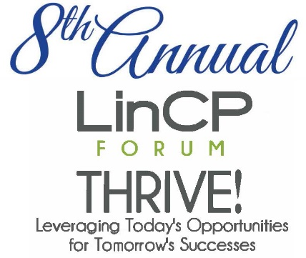
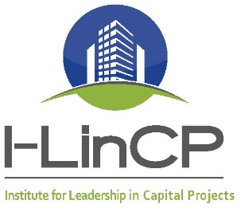


CALL FOR SPONSORSHIP!!

We need your help! The Institute for Leadership in Capital Projects (I-LinCP) is currently filling speaker and panelist positions for our 8th Annual Leadership in Capital Projects Forum. The Forum will be held April 7-8, 2016, at the Eilan Hotel in San Antonio, with a golf tournament benefitting student scholarships on April 6th.

This year’s theme is: “Thrive! Leveraging Today's Opportunities for Tomorrow's Successes.” The Design/Construction industry is growing vigorously in Texas and this Forum will be an opportunity for project stakeholders to share knowledge, ask questions and gain insights to successfully execute capital projects.

The Forum will include facilitated, multi-party discussions to understand issues and discuss solutions, as-well-as sharing of case studies, tools, techniques and best practices.

Your sponsorship will help expand our community and knowledge based solutions to common problems we face in the capital projects industry.

We are offering several sponsorship packages designed to help professionals and owners partner together. With your sponsorship you can expect a range of benefits including:
- Promotional elements
- Vendor booths
- Complimentary registrations
- Networking materials

The participants of this Forum will greatly benefit from your generosity and engagement.

If you, or someone you know has interest in participating, please contact:
Carla Bingaman
I-LinCP Executive Director
(512) 263-5521
Carla.Bingaman@I-LinCP.org

Forum Sponsorship Levels

Partner: 1 Available
$5,000

Keynote: 2 Available
$3,000

Gold Sponsor: 4 Available
$2,000

Silver Sponsor: 6 Available
$1,000

Golf Sponsorship Levels

Title Sponsor

Hole Sponsor

Drink Cart Sponsor

Lunch Sponsor

Gift Bag Sponsor

WHO ATTENDS?

WHAT PEOPLE ARE SAYING:
“Knowledge is power, and what you find with I-LinCP is a collaborative group of extremely smart people with a lot of experience. If they see you are in a bad situation, they will be more than happy to say, ‘We have been there; we understand. Let’s look at how we can better deliver successful projects.” Rob Roy Parnell, Texas State University System
“Carol uses a unique format in her LinCP Forums. As a follow-up to panel discussions or presentations, you work through exercises with your table mates. There’s lots of interaction and dialogue, and everyone gets involved.” Marie Hoke, WHR Architects
CAPITAL PROJECT AND INSTITUTIONAL:

