
Bulging Disc
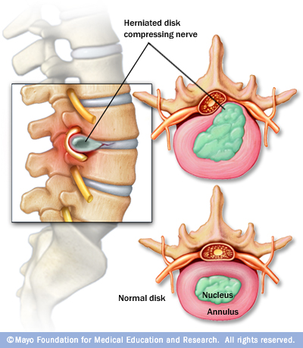
When a disc degenerates, the soft inner gel of the disc can leak back into the spinal canal. This is known as disc herniation. The herniated disc material then puts pressure on the nerve, causing pain .
Disc herniation
Compressing nerves

What is the Cause?
Disc herniation is most often the result of gradual disc degeneration. When injury occurs to soft tissue around your spine, your body will build up scar tissue to stabilize your spine. As a result, your spinal disks lose some of their water content, making them less flexible and more prone to tear or rupture; even from minor strain or twist.
Normal Disc

How to Correct

Disc Rehydration

Disc Herniation
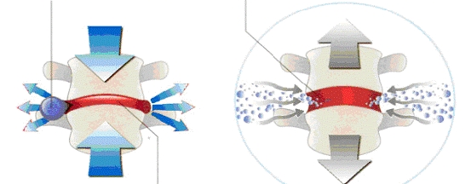

Water Loss


The ARC Method allows the body to regain function, symmetry and
muscular balance.

6 Common Causes of Hip Pain

Osteoarthritis
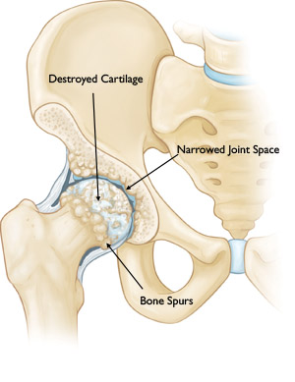
  - Arthritis: The most common cause of chronic hip pain is osteoarthritis. This type of arthritis affects many people at any age. i.e. wear-tear

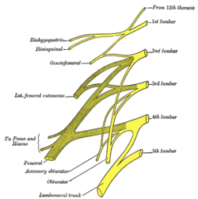
  - Herniated disk and/or Sciatica: Pinching of a nerve can cause pain in the back of the hip — the pain can start in your lower back and travel down to your buttocks and legs. This condition is called Sciatica.
  - Tendinitis and Bursitis: Many tendons around the hip connect the muscles to the hip joint. Bursa acts as cushions between bones. These tendons and bursa can easily become inflamed causing tendinitis and bursitis.

  - Muscle Spasm: Muscular imbalances steam from overworked muscles causing Trigger Points. Prolonged posterior hip pain due to Trigger Points travel through the buttock muscles causing muscle spasm.
The ARC Method allows the body to regain function, symmetry and
muscular balance.

  - Sprain/ Strain: A hip sprain/strain is a condition that occurs due to stretching or tearing of tight ligaments or muscles that support the hip joint.
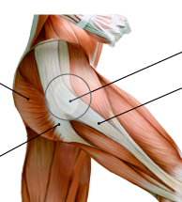
  - Poor Posture: Anterior Pelvic Tilt. A condition where a person’s pelvis tilts forward, pushing his or her torso forward bending the back in an odd position. Extended periods of sitting locks your hips in this position.
Muscle
Spasm
Tendinitis
Bursitis
Sprain
Strain
All of these are caused by POOR POSTURE

Shoulder Pain

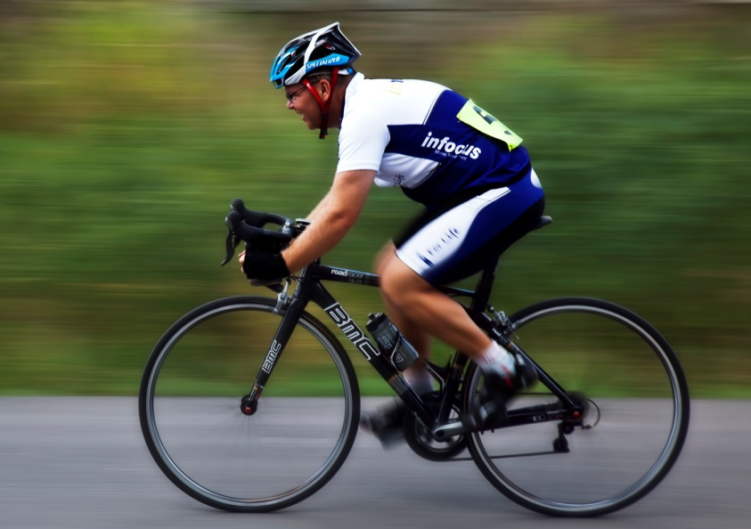
2 Foot by 2 Foot Box

Everything we do is in front of us. We reach forward when typing on keyboards, holding steering wheels and even while washing dishes. If you are a runner or a cyclist, you are likely to round your shoulders in your sport. If you lift weights to develop your “pecs”, you may build pectoral (chest) muscles that are so strong that they bring your shoulders forward.
The shoulder joint has the most complex and unstable joints in the human body. Muscle imbalances are the result of the chest and front shoulder muscles tightening up causing your shoulder stabilizers to overstretch, making them weaker
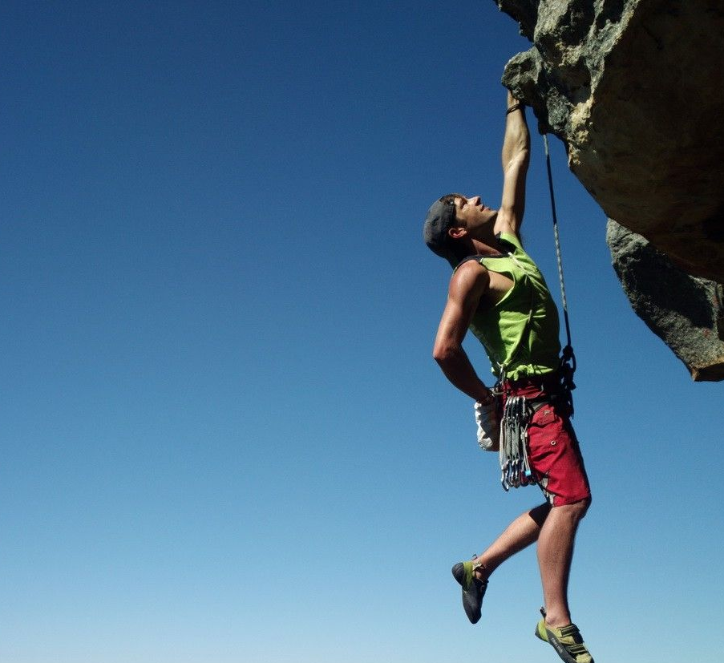

Breaking Out of the BOX
For the shoulder to function properly, you need to train ALL the muscles that help stabilize it.
The ARC Method trains all the involved muscle groups crucial for the long-term health.

