page 1:
logo
Be a part of it
Chabad Shluchim Kinnus
2015 2015

page 2:

What is Communer?

Communer is a customizable app that distributes any information, be it events, announcements, services etc. that you upload to our portal, distributing it to all the members using the app. It is an app that allows a significant increase in engagement with community members, whilst making you much more accessible to anyone who may be visiting.

Features:
Use our Announcement feature to publicize what is going on.
Display opening times of your Facilities.
Live Service Times for Shacharit, Mincha and Maariv.
An integrated Calendar that can easily sync with any smartphone.
Find out what is going on anywhere in the world using our Explore feature.

Our Vision:
We want to create a world where Jews can travel and still be connected to a Jewish Community no matter where they are. We want to enable Jews globally to get connected, creating access to every Jewish Community around the world.

page 3:
(App image)
(arrows of short explanations – put row text)

Page 4:
How can Communer help me, as a Chabad Center?
- We can help bring your Chabad into 2015, with a personalized App, for a reasonable fee
- You can easily send out Announcements, targeting specific groups so your members only see what's necessary for them
- You can easily inform both your members and visitors, of daily Prayer times and candle lighting times
- With our integrated payment tool, members can pay for your services directly through the App
- You will be able to update your members on any important dates, together with any events or classes, with our integrated calendar feature
- Communer allows any Jew, throughout the world, the ability to access your community

(review + face)
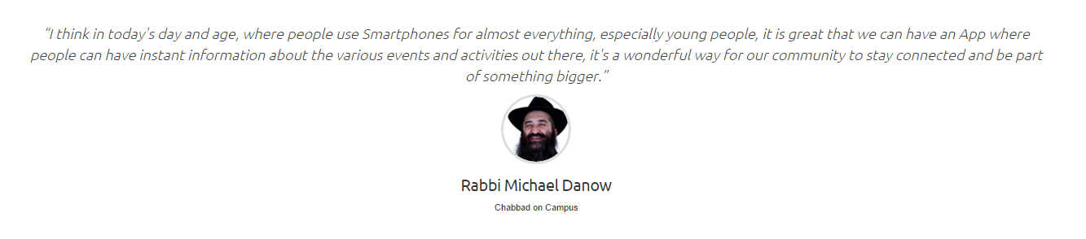

(framed saying)
"When you hold a part of the essence, you hold all of it" - Baal Shem Tov

Page 5:
(4 strips from our homepage, of course different background)
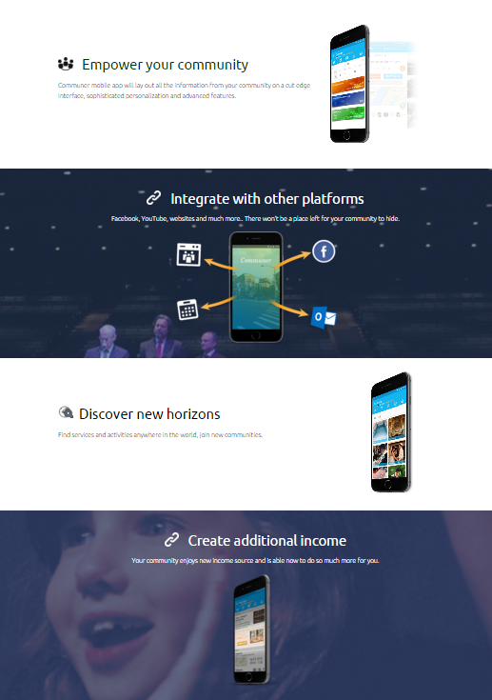

Page 6:
157
Communities, schools and organizations
Have already joined

Want to join Communer?
Email: contact@communer.co
Tel: +972-2-8002030
www.communer.co (also for the QR code)
Download Communer app at:
(google play) (app store)
Available at November 2015

