Contact QUDA for information about how to get involved in a game of Ultimate or to introduce Ultimate to your school.
Accredited Coaches and Level 1 Certifications provided.

- a hard RUNNING, high JUMPING, full length layout DIVING, point scoring, TEAM SPORT .
- NON CONTACT and is often played MIXED.
- One of the fastest growing sports in AUSTRALIA and around the WORLD
- The best way to make new FRIENDS and get FIT at the same time.

ULTIMATE is:
Looking for a NEW SPORT??
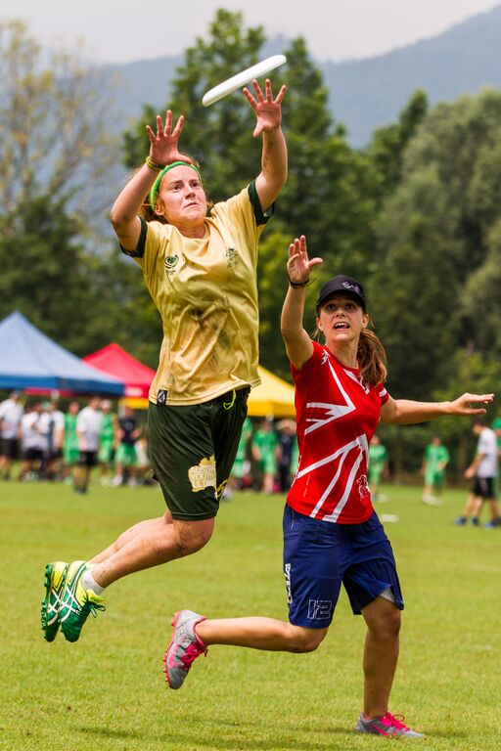
ULTIMATE FRISBEE!
Play…
Contact QUDA for information about how to get involved in a game of Ultimate or to introduce Ultimate to your school.
Accredited Coaches and Level 1 Certifications provided.

- a hard RUNNING, high JUMPING, full length layout DIVING, point scoring, TEAM SPORT .
- NON CONTACT and is often played MIXED.
- One of the fastest growing sports in AUSTRALIA and around the WORLD
- The best way to make new FRIENDS and get FIT at the same time.

ULTIMATE is:
Looking for a NEW SPORT??
ULTIMATE FRISBEE!
Play…

Contact QUDA for information about how to get involved in a game of Ultimate or to introduce Ultimate to your school.
Accredited Coaches and Level 1 Certifications provided.

- a hard RUNNING, high JUMPING, full length layout DIVING, point scoring, TEAM SPORT .
- NON CONTACT and is often played MIXED.
- One of the fastest growing sports in AUSTRALIA and around the WORLD
- The best way to make new FRIENDS and get FIT at the same time.

ULTIMATE is:
Looking for a NEW SPORT??
ULTIMATE FRISBEE!
Play…

