Here are some vacuum tube valves:
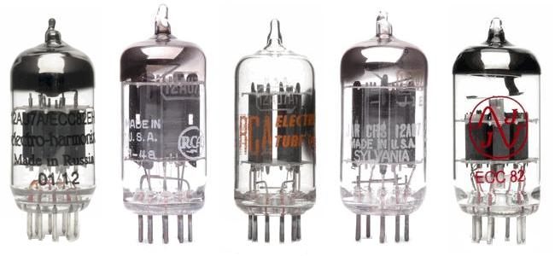

This was my first very rough idea, but don’t be limited by it


