Tuesday, 3 November 2015
9:06 PM

Manage Project Designs | DesignCrowd
http://www.designcrowd.com.au/project-progress/designs.aspx?briefId=1518546&submissionId=7770942
Screen clipping taken: 3/11/2015 9:07 PM

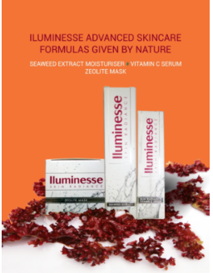

Iluminesse: Nature’s Advanced Skincare
From Australia
No Synthetics
Non Toxic



