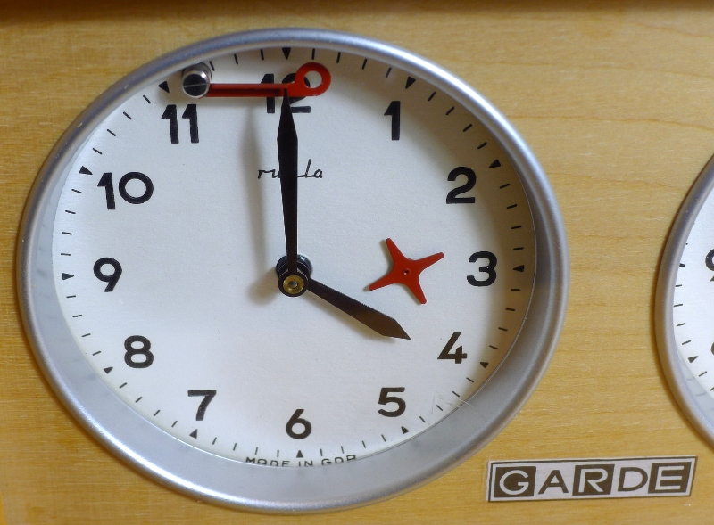

LOGO:
As you can see from the example image, there is a clock with an arrow. Do a quick research on how old analogue chess clocks work and you will easily understand the concept behind it. In essence, the less time you have, the more the flag goes up...

In the chess world, when both players reach a situation where they are about to flag (and lose the game), havoc breaks loose...which is an element I would like to see in the designs.

I envision the logo to be simplistic (even minimalistic) and to have as main components: ARROW, FLAG, and potentially other clock components that may make the logo work. The arrow must be in its peak (about to flag) in relation to the flag. You can try combining the logo with the name of the website...or not. If the principle of speed can somehow be implemented in a clever way (without standing out), that would be awesome! When I am talking about speed, In a way I am talking about those clever logos with hidden symbols within them...toblerone, fedex...etc. It's not the most important thing, but I'd appreciate to see some ideas that try to implement it. Another principle would be time - as in time efficiency. However, I am open to suggestions that follow the same direction!

Colors: What I am going for is mainly something in the shades of WHITE, BLACK, and RED. I want smooth (low contrast) colors. I've chosen these colors mainly because of the way I envision the logo. Once again, I am open to suggestions!

