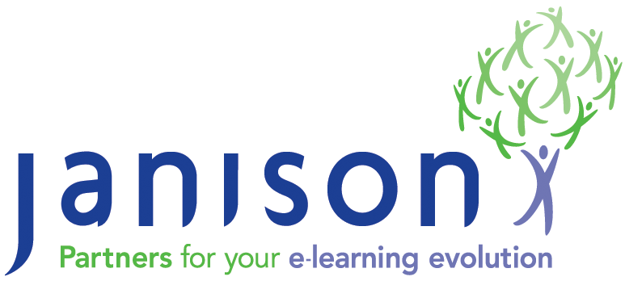
CLS / CAFe - Fact Sheet

Introduction

This fact sheet provides background information and answers to common questions often asked about the Janison CLS platform.

CLS stands for Cloud Learning Suite, it is a suite of web applications designed to provide a range of functions including:

- Complete multi-tenancy support
- Multiple organisation and complex organisational structure support
- Advanced assessment tools and services
- Advanced course creation tools and services
- Support for a variety of course delivery and access services
- Training, competency and skills management
- Compliance training and reporting
- Just in time content delivery options
- Sophisticated e-commerce support
- Support for flexible delivery channels and payment options
- Customisable and flexible delivery of learning assets
- Complete support for hosting as a Platform as a Service (PaaS) cloud system
- A variety of authentication services
- Complete support for hosting in an on-premise server environment

The suite has been built using the very latest development tools and methodologies ensuring that the application is able to perform and scale to support thousands or even millions of users online.

What are the options for hosting?

Janison offers the system in a variety of forms. The most common is as a Software as a Service (SaaS). In this form, Janison hosts the system either in Australia at its dedicated web farm environment in Sydney or from a Microsoft Windows Azure Centre located in Singapore, Hong Kong, Dublin, Amsterdam, Chicago, or San Antonio.

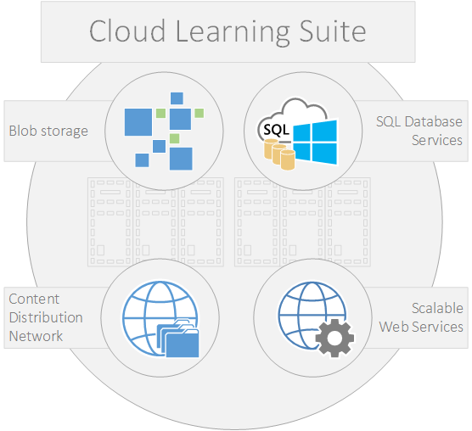

For some clients Janison provides a hybrid, hosted model, which provides the highly scalable delivery components from the Microsoft Windows Azure data centres and the management environment and data repository in a secure on premise or Australian hosted location.

What software is required on the client?

The system only requires a web browser. Whilst compatible with Internet Explorer 8 or greater, the system is designed to support and take advantage of the latest features of Apple Safari, Google Chrome, Microsoft Internet Explorer and Mozilla Firefox.

What server technologies are used by the system?
The system is built using the Microsoft .NET Framework 4.5, ASP.NET MVC and stores it data in a Microsoft SQL Server database (either Azure, 2008 or 2012 versions).

What options are available for branding or skinning the application?

The system provides a comprehensive set of skinning and branding functions allowing your web site to support your brand.

Skinning and branding is extended to the tenant and sub-domain levels, meaning that if your application uses multiple tenants, each tenant can also have its own skin. Furthermore, a single tenant can have multiple sub-domains, each with their own skin.

What authentication models are available?

A range of authentication options are provided. The application has its own built in identity management system and supports single sign on via SAML, and oAuth, CLS also has a SAML provider that connects directly to a local Active Directory, but our clients can use their own SAML providers if they wish.

What security levels are available?

There are multiple security levels available within the system by default. Including system administrator, tenant administrator, area of study administrator and student. These can be further extended via a flexible roles component.

How much user information is stored/required?

The system supports an extensive user identity store, but can also operate with a minimum of identifiable information. The user identity model is also easily extended.

How is user provisioning supported?

Users can be provisioned using a variety of tools. There is an Identity Service utility which is able to automatically load users from a local identity store, either an Active Directory or custom database containing user records. There is a web service and API that can support the creation and maintenance of users via a third party process controlled by the client. Additionally users can be loaded via spreadsheets.

Is data encrypted?

Hosted services are optionally provided using HTTPS ensuring that all data is encrypted during transport. Data stored in SQL databases is not encrypted. However, password fields are stored in an encrypted form. The authentication process from the application to the database is encrypted i.e. at no point at clear text passwords sent across the wire.

Is there a roadmap for the system?

A roadmap for the system is available to clients and is provided via a private blog site for the product.

What options exist for securing access to the system?

The system can be configured to support secured regions through the definition of IP ranges. Tests can be provided and limited to secured regions.

A lockdown browser is also under development that works with the system to lockdown access to the system, restricting the ability to access other applications and the use of copy and print functions.

What are the support options available?

Our organisation provides a range of support options.

By default, all clients have access to our support centre, online helpdesk and support team. Our support team provides telephone support during standard business hours.

Operational support for outages is provided 24 hours a day, 7 days a week.

What level of uptime is guaranteed?

The system has a guaranteed uptime of 99% each month.

How is the system protected against denial of service and penetration attacks?

Our system has been designed to be resilient to all of the latest penetration attacks. Our systems are regularly penetration tested by third party security companies to ensure the system is safe from penetration attacks.

Our hosting service partners also provide a range of firewalls and other protections that guard against denial of service attacks.

How regularly is the system backed up and where?

The system content and database are backed up nightly and stored securely.

What options are available for disaster recovery?

We have the ability to offer a variety of disaster recovery options, including hot swappable sites located in different datacentres and different regions.

