GREAT LAKES GOURMET POPCORN

Logo: incorporate the image of the great lakes.

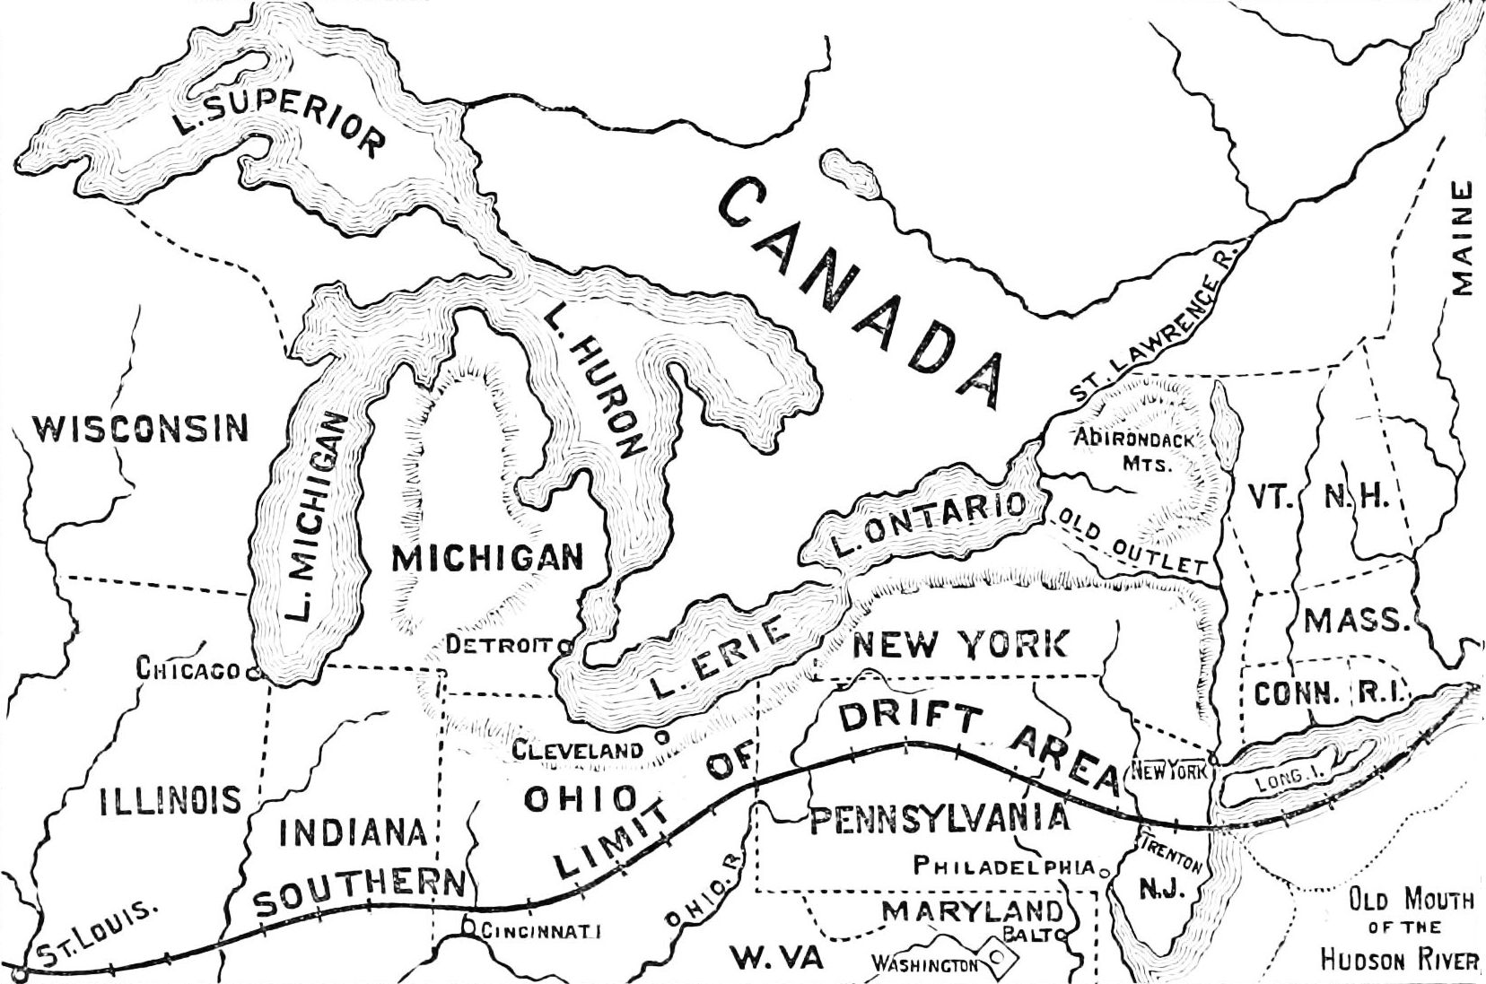

What other existing package design (either local or national) do you find appealing?
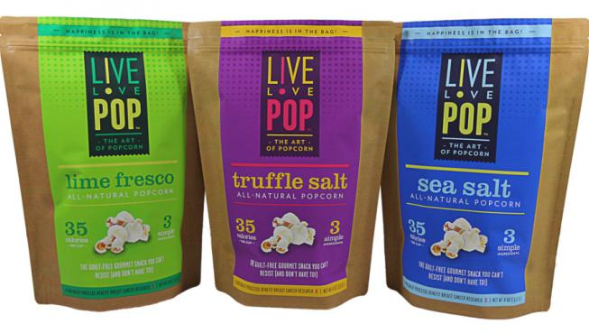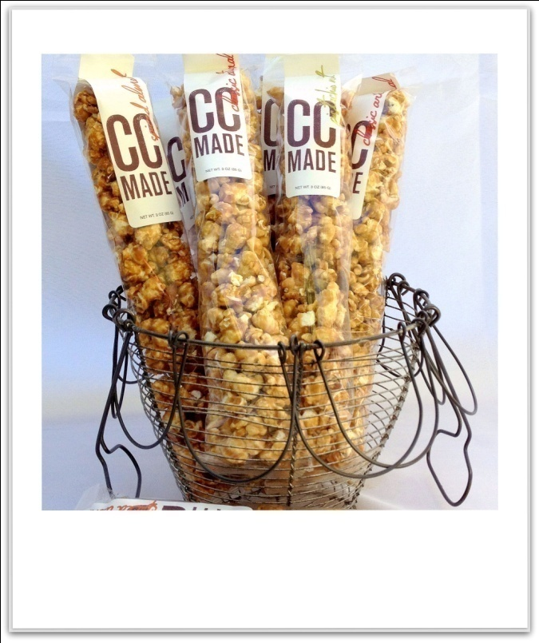
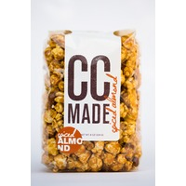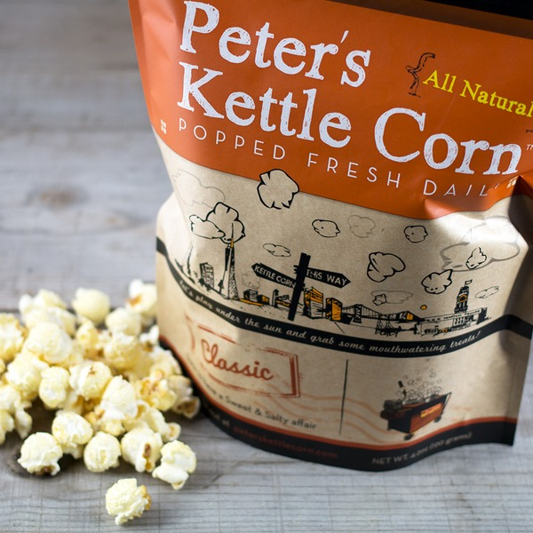

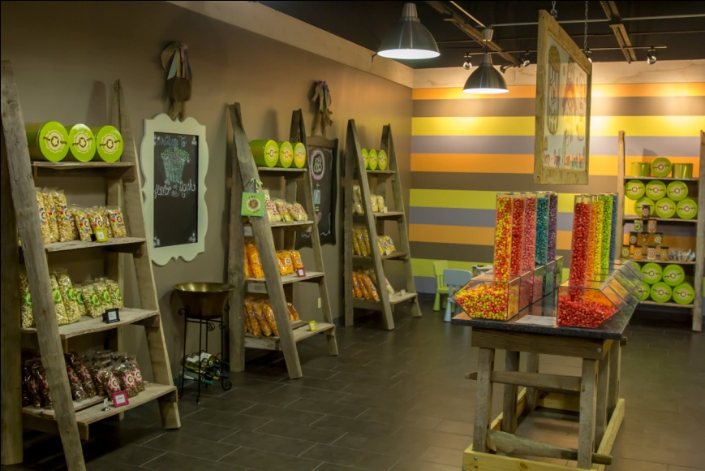We will display on similar types of shelves at the boutique stores.

Describe your ideal client in terms of age, gender, and location.
Tourist type boutiques along the great lakes as well as specialty shops (wineries, deli’s, breweries, etc) Age range would be 20-75, both male and female.

What kind of feelings do you want to project with your new brand
Unique, Boutique, Gourmet, Fun

What is the exact wording of the name for which you want a package designed?
GREAT LAKES GOURMET POPCORN Waves Of Flavor

I really like the below logos!

