Business Growth Acceleration MAP
How To Create Predictable, Profitable & Scalable Growth... With No Guessing

Update the text copy to match this version of the spec.
Try incorporating the core concept of the logo design into the header of the system... like we attempted on the sample of the next page. Stick with the BGA reds & blues you have in the logo for the headline.
Try using interconnecting circles instead of the hexagon shapes. Use a metallic style to make them stand out... see sample on page 3. When putting the copy text in the rings, use Initial Caps, not all CAPS.
For colours, try using a dark purple, dark blue and lighter blue like in the samples provided
Ensure the ring colours and the banner colours match.

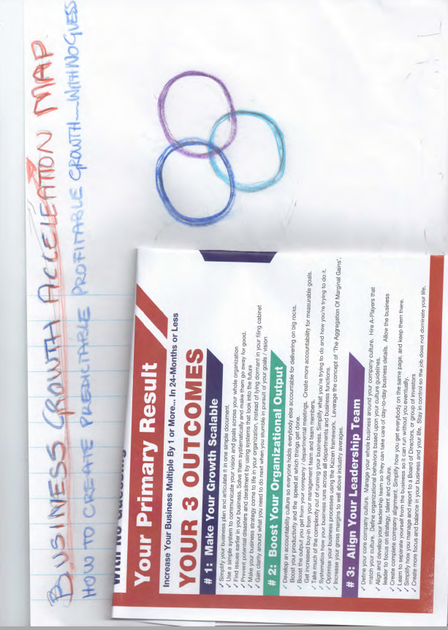

Your Primary Result
Increase Your Business Multiple By 1 or More... In 24-Months or Less
Your 3 Outcomes Remove this line
# 1: Manage The Big Picture
- Simplify your business plan and articulate it on 3 sheets of A4 paper.
- Use a simple system to communicate your vision and goals across your whole organization
- Make your business strategy come to life in your organization, instead of lying dormant in your filing cabinet
- Get crystal clear on who your Ideal Client is and what your Difference Maker is. Create Winning Moves that keep you well ahead of your competition.
- Become a real Customer Centric business and integrate the concept of Customer Success into the DNA of your company
- Prevent potential disasters and derailment by using systems that look into the future
- Increase your gross margins to well above industry averages.
- Simplify how you manage and report to a Board of Directors, or group of investors
# 2: Act On The Growth Rocks
- Develop an accountability culture so everyone holds everybody else accountable for delivering on big rocks. Boost your productivity and the speed at which things get done.
- Get everyone on your team focused on metrics that are aligned to your company priorities.
- Boost the output you get from your company / departmental meetings. Create more accountability for measurable goals. Get increased buy-in from your management team and team members.
- Take much of the complexity out of running your business. Simplify what you’re trying to do and how you’re trying to do it.
- Systematize how your business runs across all departments and business functions.
- Optimise your business processes using the Kaizen framework. Leverage the concept of ‘The Aggregation Of Marginal Gains’.
- Find issues earlier in your business. Solve them systematically and make them go away for good.
- Gain clarity around what you need to do next when you stumble in pursuit of your goals / vision
- Pursue the aggregation of marginal gains across your whole organization.
# 3: Prioritize Talent Development
- Grow and develop your management team so they can take care of day-to-day business details. Allow the business leader to focus on strategy, talent and culture.
- Create complete company alignment. Simplify how you get everybody on the same page, and keep them there.
- Implement team feedback systems linked to organizational big rocks
- Define your core company culture. Manage your whole business around your company culture. Hire A-Players that match your culture. Define organizational behaviors based upon your culture guidelines.
- Play to people’s strengths and get the right people sitting on the right seats on the bus
- Learn to separate yourself from the business so it can run without you eventually.
- Create more focus and balance in your business and your life. Stay in control so the job does not dominate your life.
- Optimize your company communication rhythm, so your whole company stays informed, aligned and engaged.

The copy on the next page is side 2 of the graphic.
Use the same core design for side 2
The copy on the next page should be laid out in similar style to what you did here... but incorporating the changes from above.

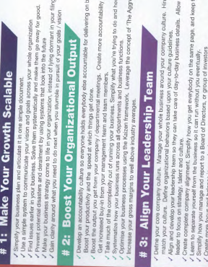

For the copy on the right hand side of the page, try a style something like this...
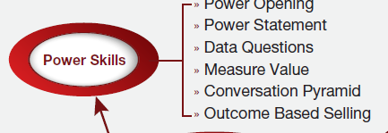

It like look something like this (see next page) in landscape mode
The copy on the last 2 pages is the correct copy... the copy in the draft images is just draft copy.

 Implementation MAP
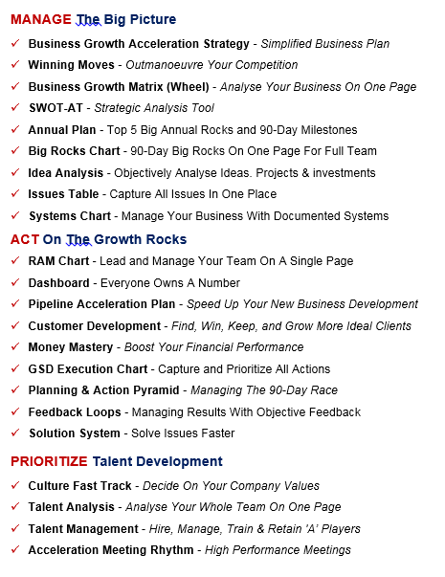 | 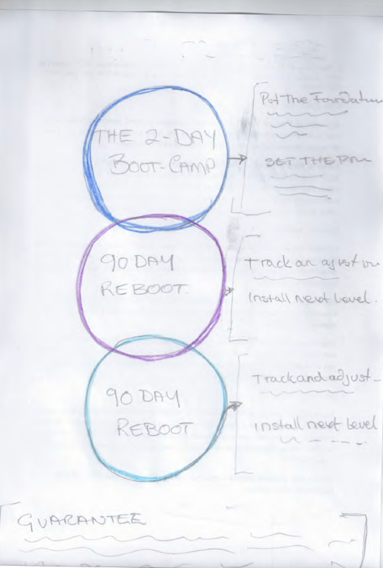

MANAGE The Big Picture
- Business Growth Acceleration Strategy - Simplified Business Plan
- Winning Moves - Outmanoeuvre Your Competition
- Business Growth Matrix (Wheel) - Analyse Your Business On One Page
- SWOT-AT - Strategic Analysis Tool
- Annual Plan - Top 5 Big Annual Rocks and 90-Day Milestones
- Big Rocks Chart - 90-Day Big Rocks On One Page For Full Team
- Idea Analysis - Objectively Analyse Ideas. Projects & investments
- Issues Table - Capture All Issues In One Place
- Systems Chart - Manage Your Business With Documented Systems
ACT On The Growth Rocks
- RAM Chart - Lead and Manage Your Team On A Single Page
- Dashboard - Everyone Owns A Number
- Pipeline Acceleration Plan - Speed Up Your New Business Development
- Customer Development - Find, Win, Keep, and Grow More Ideal Clients
- Money Mastery - Boost Your Financial Performance
- GSD Execution Chart - Capture and Prioritize All Actions
- Planning & Action Pyramid - Managing The 90-Day Race
- Feedback Loops - Managing Results With Objective Feedback
- Solution System - Solve Issues Faster
PRIORITIZE Talent Development
- Culture Fast Track - Decide On Your Company Values
- Talent Analysis - Analyse Your Whole Team On One Page
- Talent Management - Hire, Manage, Train & Retain 'A’ Players
- Acceleration Meeting Rhythm - High Performance Meetings

# 1: The 2-Day GROWTH Boot camp
- Put the foundations in place so you create predictable, profitable and scalable growth. Go further and faster than you did in previous years with predictable growth management systems.
- Set the primary targets for the next 12 months. Agree critical milestones for 90-Day Race.
# 2: 90-Day Reboot #1
- Track and adjust based on results from first 90-Day Race
- Install next level of BGA systems
# 3: 90-Day reboot # 2
- Track and adjust based on results from second 90-Day Race
- Install third level of BGA systems
GUARANTEE
Each of the 4 days comes with an unconditional money back guarantee. If you get to the end of a module day and are not 100% convinced you will achieve the primary goal, simply request a hassle-free refund at the end of the day. Your investment in that module day will be fully refunded and future dates will be cancelled.

