Welcome to TSI Volleyball

“Winners are not people who never fail, but people who never quit.” -Unknown

TSI is a place for all athletes looking to give 100% effort to further develop their skills, knowledge, and love for the game of volleyball. At TSI we break down the skills of volleyball to the simplest form so athletes can reach a new level of personal achievement. TSI Volleyball will accelerate the rate at which its athletes learn. We invite you to take a look at our program and then you will see why we are one of the fastest growing programs in North Texas.

TSI Volleyball – Crafted and Designed

“Strive for progress, not perfection” - Unknown

At TSI our goal for all athletes is to see a continuous development and growth in all aspects of volleyball; skills, movement, agility, IQ, and court awareness. Volleyball is the sport that has to aim for perfection because no two balls are the same; not in serve, serve receive, defense, or offense. The athlete’s ability to learn how to adjust to each and every single ball that comes their way is where our job comes in to play. We integrate our coaches’ skill set with the Sports Performance program to mold the athlete’s game, giving them the tools to succeed. TSI Volleyball is a program for any athlete at any level who is looking to take their game to the next level.

Coaching Staff

“A coach is someone who tells you what you don’t want to hear, who has you see what you don’t want to see, so you can be who you always known you could be” – Tom Landry.

There is nothing more important than investing in your coaching staff. TSI’s coaching staff is one of the most diverse groups in the market. Our coaches have vast playing experience and understand the game at the club, middle school, high school, collegiate and professional levels. At TSI we hire coaches that not only can coach the game at a high level, but who are great teachers, role models, mentors, that have high moral and ethical values and character who are capable of differentiating their coaching strategies for individual athletes. The staff member’s playing experience covers all six positions on the court and over 30 years of coaching experience combined. TSI coaches have seen the game of volleyball transform over the years and as students of the game they have been able to make the adjustments to stay ahead of the curve as the game of volleyball continues to evolve. At TSI our goal is to create an achievement plan for each individual athlete to make sure they continue to grow in all areas of the sport. Additionally, because all of our coaches are IMPACT certified, they understand very intimately the environment that your son or daughter will be trying out or playing in over the years to come. They uniquely understand every point of view that your son or daughter will encounter in the volleyball landscape. Our volleyball coaching staff in combination with our Sports Performance trainers is like no other program in the area. Join us at our next training session to see for yourself!

Come and See Us!
Times and Dates of Sessions

TSI Volleyball operates on Monday and Wednesday evenings from 6-9pm at Maus Middle School in Frisco, Texas.

Our location changes to Roach Middle School for the month of November!! Please mark the change on your calendar so you do not miss out on a night of progress!

Skills Sessions

Mondays/Wednesdays

6-7pm skills/private lessons: - these sessions are designed for the player who is new to the game or is capable of playing at the recreational level. The players are instructed on the core fundamentals, will get many repetitions and feedback throughout this skills session.

7-8pm: Sports Performance/private lessons: the sports performance sessions are designed to improve the players athleticism through repetitive agility, strength, flexibility and conditioning exercises.

8-9pm skills/private lessons: these sessions are designed for the advanced players who are capable of playing at the tournament level or looking to play at tournament level. During these sessions the players are focused on fine tuning the core fundamental base, implementing advanced skills and game-like strategies to become a player that that can succeed at the next level.
Volleyball Teams
At TSI, we offer a team for all levels K through 12th grade for girls and boys. Volleyball is not only a female sport, but male as well! We are looking forward to developing our boys program to expand in the Dallas area with the help of the North Texas Region. Invite a friend, girl OR boy, to one of our TSI practices for a one time free of charge session!

Recreational Teams
TSI enters its teams in the Fieldhouse and PSA leagues. The teams are formed based of ability and then are placed in the correct division in the local leagues so that the players can maximize the experience, thrive, and love of the game. TSI has teams all year round Fall/winter/Spring/Summer. The teams play 8 game seasons with a team practice and skills session. You can find more information on the here on the Frisco Fieldhouse and PSA websites.

Uniforms: Jersey and Spandex

Tournament Teams
TSI offers tournament teams from 6th-12th grade that will play in local and regional events. The tournament season goes from December to June and will be located in the Dallas/Fort Worth area. Teams will play on average 2 weekends a month. TSI is affiliated with the North Texas Region, which is a part of USA Volleyball.

Uniforms:
Jersey, spandex, knee pads, socks, shoes, backpack

Uniforms can be purchased through the team store ADD LINK HERE

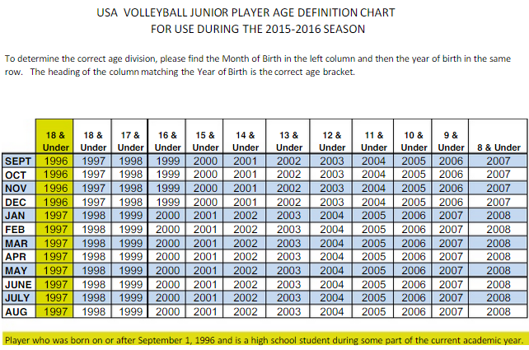

Program Fees

TSI Volleyball offers something for everyone.

Skills Only

Monday Night
4 sessions -- $100/month

Wednesday Night
4 Sessions -- $100/month

Punch Card
4 sessions of skills and/or sports performance -- $115

Packages

Bronze Package
4 skills sessions + 2 sports performance -- $140

Silver Package
4 skills sessions + 4 sports performance -- $175

Gold Package
Mon + Wed -- 8 sessions -- $175

Platinum Package
Mon + Wed -- 8 skills sessions + 8 sports performance -- $275

Private Lessons

1 session TSI member -- $40
1 session -- Non-TSI member -- $65

5 sessions -- TSI member -- $150
5 sessions -- Non-TSI member -- $250

Location

October Maus Middle School 12175 Coit Rd, Frisco, TX 75035, United States

November Roach Middle School 12499 Independence Pkwy, Frisco, TX 75035, United States

Registration
ADD VOLLEYBALL LINK HERE

Tryout Information

Things you need to complete before tryouts
-Register online for TSI Volleyball Club Tryouts (ADD LINK TO PLAYER PROFILE REGISTRATION FORM)
Register or Renew membership with North Texas Region
Registration
Membership Types and Fees
Complete and bring Medical History and Release forms to tryout

Important things to remember before tryouts:
Complete Registration and Payment
Register or renew membership with CHRVA
Arrive 30 minutes before tryout begins

What to bring to tryouts?
Copy of online membership registration with USAV/CHRVA
A completed Medical History & Release form
Copy of child’s birth certificate

All tryouts and clinic will take place at ___new gym location_______________

USA Volleyball Forms and Information

