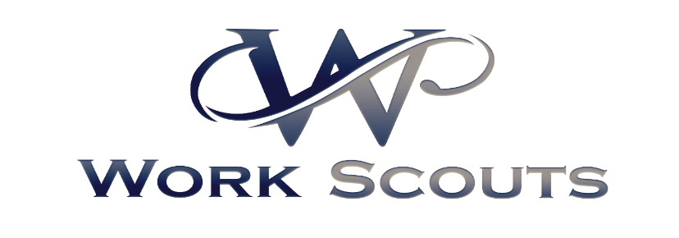

Proposal for Executive Placement Services

Here at Work Scouts we believe in building lasting relationships with our customers. We started out as a family owned business, and we relate to wanting only the best of the best within our industry. We know there are many people seeking work with the economy’s growth and we are determined to provide our clients with only the best. That is why we have such a rigorous assessment of each potential candidate. We complete skill testing we understand the challenges your company may face, trying to cope with the advances of technology and the ever-growing demands of the markets are some of the major concerns of businesses. Complexities of running the daily operations, managing the cash flow, providing excellent products and services, hitting the sales revenues - these impact the business cycle and more importantly, the capacity of the organization to get ahead of the competition while maintaining customer satisfaction and increasing revenues. The fundamental blocks of building and running a stable business will not be complete without a competent and dependable workforce. That’s what we are here to find for you and your company. We understand the extremely competitive job market and the challenges you may face when searching for the best in specific lines of work. So many critical positions are extremely difficult and time-consuming to fill. As part of our direct placement services, Work Scouts takes the time to learn your business so that we fully understand your priorities and what would character an individual must possess in order to be a perfect fit for your company. With this insight on your companies’ atmosphere, process, and history it will enable our career agents to provide potential candidates with a proposition that is compelling to the most experience, and goal oriented individuals. This will ensure that both yourself, and your future employees are satisfied with their choices. At Work Scouts, we believe that people are the best asset in any company, regardless of the business size, industry or market share. We provide the best professionals, backed with solid years of expertise, experience and knowledge, who can integrate solutions for your business needs.

We implement a scientifically proven, Pre-Employment testing database system. We start with a general test which includes aptitude, personality, and basic skills. The testing we have available includes:
Aptitude tests-assess cognitive ability, which research shows is the single best predictor of job performance. Our employment aptitude tests measure problem-solving ability, critical thinking, attention to detail, and learning ability.
Criteria Cognitive Aptitude Test (CCAT)-A general aptitude test that measures a candidate's problem-solving ability, critical thinking, reasoning, and aptitude for learning and applying new information. 15 minutes.
Wiesen Test of Mechanical Aptitude (WTMA)-The WTMA measures an individual's mechanical aptitude, or ability to learn to operate, maintain, install and repair equipment and machinery. 30 minutes.
MiniCog Rapid Assessment Battery (MRAB)-A nine-test aptitude battery created by Harvard University psychologists, the MRAB measures an individual's ability to process information, including specific cognitive functions such as attention, working memory, and reasoning ability.
Criteria Attention Skills Test (CAST)-A four-test subset of the MRAB, the CAST measures a person's concentration and ability to sustain focus on one or more tasks while avoiding distractions
- Employment Personality Tests
Personality tests, sometimes called behavioral tests, assess a person's behavioral traits and tendencies, and provide valuable information on a candidate's likely job and culture fit. They also measure traits that have been shown to be linked to performance in a range of occupations, and often provide benchmarks for predicting suitability for a particular position.
Employee Personality Profile (EPP)-The Employee Personality Profile is a general personality inventory that measures twelve personality traits that provide valuable insights into a person's work style and behavior. It can be used for any position, and contains position-specific benchmarks that allow administrators to compare an individual's scores against composite profiles to determine likely job fit. The EPP takes about 15 minutes to complete, and measures the following traits: Achievement, Assertiveness, Competitiveness, Conscientiousness, Cooperativeness, Extroversion, Managerial, Motivation, Openness, Patience, Self-Confidence, and Stability.
Workplace Productivity Profile (WPP)-The Workplace Productivity Profile is a personality test that is used to predict whether an applicant will be a conscientious, productive, and reliable employee.
Criteria Personality Inventory (CPI)-A general personality inventory based on the most widely accepted personality model — the "Big Five" — which describes an individual's personality in terms of five psychological traits: Agreeableness, Conscientiousness, Extroversion, Stability/Neuroticism, and Openness.
- Employment Skills Tests
Skills tests measure job-related competencies ranging from broader job-readiness predictors such as reading, math, and communication skills to more specific acquired proficiencies such as typing and computer skills.
Criteria Basic Skills Test (CBST)-A 20-minute, 40-item test that measures basic math, verbal, and communication skills as well as attention to detail. Predicts basic job readiness and "trainability" for a wide variety of entry- and mid-level jobs.
Computer Literacy and Internet Knowledge Test (CLIK)-A test of basic computer literacy, that measures an individual's proficiency with using Internet browsers and common desktop applications such as email and word processing programs. It is a 10-minute test consisting of two 3-minute task-oriented simulations followed by ten multiple choice questions.
Typing Test-A 1-minute test that measures an individual's typing speed and accuracy. An adjusted words-per-minute (WPM) score is given, which reflects the total number of words typed correctly during the time allotted.
Ten Key Test-The Ten Key Test measures an individual's ability to perform numerical data entry. The test provides both a speed and an accuracy score.
Microsoft Excel (2010 and 2013)-A 10-minute, 20-item test that measures an individual's proficiency with Microsoft Excel.
Microsoft Word (2010 and 2013)-A 10-minute, 20-item test that measures an individual's proficiency with Microsoft Word

We also provide Job specific testing which you may acquire more information about when speaking to one of our Account Specialists.
I know this seems like a lot of testing but this is how we are able to assure you that we can provide the best match for your staffing requirements, so that you and your future employee are satisfied and content. We want to help your business grow and strive. Please feel free to get in touch with our team from any of the numbers indicated below at any time to understand and learn about more of what we offer, and what makes us different.

Skills. Expertise. Excellence. Dedication
This is what makes our company unique. We at Work Scouts, believe that every employee is a valuable asset. We will provide your workforce with a multitude of skills and experience. Our company is able to respond to the staffing needs of businesses in various industries and professions, ranging from small and medium enterprises to Fortune 500 corporations. At this time we are focusing on providing expert Engineers and Logistics personnel, but no matter how simple or complex the requirement may be, we can provide you the best match for the services you need. Just tell us what you are looking for and we will make it our mission to fulfill your unique needs.
Based in Spartanburg, South Carolina, we proudly serve companies world-wide.

Pricing Estimate
We believe in fair prices. We don’t believe in overpricing our services, and we value our relationship with you. Our prices are based on our placements. Most of our competitors are charging 20-35% of placements annual salary. We are offering a major discount to first time customers, with the rate being 10% of the placements annual salary. This is to prove to you that we can provide the best customer service, as well as find the perfect employees for the position you need filled. We want to develop a relationship with you and your company, not just make a sale. Our typical price is 15% of the placements annual salary, however this is negotiable. We also offer contractual agreements for our services, however these will vary based on your needs.
Please let me when it’s convenient for me to swing by and speak with you. I’d love to meet with you in person to answer any questions you may have, and discuss the future needs of your business. We look forward to growing with you!

Thank you very much for your time. We look forward to working for you.
Best Regards,
Work Scouts


Company Details & Contact Information
Company Name:
Work Scouts
Website: www.workscoutsllc.com
Telephone Number: (864) 406-4047
Local Account Manager and Client specialist:
Jessica Morgan
Email: JMorgan@workscoutsllc.com
Cell: (864) 706-6946
Office: (864)406-4047
Customer Service
Email: customerservice@workscoutsllc.com

