Annexes

Contents
- Company Overview
- The Magnesium Trend
- The Aluminium-Free Deodorant Trend
- Demand for Nasanta Analysis
- Sales of Nasanta since May 2011
- Reorders of Nasanta by Distributor
- Testimonials

Company Overview
"Lorem ipsum dolor sit amet, consectetur adipisicing elit, sed do eiusmod tempor incididunt ut labore et dolore magna aliqua. Ut enim ad minim veniam, quis nostrud exercitation ullamco laboris nisi ut aliquip ex ea commodo consequat. Duis aute irure dolor in reprehenderit in voluptate velit esse cillum dolore eu fugiat nulla pariatur. Excepteur sint occaecat cupidatat non proident, sunt in culpa qui officia deserunt mollit anim id est laborum."

The Magnesium Trend

Google search interest for magnesium supplements increases by 200%
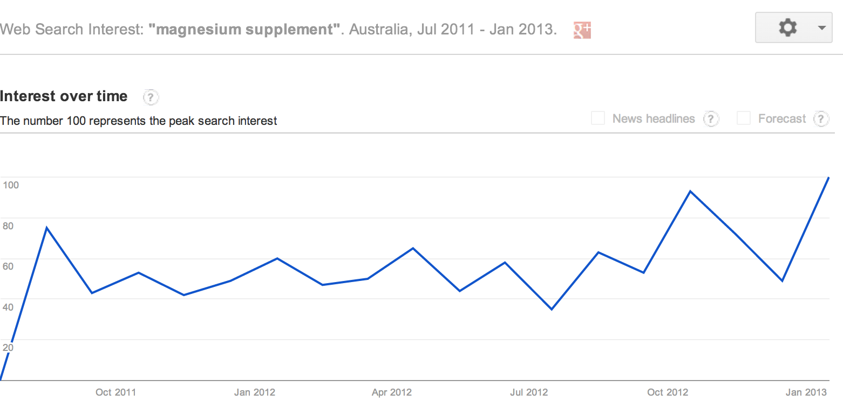
Source: Google Trends 2013

‘The magnesium market is second only to calcium, currently, but it has the potential to exceed the calcium market.’
Max Motyka
Director, Albion Human Nutrition

‘Growing consumer awareness of their own deficiencies, its health benefits, and the emergence of innovative forms are making magnesium the hottest ingredient in the mineral category. With between 70 and 80% of the population not meeting their recommended intakes of magnesium, consumers – and the health care professionals who advise them – are waking up to the importance of the mineral.’ (Nutra Ingredients, January 2013)

Google search interest for magnesium deficiency increases by 200%

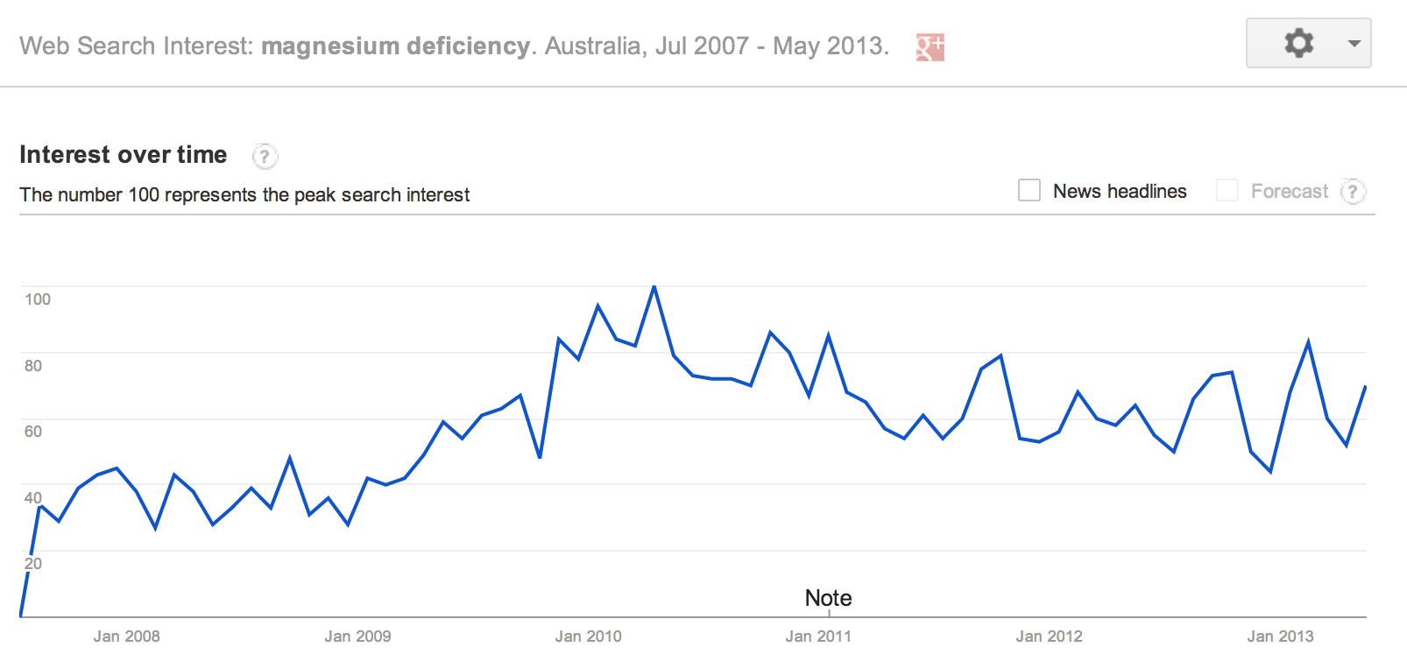
Source: Google Trends 2013

The Aluminium-Free Deodorant Trend

Google search interest for aluminium free deodorant increases 60% in Australia
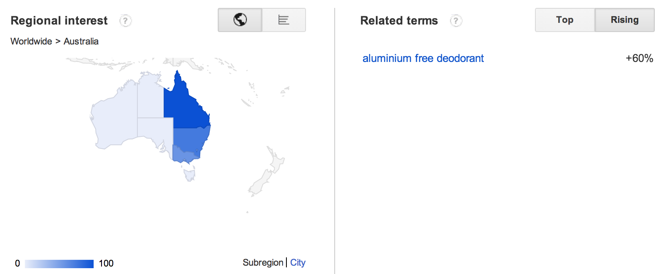

Source: Google Trends 2013

‘Despite Cancer Research UK issuing a statement saying that “there is no convincing evidence that antiperspirants and deodorants cause breast cancer,” ongoing consumer concern means that sales of previously niche aluminium-free deodorant brands such as Jason and Tom's of Maine are growing, and are increasingly being sold in mainstream retail outlets such as Waitrose in the UK. As these natural, free-from aluminium deodorants typically retail at around twice the price of their standard counterparts, the natural segment will be an increasingly important area of growth going forward.’ (Euromonitor 2009

Demand for Nasanta Analysis

Sales of Nasanta® Magnesium Deodorant increase by 183% year on year
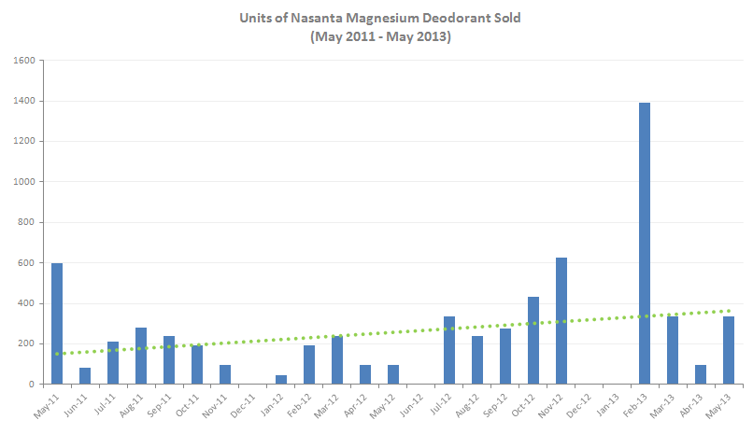
Source: Invoiced sales from May 2011-May 2013

Wholesale Reorders of Nasanta® Magnesium Deodorant by Regional Distributor

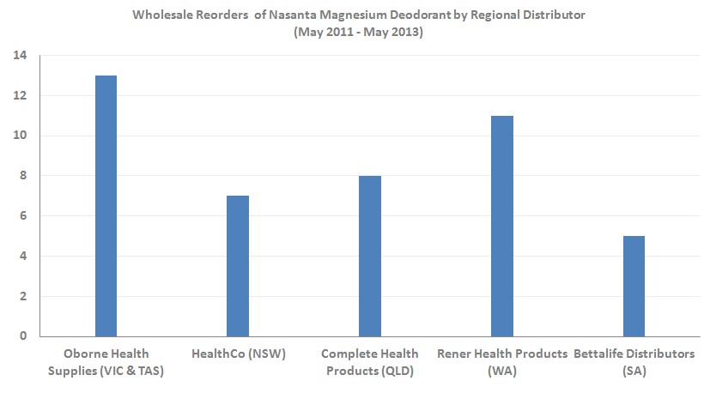
Source: Invoiced sales from May 2011-May 2013

Testimonials
I discovered the Nasanta name by Googling "aluminium-free deodorants". The aluminium present in Alzheimer patients' brains had made me wary of absorbing it via roll-on deodorants on a daily basis. Replacing it with magnesium struck me as an ingenious and healthy solution. I hope (and believe) that my idea of promoting the product to doctors deploying this reasoning will be successful. I also predict flow-on sales to their patients.
Dr. Alf Liebhold, PHYSICIAN
Hunters Hill NSW
As a Pharmacist, I am often asked by patients for a suitable deodorant. Current alternative deodorants on the market often do not meet my expectations, until now. Nasanta Magnesium Deodorant is the only aluminium free, alcohol free, fragrance free and paraben free deodorant that I can recommend with confidence. Its unique magnesium formulation not only neutralises body odour, but any magnesium absorbed transdermally can be beneficial to health. I suggest recommending this product to all your patients as one of the most effective alternative deodorants on the market.
John-Paul Daggian, PHARMACIST
Priceline Clayton Owner
Clayton VIC
Just sending through some feedback on the Nasanta product. In the interests of our health my wife and I have been dialing products containing toxins out of our house (cosmetics; cleaning products; body care products) and replacing them with natural products. The challenge is always to find products that use natural ingredients AND deliver what they say they will. Well, I am happy to say Nasanta certainly does deliver. And, with the added advantage of magnesium, we are converts and will become evangelists.
Marc Pomery, PROFESSIONAL TRIATHLETE
Morley WA
This is the ultimate deodorant for a triathlete. Nasanta is magnesium-based and aluminium, fragrance, alcohol and paraben free. The low solubility is the key to this product for triathletes, as it won’t wash off when you crank up the intensity on the bike and run even under heavy perspiration. TMSM’s testers were surprised how effectively this product worked, and commented it lasted from start to finish during their Olumpic-distance race.
TRIATHLON AND MULTI-SPORT MAGAZINE
‘The Top 10 Products for a Triathlete’

