TiE Sponsorship Benefits

Join the Global Ecosystem of Innovation & Entrepreneurship
Become connected to the TiE Global Network with members who are entrepreneurs, professionals, senior executives from Global 100 0 companies, thought leaders, academia, service organisations, and government policy makers.

Enhance your Brand Awareness & Positioning
Gain visibility at the TiE annual conference, monthly meetings, mentoring events, key note dinners, etc. held throughout the year for members and Charter Members.

Gain Insight from World Business Builders
Learn from the experts who appear throughout the year at TiE Events – founders, executives, investors, venture capitalists, lawyers, bankers, accountants, recruiters, consultants, academics and government leaders.

Access Emerging & Developer Markets
TiE has significant chapters in South Asia, Asia Pacific, Middle East, USA, UK and Europe increasing the chances of cross border trade and business opportunities leading to partnerships and policy enhancements.

To find out more, contact TiE Sydney and start benefiting from the enhanced brand awareness and influence now.

Brian Dorricott
Executive Director TiE Sydney
On behalf of the TiE Sydney Board
V1, September 2015

TiE Sydney Sponsorship Packages

Opportunity | Unicorn | Gold | Silver
Logo on promotional material | Yes | Yes | Yes
Inclusion on emails to TiE database mentioning special offers, promotions, events or business literature. | Yes and 2 sole postings. | Yes | Yes
Logo on TiE Website as sponsor | Yes, for the full year. | Yes, for the full year.  (Size may vary) | Yes, for the full year.  (Size may vary)
Business literature on TiE Sydney website blog | Yes, unlimited for full year. | Yes, up to 5 items. | Yes, 1 item.
Jointly agreed business development activity such as clinics, etc. | Yes. | Yes. | Yes.
Tweets from #tiesyd | Yes, unlimited for full year. | Yes, up to 20 tweets during the year. | Yes, up to 5 tweets during the year.
Referrals from leads at TiE Events. | Yes. | Yes. | Yes.
Banner/pullups at TiE Events. (Sponsor to provide material) | Yes, minimum 10 events. | Yes, up to 5 events. | Yes, up to 2 events.
Marketing material distributed at TiE Event. | Yes, minimum 10 events. | Yes, up to 2 events. | Yes, at 1 event.
Two minute sponsor speaking time at events. | Yes, at 3 events. | Yes, at 2 events. | No.
Invitation for Panel Participation at TiE Events. | Yes, When required at two events. | Yes, when required at one event. | No.
Invites to TiE Charter Member events. | Yes, up to 4 people to all events. | Yes, up to 2 people to all events. | Yes, 1 person at all events.
Complimentary invites to TiE Events. | Yes, up to 4 people to all events. | Yes, up to 2 people to all events. | Yes, 1 person at all events.
Complimentary invites to TieCon Sydney | Yes, 4 people. | Yes, 2 people. | Yes, 1 person.
Sponsorship fee (+GST) | $20,000 | $10,000 | $5,000

A brief introduction to TiE
TiE is short for The Indus Entrepreneurs – the Indus is the longest river in India running 2900km from Tibet to Arabian Sea. TiE was created in Silicon Valley by a group of Indians who enjoyed meeting each other and sparking ideas off each other. Now the two largest of 60 chapters are based in Delhi and Silicon Valley.
Through the contributions of its Charter Members, TiE Sydney inspires Entrepreneurs. It is best explained in the words of our members:
“I was so inspired by the start-up founders at a TiE Pitch Contest that I decided to pitch my own business the following year. That started my journey that took me to Silicon Valley and San Francisco. It was an unforgettable, valuable experience - only possible through the things I learnt at TiE.”
Emma Veiga-Malta
Bespoke Backdrops, CEO & Founder
"TiE has opened up amazing doors for us, particularly in the early stages of our business. Winning the TiE Female Entrepreneurs Pitching Competition in 2012 was a defining moment in our entrepreneurial journey and set the course for what is now the Workible success story.”
Alli Baker
Workible, CEO & Co-founder
Rhett won first prize trip to Silicon Valley with an entry to TiECon SV at Sydney’s annual TiE Conference. He met over 200 people, two billionaires and had lunch with one. As he said: “It’s the best thing I’ve ever done in business. Period.”
Rhett Sampson
GT Systems, CEO & Founder
TiE Sydney is inspiring local Entrepreneurs to think bigger and globally by preparing them for the growth and acceleration that their business needs. How do we do this? We provide a structured way for those with experience (our Charter Members) to help those who are on their journey (our Members).
Our Charter Members are hand-picked from industry so we have a range of experience, skills and a wide knowledge base.
Our Members are the Emerging Entrepreneurs and Entrepreneurs who are seeking to take their exploitation of their idea to the next level.
Our Sponsors want to be associated with aspirational people like you.
So what makes us different?
- TiE is member driven. Our members and sponsors pay TiE’s operating expenses so we listen to you.
- TiE is Not For Profit. We don’t seek to profit from your endeavours by charging you excessive fees (neither upfront nor hidden).
- TiE doesn’t take equity. We never take a part of anyone’s business after all, it is their baby, not ours.

Website: http://sydney.tie.org
Telephone: 02 800 64843 (MiTiE)
Your company logo

Email: ed@sydney.tie.org

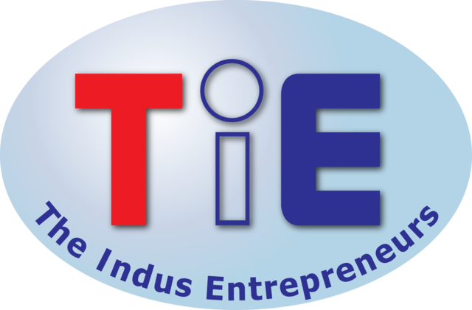

Sponsorship Opportunities

Proudly sponsored by…


