Member Information
Thank you for asking to know more about becoming a Member of TiE. Engaging with TiE is a way that you can meet and inspire Emerging Entrepreneurs and the Entrepreneurs of the future.
Throughout the year we organise events to help you connect with the right people and grow along the pathway from Emerging to Successful Entrepreneur. Our Charter Members attend events because they want to help you achieve your goals.
The specific events that we organise are:
- Group Mentoring. Each monthly a small group of up to ten entrepreneurs get together to learn more about a specific topic of interest from building a business through to pitching for money.
- 1-2-1 Mentoring. All members have the opportunity for a 30 minute mentoring session with a Charter Member during the year.
- Training. We run specific training sessions for members at reduced rates – for example a day’s pitching workshop, how to build your personal brand, etc.
- Networking. We run monthly meetings based around a topic or activity where entrepreneurs are connected with those who may help them. A drink and some snacks are included.
- Competitions. We run and help entrants win the annual international TiE competition with prizes of trips to Delhi and Silicon Valley to present your ideas.
- Annual Conference (TiECon). Be inspired and meet today’s leaders.
- Discounts. We provide discounts to members to key events in Sydney (e.g. SydStart)
- Global connections. TiE Sydney is the local chapter of a global organisation with over 60 chapters. So if you’re in London and you want to meet a friendly face… ask a Charter Member to find someone.

How to become a Member
To become a member of TiE all you need to do is select the “Join TiE” option on our website. Choose “Regular Member” then enter your email address and follow the instructions. If you are lucky enough to have a discount code, this is the time to use it.
Membership costs only $120 for a full year and that is for events that would cost you over nearly $1000 individually!
All our evens are booked through this website since it knows whether to charge you or give you a discount.

You should know…
TiE is a not-for-profit organisation or Charity with a very small executive to aid administration. The President and all board positions are voluntary and unpaid. Charter Members pay considerably more towards administration and are members because they want to help you. TiE is all about being inspired by meeting great people.
We are completely open to new ideas and how you may like to contribute so let us know. TiE’s ethos is expressed by these concrete points:
- We help Members and are clear where the help stops and any fees may be expected.
- We are not-for-profit.
- We run at incredibly low cost. We do as much as we can at no cost to TiE or its members.
- We never take equity from those we help.
- We connect Entrepreneurs with those who can help them at the appropriate time.

Thank you
I hope this this overview answers any questions you may have and that you are now keen to help us help Entrepreneurs achieve their goals. We look forward to welcoming you to TiE.

Brian Dorricott
Executive Director TiE Sydney
On behalf of the TiE Sydney Board
V2, October 2015

A brief introduction to TiE
TiE is short for The Indus Entrepreneurs – the Indus is the longest river in India running 2900km from Tibet to Arabian Sea. TiE was created in Silicon Valley by a group of Indians who enjoyed meeting each other and sparking ideas off each other. Now the two largest of 60 chapters are based in Delhi and Silicon Valley.
Through the contributions of its Charter Members, TiE Sydney inspires Entrepreneurs. It is best explained in the words of our members:
“I was so inspired by the start-up founders at a TiE Pitch Contest that I decided to pitch my own business the following year. That started my journey that took me to Silicon Valley and San Francisco. It was an unforgettable, valuable experience - only possible through the things I learnt at TiE.”
Emma Veiga-Malta
Bespoke Backdrops, CEO & Founder
"TiE has opened up amazing doors for us, particularly in the early stages of our business. Winning the TiE Female Entrepreneurs Pitching Competition in 2012 was a defining moment in our entrepreneurial journey and set the course for what is now the Workible success story.”
Alli Baker
Workible, CEO & Co-founder
Rhett won first prize trip to Silicon Valley with an entry to TiECon SV at Sydney’s annual TiE Conference. He met over 200 people, two billionaires and had lunch with one. As he said: “It’s the best thing I’ve ever done in business. Period.”
Rhett Sampson
GT Systems, CEO & Founder
TiE Sydney is inspiring local Entrepreneurs to think bigger and globally by preparing them for the growth and acceleration that their business needs. How do we do this? We provide a structured way for those with experience (our Charter Members) to help those who are on their journey (our Members).
Our Charter Members are hand-picked from industry so we have a range of experience, skills and a wide knowledge base.
Our Members are the Emerging Entrepreneurs and Entrepreneurs who are seeking to take their exploitation of their idea to the next level.
Our Sponsors want to be associated with aspirational people like you.
So what makes us different?
- TiE is member driven. Our members and sponsors pay TiE’s operating expenses so we listen to you.
- TiE is Not For Profit. We don’t seek to profit from your endeavours by charging you excessive fees (neither upfront nor hidden).
- TiE doesn’t take equity. We never take a part of anyone’s business after all, it is their baby, not ours.

Website: http://sydney.tie.org
Telephone: 02 800 64843 (MiTiE)
Email: ed@sydney.tie.org

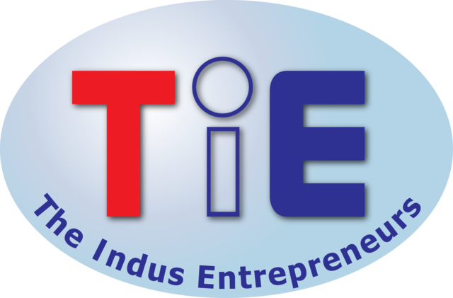

Membership Overview

Proudly sponsored by…


