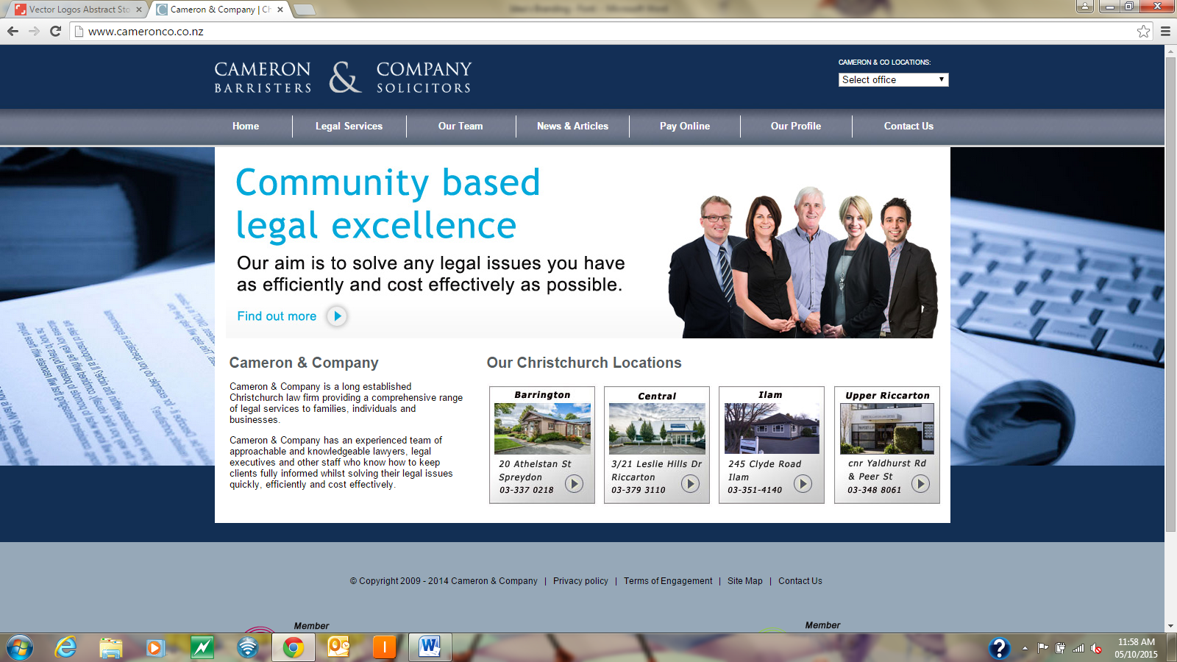

Current logo and font is very dated, and traditional. We want to move away from this staid, conservative look, and present a very fresh, modern, and clean look.
The colourways should be a dark contemporary blue/gray ( Ink/Greyfriars), with a strong non-primary colour contrast. Refer image 158661428 for .
The font must be a modern clean font perhaps something like cobel, century gothic, I am happy to explore contemporary lowercase presentation.
The logo might incorporate interlinked CC . ????
Starting conceptually I’ve just thrown together a few ideas.
I don’t have access to any design software, so a bit challanged with layout, spacing etc. I have selected a few images off shutterstock, these are representative of the direction I would like to see this go.
cameron 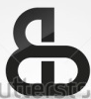 co legal (corbel)
private ∙ family ∙ commercial (century gothic)
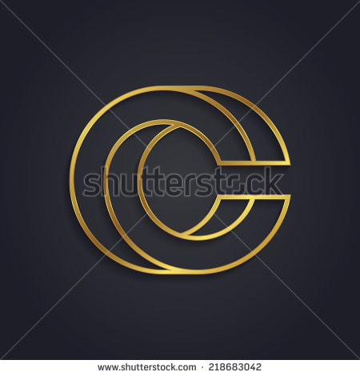
Too corporate, too ‘big’ firm, but if loose the gold bling could work logowise.
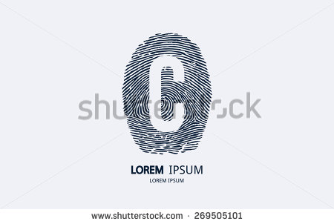 ( reposition font to align with middle of front C)
ameron co legal
Want a really strong visual. Memorable image, quite like the finger print ( unique, identifying,strong)
cameron co legal 
( quite like the lower case font and stylized ampersand ) Would like to introduce some form of logo/icon to the front of this .
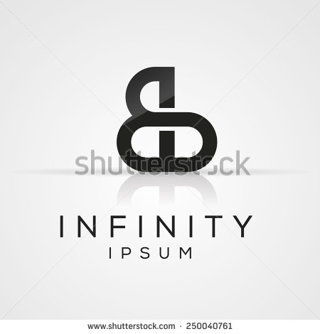

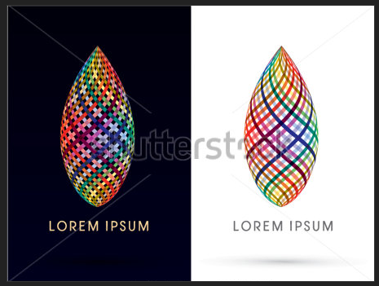
Interwoven image strong, quite like the font on this too. Possibly a bit too traditional.

CAMERON & CO
>>>>>>>>>>>>>>> L E G A L >>>>>>>>>>>>>>>>>>>> (IrisUPC)
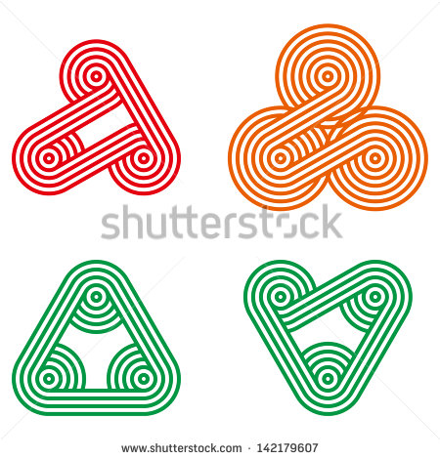

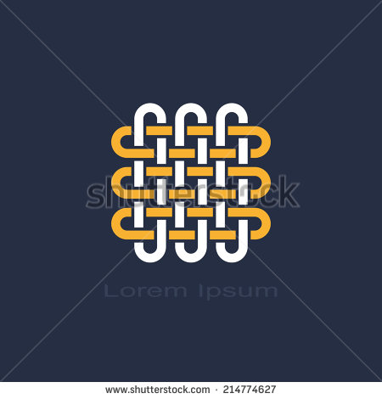
Too similar to Cavil Leitch. But like the conceptual ‘interwoveness’ , service provider with client, ongoing relationship.

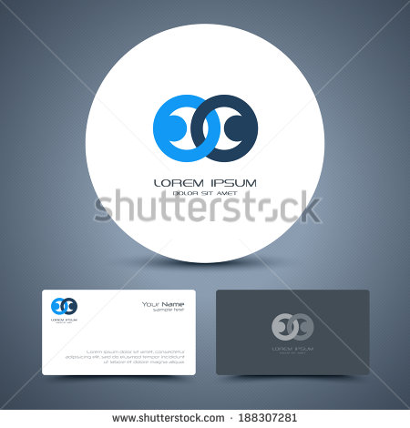
People/interwoven C C ??? Not quite there.
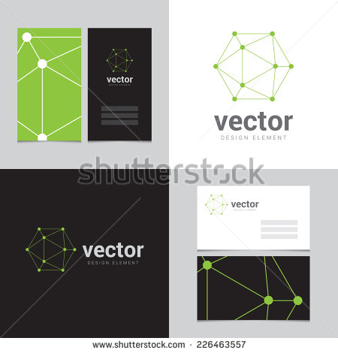
Like the simplicity. Not quite there, but like the image. Mapping the dots, getting the solution to make a whole.
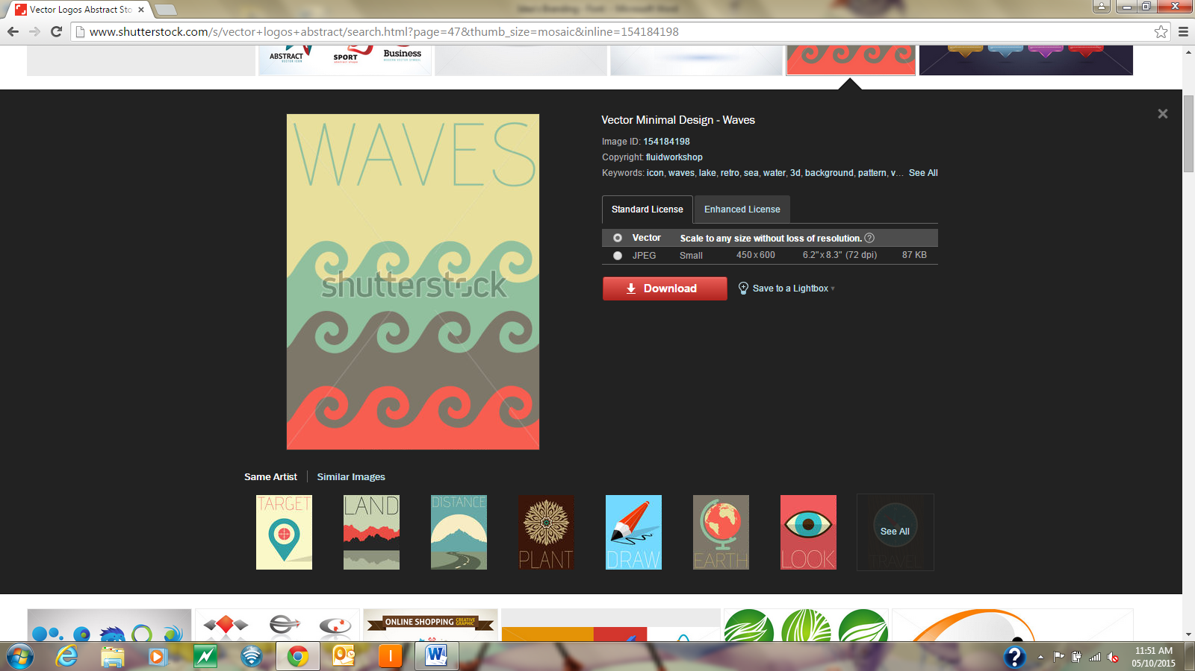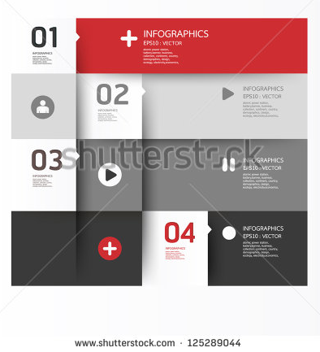
webpage setout/design ideas. Like the design element. Something a little bit different.

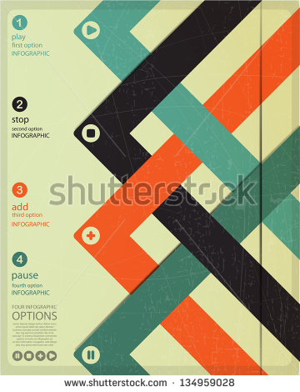
Webpage design ideas. Want something a bit out there, to get chatter going – ‘Wow, far out look at what these lawyers are doing, they are presenting something really new and fresh, they’re not offering up the same staid ‘lawyer’ image.

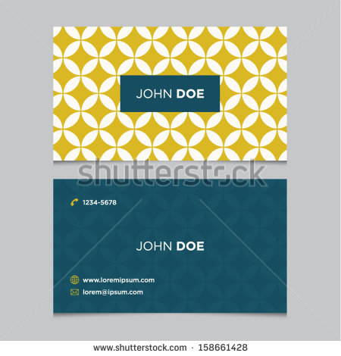
Really like the colourways and graphics of these. We are looking for an Inky Blue/Gray, and could contrast with this green/yellow colour. Really like this visually for business cards.

Present webpage is very outdated and doesn’t present well at all, some good content and sincere sentiment which accurately gives potential clients an idea of what we’re about, the images are very poor despite having been recently updated. The website attempts to present there too much, and is too disjointed – it’s a real hodge-podge of cintent and presentation,
This website is not going to pull people in, it turns them away, we look old-fashioned and boring. Having said that the websites of our competiors in the region are very poor, and don’t offer potential clients much of a draw card – we want to draw people in, interest them. We want young professional clients who think ‘Wow, these guys are not just boring lawyers, they look like they offer up something different’. Possibly the only two that I almost like are Tavendale and Partners, and Duncan Cotterill wh are making some attempt to present a clean uncluttered website, although neither are particularly interesting..


