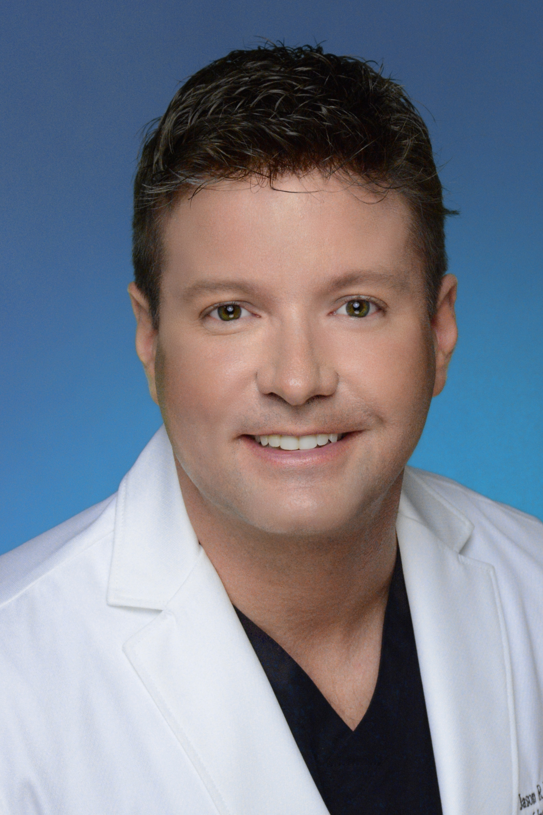
Jason Williams, MD

This New Cancer Therapy Is Less Invasive, Has Fewer Side Effects, Is More Effective And Costs Less Than Typical Cancer Treatments. Why You Can’t Get It.

The new cancer immunotherapy drugs are a hot topic, which have filled the news recently due to their extraordinary success over standard cancer therapies. In addition, they are also making the news because they are the most expensive drugs in existence with a price tag of about $250,000.

Research has shown that these drugs can be injected directly into cancer, which reduces cost and side effects, using 1/8th of the standard dose. In addition, when combined with the image-guided, minimally invasive procedure of Cryoablation, the effectiveness is greater than either of these therapies alone. Cryoablation is a minimally invasive, essentially scar-less therapy, where a needle is placed into the cancer, which is then killed by freezing. Studies are already showing that this treatment is effective and may replace standard cancer surgeries such as lumpectomy and mastectomy for breast cancer. It is already replacing many surgeries for lung and liver cancer.

Story Ideas

1. New Minimally Invasive Breast Cancer Treatment is Essentially Scar-less.

2. This Cancer Researcher Stumbled Onto A Gene Therapy That May Slow Aging and Extend Your Life. The Results Were So Compelling, He Tested It On Himself.

3. Should This Last Resort Cancer Treatment Actually Be Your First Stop?

4. New Breakthrough Cancer Immunotherapy Medications: How To Make Them More Effective, Have Fewer Side Effects and More Affordable.

5. Breast Cancer: First There Was Mastectomy, Then Lumpectomy, Now Cryoablation. The New Minimally Invasive Breast Cancer Therapy That Is Essentially Scar-less.

6. This New Highly Effective Immunotherapy Costs $250,000, But A Unique Technique With Equal Or Better Results And Fewer Side Effects May Bring The Cost Down To $32,000.

7. Learn About A Cancer Treatment That Takes The Newest, Hottest, Expensive and Most Effective Cancer Immunotherapy And Makes It More Affordable With Fewer Side Effects.

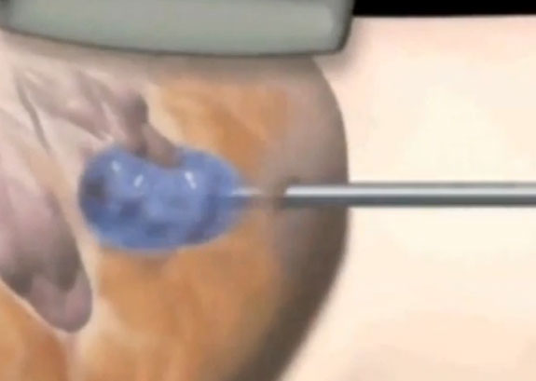

Media Experience

Multiple interviews and features on local news channels, Fox, ABC, CBS and NBC

National news interview in Mexico on Televisa

Interview with USA Today Sports

Bio

Dr. Jason R. Williams is a medical doctor and board certified radiologist and pioneer in minimally invasive, image-guided cancer therapies, especially Cryoablation combined with injection of immunotherapy into the cancer. He obtained his medical doctorate from Louisiana State University. He completed an internship in internal medicine, followed by a residency in radiology at the University of South Alabama. He was selected for the Radiological Society of North America research and fellow award in 2004. In 2006, he won a Telly award for a video explaining ablation of cancer. He speaks at numerous national and international conferences. Also, he has trained doctors on image-guided cancer therapy in the USA, Mexico and South Africa. Dr. Williams’ research interest is in cancer immunotherapy and gene therapy.

Contact

Email: drwilliams@cancerimmunebio.com
Cell: 305-846-6940
Office: 844-359-4201
Website: www.cancerablation.com

