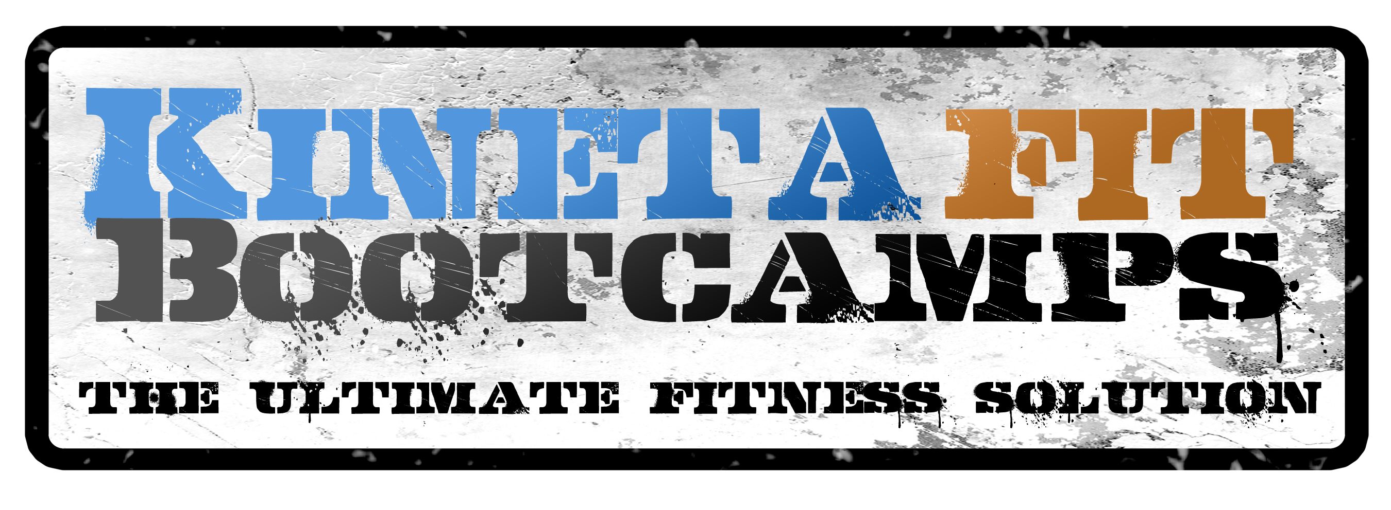
Have you been looking for a good reason to get in the best shape of your life?
KINETAFIT PRESNETS
THE FITTEST IN BRIGHTON CHALLENGE!
If you have been looking for a great reason to get in the best shape of your life, but need some accountability and coaching to get there, we have the PERFECT Program for you!
Over the course of 21 days, Kinetafit is holding it’s first ever individual PROVE YOU’RE THE FITTEST IN BRIGHTON CHALLENGE!
Our 21-Day Fitness Challenge will give you the world-class training and testing to ensure that you are prepared to take on anything that life throws at you and are in the best shape of your life at the end of 21 days!
During the PROVE YOUR FITNESS CHALLENGE, you will be tested on your initial fitness skills, trained in an intense training program for 21 days, and re-tested to see who is the fittest in Brighton and who had the most improvement!
Call 303-503-9344 to reserve your spot today!
The contest will run from Over $500 in cash prizes are up for grabs for the best raw scores and best improvement!
STARTS NOVEMBER 30th through DECEMBER 21st 2015
SIGN-UPS ARE LIMITED FOR THIS CHALLENGE SO DON’T WAIT
Male and Female Divisions!
VISIT WWW.KINETAFITBOOTCAMPS.COM FOR MORE INFO

