Correct Design File Layout with 1pt Outline
Width of lines should be .25 point (or .003”) or thicker. No hairlines!
No type smaller than 6 points. Letterpress excels at printing type and handles most fonts very well. Still, don’t use type smaller than 6 point.Outline your fonts when submitting your files.
Number of inks: letterpress printing traditionally uses 1 or 2 spot colors. The cost increases with each additional ink. 3 or 4 spot colors make for an extravagant and lavish production, though it sure is pretty if you have the budget.
Screens are best suited for offset printing. Letterpress excels at printing colors at 100%. If you’d like to incorporate a lighter color, use a second lighter ink color instead of a screen.
Dies and scores: letterpress printing presses can die cut and score paper—even very thick stocks. If you’re creating a custom die pattern, send it over (via email or yousendit.com) and we’ll make sure that it works well on our equipment.
Letterpress on envelopes: in general, letterpress can print envelopes well. We can print on the flap and also on the front of the envelopes. See our envelope templates for the exact printable areas.
Use font size of 12 point or larger for reverse type: if your reverses are too small, your reverses can clog up on a letterpress. That’s why we recommend a 12 point or larger font size for reverse type, though this does vary depending on the typeface that you use. You may have to add a small stroke to the reverse type to compensate for letterpress ink gain. Also, if we’re printing text and the solid area around your reverse type in the same color, we may need to print the solid area in a separate print run. Extra press runs increase the cost of printing.
Light ink on dark paper: with letterpress, we tend to print dark ink on light paper because that is letterpress printing’s strength! Light ink on dark paper is really best suited for engraving or foil stamping. When a letterpress client wants to incorporate a darker color, we might suggest printing an offset flood on the back side of a light colored paper, or duplexing a dark colored paper to a light colored paper. That said, if you really want to letterpress light ink on dark paper, just be prepared for paper show through. Our letterpress inks are translucent. Printing light ink on dark paper will be like using a thin coat of white paint on a brown wall: you’ll see the brown color through the paint (think chalkboard for the final look). If using a pure white ink or metallic ink, we can run a piece through the press twice, at an additional cost, to create a denser color.
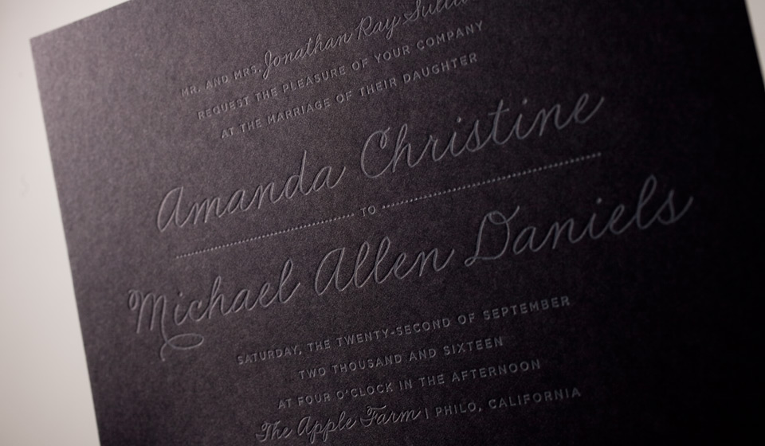
Large solids (areas larger than ½” thick) and paper show through: letterpress printed solids look somewhat different from offset printed solids. With letterpress, the paper tends to show through large solids, creating a slightly textured look that’s almost suede-like (we think this is a beautiful look by the way). If you have a large solid and thin text in the same color, we’ll need to print the solid in a separate press run, to give the text a good deep impression and proper inking. Extra press runs increase the cost of printing. Large solid areas can cause buckling of the paper, especially if using a thinner machine-made paper stock. You’ll also notice the depth of impression may appear less noticeable on really large letterpress solids.
