Page 1
Guild logo & Nationally Recognised Training (NRT) logo
Image of student
Pharmacy Assistant Training
Give yourself a head start with the NSW Smart and Skilled training program.
This training program is subsidised by the NSW Government and delivered by the Pharmacy Guild of Australia NSW Branch.
Page 2
Smart and Skilled
Smart and Skilled is a NSW Government initiative, introduced to help eligible students in NSW access government funding that will provide them the opportunity to undertake a course in a qualification of their choice. Its objective is to help people gain the skills and knowledge they need for employment opportunities and career advancement.
The Pharmacy Guild of Australia Pharmacy Assistant Smart and Skilled Training Program
We are pleased to announce that The Pharmacy Guild of Australia NSW Branch has been granted the right to deliver Nationally Recognised Training under the Smart and Skilled Program for Pharmacy Assistants in NSW.
The Pharmacy Guild of Australia is a Registered Training Organisation (RTO) that has been delivering training and education services to pharmacy assistants for over 15 years, longer than any other provider. Our trainers and assessors are highly qualified and experienced, all of whom have worked in community pharmacy and return to pharmacy every year to update their skills and knowledge. They understand the needs of pharmacy assistants and community pharmacy.
Training helps ensure you can work directly with your customers. The health information and product knowledge that you learn will mean you can help your customers get well and stay well.
The Smart and Skilled Training for the courses below will be subsidised by the NSW Government.
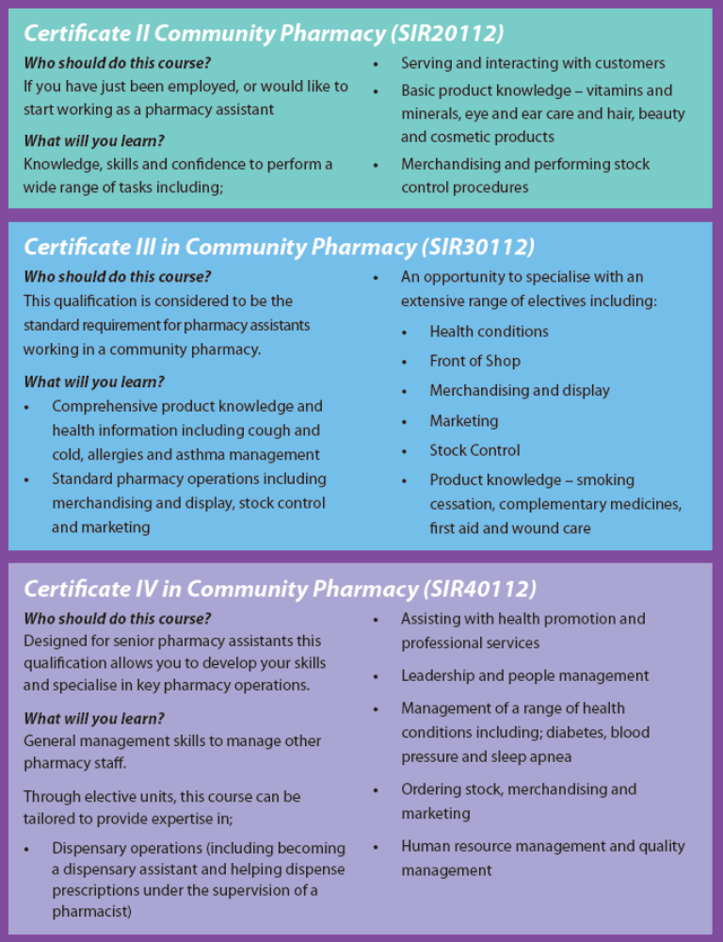
Page 3
Course Fees
The NSW Government subsidised training means the Government will pay a portion of the course fee for eligible students. The students are also required to contribute towards the training cost through the payment of a student fee. The fees have been established by the NSW Department of Education and Communities and approved Smart and Skilled providers must charge the set student fee for the qualification that is applicable to the student.
Course | Student Fee | Government Subsidy
Certificate II in Community Pharmacy (SIR20112) | $870.00 | $3,420.00
Certificate III in Community Pharmacy (SIR30112) | $2,110.00 | $6,190.00
Certificate IV in Community Pharmacy (SIR40112) | $1,560.00 | $5,410.00

The above Smart and Skilled student fees are for the whole qualification.
Pharmacy Guild of Australia (NSW Branch) Payment Plan Options
The Pharmacy Guild of Australia is committed to help Pharmacies support Pharmacy Assistants within their career by completing a certificate in Community Pharmacy through a traineeship.
To help with the new fee structure implemented by the NSW Government under Smart and Skilled, the Pharmacy Guild of Australia have implemented payment plans as below to ensure that pharmacies are not out of pocket when signing up a new trainee.
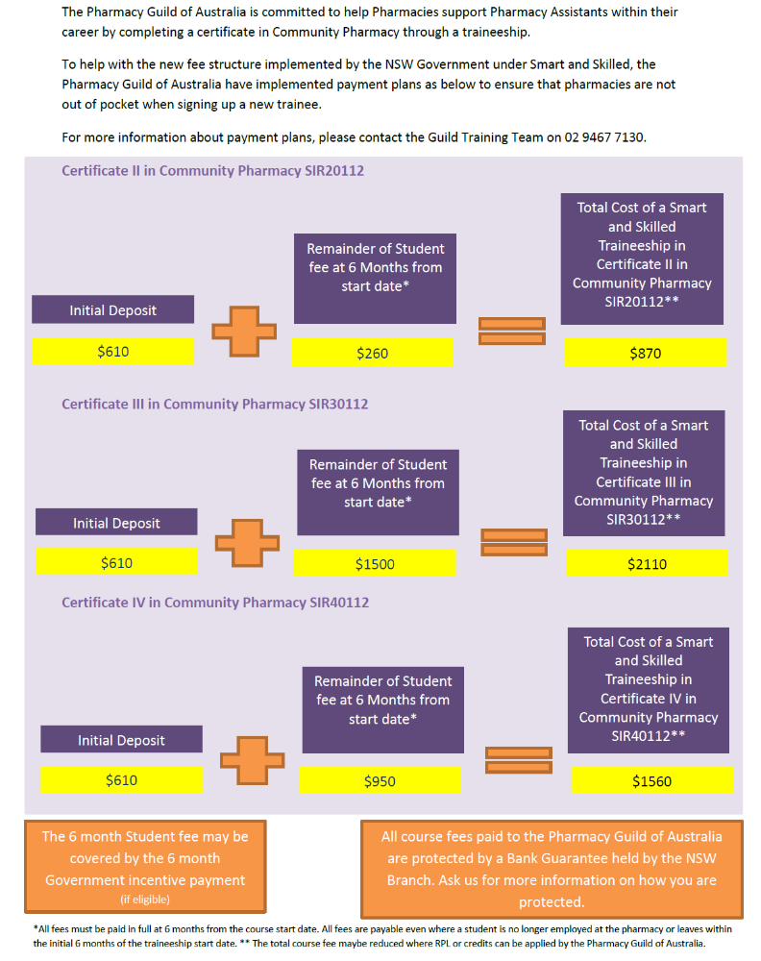
*All fees must be paid in full at 6 months from the course start date. All fees are payable even where a student is no longer employed at the pharmacy or leaves within the initial 6 months of the traineeship start date.
**The total cost fee may be reduced where RPL or credits can be applied by the Pharmacy Guild of Australia.
Enrolment before 31 December 2015
Students must enrol before 31 December 2015 to receive subsidised training under this Smart and Skilled program. The course training will extend past 31 December because the training is delivered over the relevant period of each individual course until completion.
This funding is strictly limited and will fill on a first come, first served basis. To avoid disappointment, make your enrolment enquiries today by:
1. filling in the enclosed form and faxing it to 02 9467 xxxx; or
2. calling the Pharmacy Guild of Australia on 02 9467 7130; or
3. emailing: training@nsw.guild.org.au

Page 4
Image of student
Did you know that your prior knowledge and experience gained on the job may help work towards gaining a nationally recognised qualification? If you’ve been working in pharmacy for a while, make sure you ask about ‘Recognition of Prior Learning (for ‘RPL’).

The Pharmacy Guild of Australia NSW Branch
84 Christie Street, St Leonards NSW 2065
Ph 02 9467 7130 Email training@nsw.guild.org.au

The Pharmacy Guild of Australia is a Registered Training Organisation (RTO)
This training is subsidised by the NSW Government.

