
Welcome to the Smoot Community!
Every member of Smoot Commercial is important to us, be a part of our community and explore your neighborhood.
  Receve a free month when you enroll!  BROUGHT TO YOU BY SMOOT COMMERCIAL | 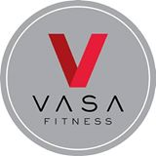  Drop the sign-up fee.  BROUGHT TO YOU BY SMOOT COMMERCIAL  Savings of $59 |   Purchase $25 and recive a free pair of desinger earrings.  BROUGHT TO YOU BY SMOOT COMMERCIAL |   BOGO FREE!  BROUGHT TO YOU BY SMOOT COMMERCIAL
  Buy a sandwich and receive a free Galaxy shake or malt  BROUGHT TO YOU BY SMOOT COMMERCIAL |   20% OFF Entire Service  BROUGHT TO YOU BY SMOOT COMMERCIAL |   Free Cookie Dough with regular pizza  BROUGHT TO YOU BY SMOOT COMMERCIAL | Jackie Horan’s  Free Nail Clipping with Pet Grooming  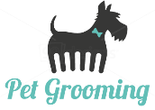  BROUGHT TO YOU BY SMOOT COMMERCIAL

OR
Welcome to the Smoot Community!
Every member of Smoot Commercial is important to us, be a part of our community and explore your neighborhood.

Deals to implement:
Smoot’s: Refer a friend to rent with us and both of you will receive $200 off rent.
Urban Country: Free designer earrings for you and a friend when you purchase $25+
Galaxy: BOGO Waffle Cone
Academy mortgage: Free approval for a mortgage loan
Millcreek: Free Whitening
Papa: 2 Favs $8

