Project1 Notes

Colour Scheme
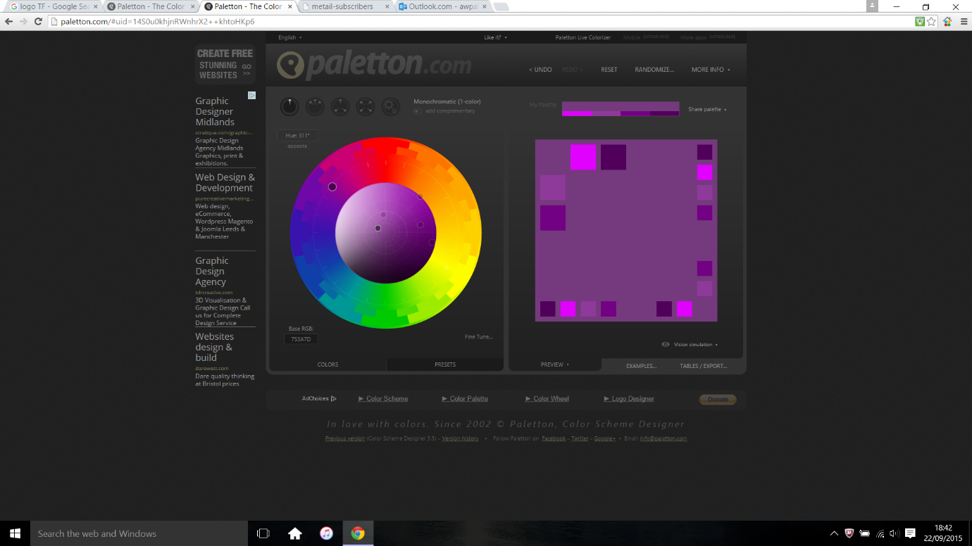

(Dark Neon style) Purple and Dark Yellow

