


Proudly hosted by St John Vianney’s Primary School
Sunday 25th October
Were Street Calwell

Welcome to the 2015 Catholic Schools’ Netball Carnival proudly hosted by the St John Vianney’s Primary School Community in Waramanga ACT.

Catholic Schools Prayer
Jesus, Good Shepherd,
Teach us through your Spirit
to walk your way of light,
to live your way of truth
and in all things to act with love and compassion.
Help us to come to the Father
by knowing you, loving you
and serving you in each other.
May our schools be places of wonder,
learning and peace where the lessons of today
prepare us for the challenges
of tomorrow.
May your Mother, Mary,
guide our footsteps as she guided yours.
This prayer we make in faith, through our patron Saints.
Amen.
The Archdiocese of Canberra and Goulburn.

LOCAL PARISH MASS TIMES
Holy Family Gowrie  Sat 6pm Vigil  Sun 8am, 10am & 6pm | St Anthony of Padua Wanniassa  Saturday 6pm Vigil  Sunday 9am and 5:30pm | St John Vianney's Waramanga  Saturday 6pm Vigil  Sunday 9am (St Judes Holder)

GAME STRUCTURE/TIMING AND PRESENTATIONS 2015
- 8.00 onwards Registration open – all teams must register prior to their first game
- 8.20am Opening Prayer
- 8.30am First game commence
- 2.20pm Last games commence
- 3.00pm Presentations and Raffle Draw
NB. All registered players will automatically be entered into the raffle barrel.
GAME STRUCTURE
- 2 x 10 minute halves
- 2 minutes for half time
- 3 minutes change over per game

HOOTERS-Hooters will sound at:
- Start of game
- Half time
- Start of second half
- End of game
PRESENTATIONS
- Netta: Non-competitive – no presentations, participation certificates in team packs
- Junior – Presentations will be on the hard courts near the pavilion at 3.pm for the winning team of each division from Year 4 to Year 6 teams.

FOOD AND ENTERTAINMENT
The Catholic Schools Netball Carnival is going to be amazing. We have a range of foods catering for everybody’s tastes. There is a sausage sizzle, cake stall, gourmet Italian food from Nadia’s Red Kitchen, wood fired pizzas and delicious nachos. Goodberry’s will be there, as well as icy slushies and ice-creams to cool you off. The BBQ will be running for breakfast from 7.30am with delicious egg and bacon rolls.

DON’T FORGET TO BRING YOUR FOOD HANDS!

- Free Water Stations will be available on the day with other beverages being available for purchase. Café2U will have coffee available for purchase.

- Tommy Tenpin and the Bushfire Brigade will entertain us. The Gecko Gang will provide face painting and slides (wrist bands available for $10), SandWizard will be there and we even have horse rides! We’ll have a plant store stocked with seedlings ready for Summer and there’s a raffle where you could win $1000!

BRIEF OVERVIEW OF NETBALL RULES
SPECIFICS | COMPETITION | NETTA MODIFICATIONS
Ball | Size 5 | Size 4
Time to Pass the ball | Up to 3 seconds | Up to 6 seconds
Defending | A variety of defending tactics may be used | Strict one on one defence. Goals are undefended
Obstruction | A player defending an opposing player must be 0.9m or 3 feet | A player defending the opposing player must defend from 1.2m or 4 feet
Obstruction/Contact | A player who obstructs or contacts a player from the opposing team must stand out of play whilst the penalty pass or shot is taken | A player who contacts or obstructs will not be stood out of play. The umpire will blow the whistle for the infringement but will allow the player to continue after a brief explanation
Substitutions | A team may make unlimited substitutions in any one game at ½ time unless there is an injury | A team may make unlimited substitutions in any one game at ½ time unless there is an injury.  Players should be rotated amongst all positions.
Scoring |  | Scores should not be recorded. No final matches will be played.
Over a third | The ball cannot be thrown over a complete third without being touched by another player in that third
Offside | Players must stay in their designated playing areas.
Footwork | - When a player lands on one foot they may step with the other foot, lift the landing foot, but must throw the ball before re-grounding the lifted foot.  - If a player catches the ball and lands on both feet simultaneously, they may step in any direction with one foot, lift the other foot but must throw or shoot before re-grounding this foot.
Short Pass | There must always be room for a third player to move in between the hands of the thrower and those of the receiver when passing.

CARNIVAL RULES
1. Correct sport/netball uniform is to be worn and jewelry or taping is not permitted.
2. Teams will co-umpire their own games. Umpires are requested to wear either white or school colours.
3. Each team is to provide a scorer. Scorers will stand and score together. The winning team is to return the score sheet to the tournament control area near the Scoring will be win = 3, draw = 2, loss = 1 and forfeit = 0.
4. Matches to be conducted as per the AANA rules and no injury time will be allowed. First Aid will be available although the organisers are not responsible for injuries. All children must supply their own strapping tape if required.
5. Blood rule applies and no casts permitted.
6. Players may only be interchanged within divisions or from lower but NOT from higher divisions.
7. No more than 3 boys are permitted on the court at any one time in mixed teams.
8. One boy only in each of the thirds, ie 1 attack (GS or GA), 1 centre court (WA, WD or C), 1 defence (GD or GK) – in mixed teams.
9. Games will be of 2 x 10-minute halves with a 2 minute half time break. Games will start on the hooter and finish on the umpire’s whistle.
10. Coaches and parents are reminded that they MAY NOT interfere from the sidelines during a game. Aside from the players and the umpires no other personnel are to be on the court.
11. Everyone is reminded that the umpires are there to enjoy the day also and that their time is given voluntarily. Critical comments will not be tolerated. Disputes should be directed to the Dispute Officer located at the Pavilion.
12. Should a breach of rules 10 or 11 be brought to the attention of, or be seen by the competition team, the team concerned will forfeit that game.
13. Spectators must leave a clear area along the sidelines of all courts to allow the umpires free movement. Spectators are asked to keep clear of goal ends as this may distract goal shooters.
14. All Netta players will receive a participation certificate. Years 4,5 & 6 division winners will receive medals.
15. Parents, coaches, umpires and players are expected to abide by the Code of Conduct. Any breach will result in the team forfeiting that game.
16. Please note that no dogs are allowed at the Carnival.CODES OF BEHAVIOUR
To keep the Spirit of our netball carnival fun, enjoyable and fair to all involved please read this section.
The codes of behaviour detailed below have been adapted from those promoted by the Australian Sports Commission. It is expected that everyone associated with the 2014 Catholic Primary Schools Netball Carnival, that is players, parents, coaches, and spectators alike, will adhere to them.
Player’s
- Play by the Rules
- Never argue with an official. If you disagree, have your team manager or coach approach the official during a break or after the competition.
- Control your temper. Verbal abuse of officials, deliberately distracting or provoking an opponent, and sledging other players is not acceptable.
- Be a good sport. Applaud all good plays whether your team or the opposition makes them.
- Respect the rights, dignity and worth of all participants and treat them as you would like to be treated. Don’t interfere with, bully or take unfair advantage of any player.
- Co-operate with your team Manager/Coach, team mates and opponents. Without them there would be no competition.
Parents
- Remember that children participate in sport for their enjoyment, not yours.
- Encourage children to participate, do not force them.
- Focus on the child’s efforts and performance rather than winning or losing.
- Encourage children always to play according to the rules and to settle disagreements without resorting to abuse or violence.
- Never ridicule or yell at a child for making a mistake; be supportive.
- Remember that children learn best by example. Appreciate good performances and skilful plays by all participants.
- Support all efforts to remove verbal and physical abuse from the game.
- Respect officials’ decisions and teach children to do likewise. If you disagree with an official, raise the issue through the appropriate channels rather than question the officials’ judgement in public. Remember, the officials give their time and effort for your child’s involvement.
- Show appreciation for volunteer coaches, officials and administrators. Without them your child could not participate.

Coaches and Managers
- Remember that young people participate for pleasure and winning is only part of the fun.
- Never ridicule or yell at a young player for making a mistake. Positive comments are motivational.
- Be responsible in your demands on players’ energy and enthusiasm.
- Operate within the rules and spirit of netball and teach your players to do the same.
- Ensure that the time players spend with you is a positive experience. All young people are deserving of equal attention and opportunities.
- Avoid overplaying the talented players; the just average need and deserve equal time too.
- Display control, respect and professionalism to all involved with netball. This includes opponents, coaches, officials, administrators, the parents and spectators. Encourage your players to do the same.

Spectators
- Remember that children participate in sport for their enjoyment and benefit not yours.
- Applaud good performance and effort from all individuals and teams. Congratulate all participants on their performance regardless of the game’s outcome.
- Respect the decisions of officials and teach young people to do the same.
- Never condemn or ridicule a young player for making a mistake; offer encouragement.
- Condemn the use of violence in any form, whether it is by spectators, coaches, officials or players.
- Show respect for your teams opponents. Without them there would be no game.
- Encourage players to follow the rules and the officials’ decisions.
- Do not use foul language, sledge or harass players, coaches or officials.
- Show appreciation for volunteer coaches, officials and administrators.
- Support all efforts to remove verbal and physical abuse from sporting activities.

Administrators and Officials
- Create pathways for young people to participate in sport not just as a player but as a coach, umpire, administrator, etc.
- Provide quality supervision and instruction, etc.
- Remember that young people participate for their enjoyment and benefit, do not overemphasise awards.
- Help coaches highlight appropriate behaviour and skill development, and help improve the standards of coaching and officiating.
- Be consistent, objective and courteous when making decisions.
- Ensure that everyone involved in junior sport emphasises fair play, and not winning at all costs.
- Remember that you set an example. Your behaviour and comments should be positive and supportive.
- Make it clear that abusing young people in any way is unacceptable and will result in disciplinary action.
DRAWS
DRAWS
OUR SPONSORS
The St John Vianney’s School Community would like to sincerely thank the following sponsors for their generosity towards the 2015 Catholic Primary Schools’ Netball Carnival:

CARNIVAL PARKING
Please plan ahead to avoid frustration and lengthy delays. There are limited spaces in the sealed carpark at the Calwell Ovals. A one way system shall operate within the carpark with a pick-up and set down area available immediately adjacent to the courts. Three other parking areas are available as follows:
Area A: This is an unsealed area to the west of the Netball courts. Access is from Were Street with left turn in and left turn out only.
Area B: There are several carparks located at St Francis of Assisi Primary School on Casey Street. The carparks are located approximately 400m or 5 minutes’ walk from the carnival.
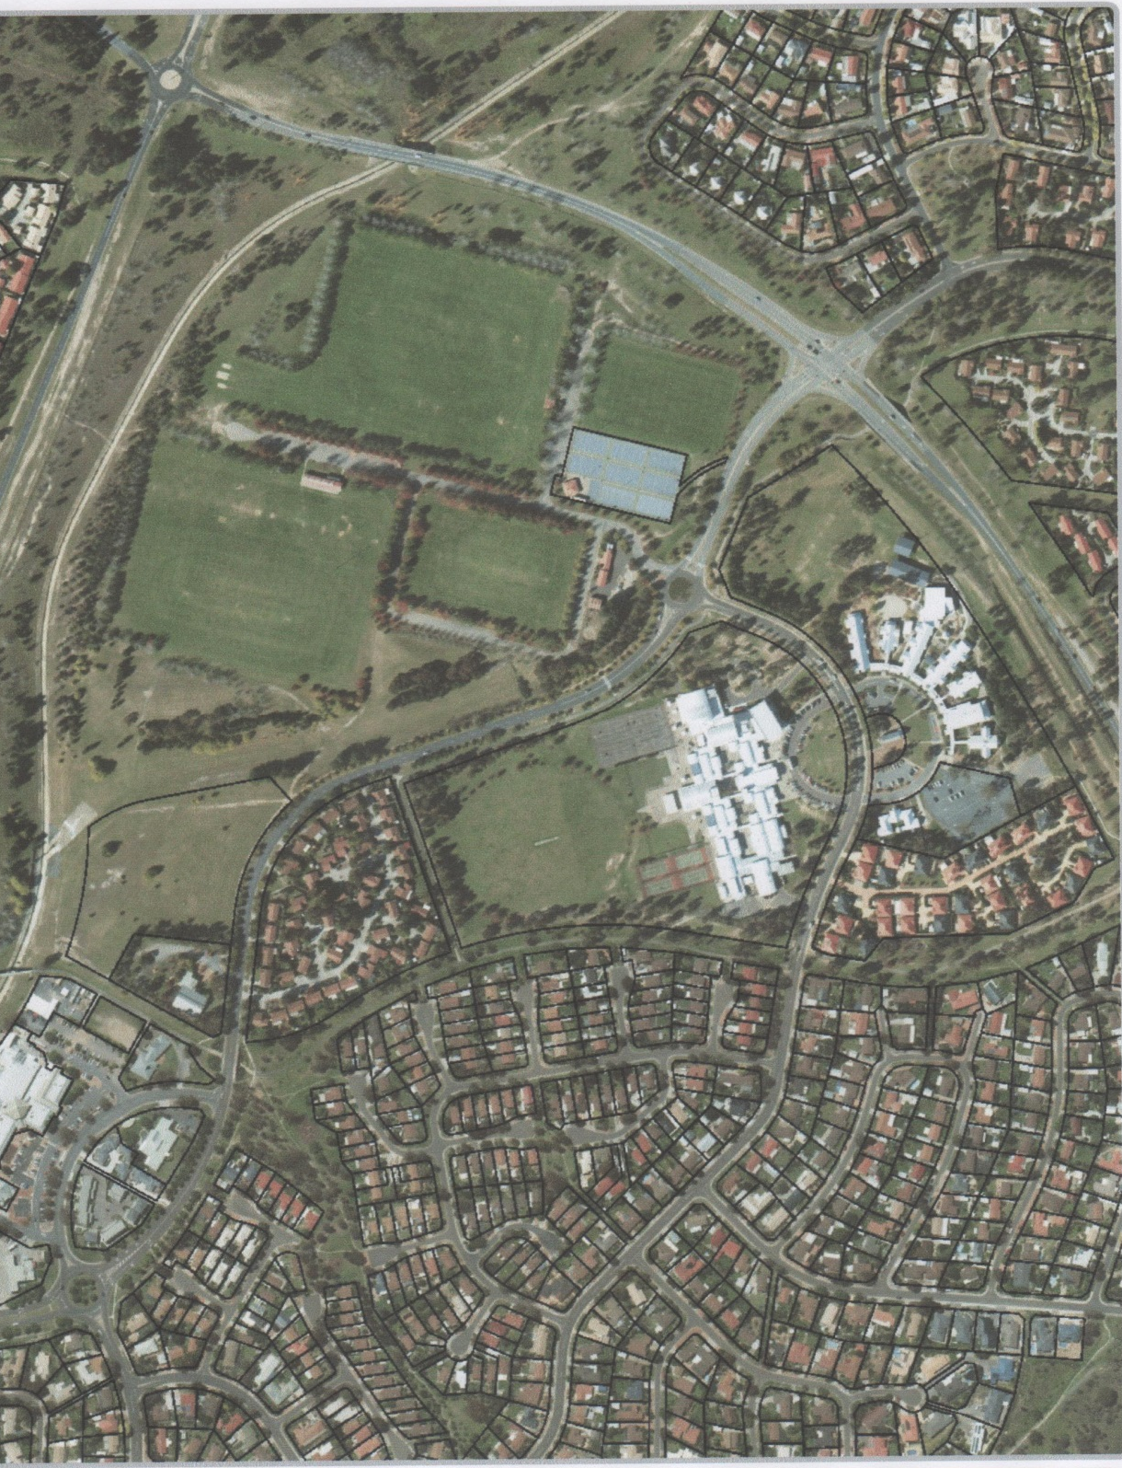
Area C: This is a very large open paddock located to the northwest of the carnival. Access to this area is off Were Street with left turn in and left turn out only. This carparking area is also approximately 400m or 5 minutes’ walk from the carnival.
Pick Up & Set Down Area
Netball Carnival
C
B
A
Legend

Parking

St Francis of Assisi
Primary School

Casey Crescent
Were Street
Tharwa Drive

