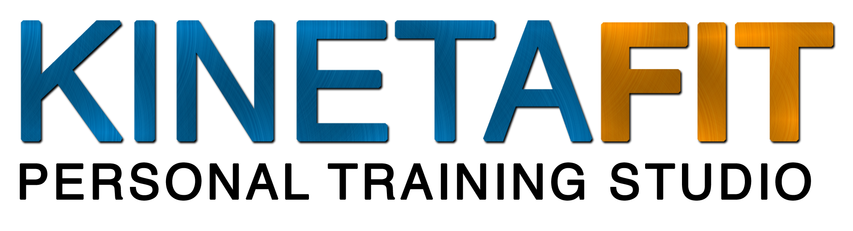
Presents...

HALLOWEEN CHARITY WORKOUT

Featuring The Freaky Fat Loss Total Body
PUMP-kin Workout!

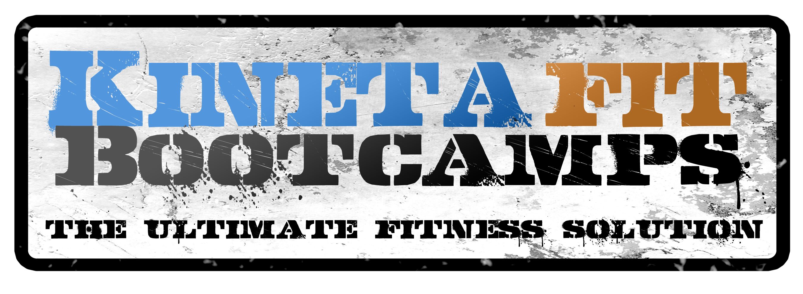

Kinetafit is happy to announce its Halloween Charity Workout!
We will be donating $5 for every person that attends. So bring your friends!
All proceeds will go to Restore Innocence

$5-10 Donations are appreciated, but they aren’t required.

When and Where: October 31st Halloween Day!
Kinetafit Personal Training Studio @ 9am

What to Wear: Costumes are highly encouraged but optional. You can be as simple or as elaborate as you want, but please remember you need to be able to move in it!

What to Bring: Your own pumpkin! Bring one that’s 10-20 lbs in weight, depending on your fitness level.

We will also be raffling out some cool prizes for attendees. Lastly, all attendees will be able to indulge in Pumpkin Protein Smoothies after the workout!

We expect a large turnout! Please join us for a great workout to support a great cause! We have limited space so please sign up ASAP to lock in your spot!
Kinetafit Personal Training Studio 50 N. Main St. Unit 114 Brighton, CO 80601
www.Kinetafitbootcamps.com 303-503-9344
You can sign up on the website or call!

