FRONT OF CD COVER
PIPERLAIN (LOGO)

MOTHER DAUGHTER (TEXT)


BACK OF CD COVER


Mother Daughter…………….....4:12
Slip Away………………………….….2:58
Blow up the Telephone…..…….4:45

Put the “P” in a circle like the ©

Rebecca Voorn-Knight: Vocals, lyrics.
Benjamin Knight: Guitars, drums, keyboard, percussion, vocals.
All songs written and produced by Benjamin Knight and Rebecca Voorn-Knight. Consultant producer Josh Telford and executive producer Paul Iannuzzelli. Recorded at The Grove Studios. Mixed by Jackson Barclay and Benjamin Knight. Mastered at Studios 301 by Steve Smart.
Cover art by Amy Bell. CD artwork design by XX sourced at DesignCrowd www.designcrowd.com.. SFX credits: drewkelly, connum, bates8590, chewiesmissus, adam-n, ashfox, juskiddink, charel-sytze, eelke, bknight.
For more information visit the Piperlain site at www.piperlain.com or www.facebook.com/piperlain.
© and (P) 2015 Audiofunk <Audiofunk logo> BARCODE
Made in Australia. All rights reserved.

Piperlain (logo)
Mother
Daughter (text)
© and (P) 2015 Audiofunk <Audiofunk logo>
Made in Australia. All rights reserved.

Imagery

SPECIFICATIONS - Please visit www.diskbank.com.au/templates/ for artwork specifications and templates
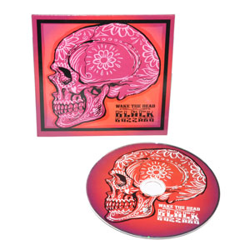
Cardboard sleeve

