Security Cameras for Better Business
Ensure safety in the workplace while protecting your assets with business security cameras. Choose from standalone cameras to cover especially vulnerable areas of your business like the safe or the cash register, or capture everything that happens with multi-camera systems and covert devices that are easy to install and operate. Weatherproof outdoor security cameras also help you manage your business, cutting down on vandalism and property damage.

BUSINESS SECURITY
Deter Theft • Reduce Shrink • Reduce Liability • Improve Productivity

Benefits of a Security System
A video security solution for your business doesn't have to be expensive or difficult to install. In most cases the security solution will pay for itself within months by deterring theft, reducing shrink, preventing liability claims, and increasing employee productivity.


Deter Theft, Intruders
& Protect Your Assets
Ensure that only authorized employees and suppliers are able to access sensitive areas of your operations and facility during the day and after hours.


Reduce Shrinkage
& Reduce Cash Loss
Strategically placed surveillance equipment can give you peace of mind that your most valuable assets are protected 24/7, 365 days a year.


Reduce Liability
& Save on Insurance
In addition to reducing your risk from false claims such as slip and falls, video security systems entitle your business to discounts from your insurance provider.


Improve Productivity
& Customer Service
Employees perform better knowing their actions are monitored. Be sure that your operations are running smoothly at all times and monitor from anywhere.

We'll Help to Build the Perfect Solution for YOUR Application
A video security solution for your business doesn't have to be expensive or difficult to install and time-consuming to operate. In most cases the security solution will pay for itself within months by deterring theft, reducing shrink, preventing liability claims, and increasing employee productivity.
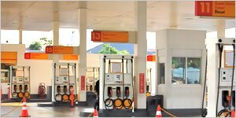

Convenience Stores
Burglary and theft are two of the biggest security challenges for convenience stores. A video surveillance system enables you to monitor your store 24/7, provides a powerful criminal deterrent, and helps to protect your employees and profits.
Our analog, HD analog and IP video surveillance systems are engineered to meet the demands of continuous surveillance and offer remote viewing of live and recorded, from anywhere you have Internet access.

Retail
Employee theft, shoplifting, merchandise shrinkage and transaction fraud are just a few of the security challenges that every retailer faces on a daily basis. Our video surveillance and access control solutions will help to protect your profits, enhance security and improve customer experience at your store.
Add hidden cameras to secure your most valuable merchandise, or integrate with your point-of-sale system to detect potential fraud at your registers.
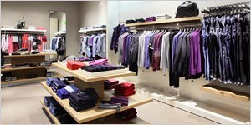
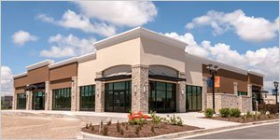

Small Business
Whether you manage a single mom-and-pop shop, a small business chain, an office space or a warehouse – you face common security challenges, from employee theft to vandalism.
Our security specialists are here to help you design the perfect video surveillance solution for your business, to address your specific concerns, and deliver your desired results. Our analog and IP solutions are completely customizable, and highly scalable – to protect any size of business.

Corporate Enterprise
The larger your business, the more vulnerable you are to employee theft, productivity issues, insurance liability, and the resulting impact on your profitability. Our security experts are here to provide a FREE business needs analysis to understand your security concerns, identify other areas of potential vulnerability, and design the perfect video surveillance system to protect your single or multi-site operation.
