Some Inspirational logos

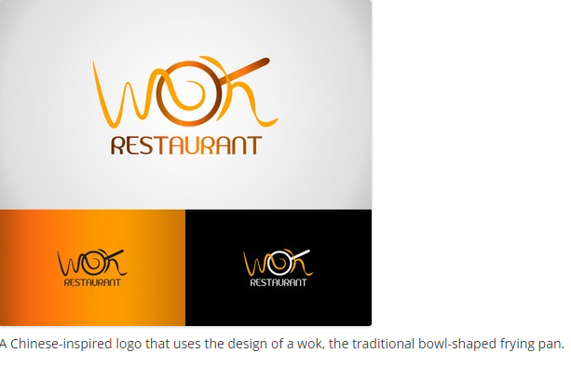
©2011-2015 mrSEVENRAY

Riviera Grill
by Proteo • Uploaded: Nov. 28 '12