High Country Ballooning
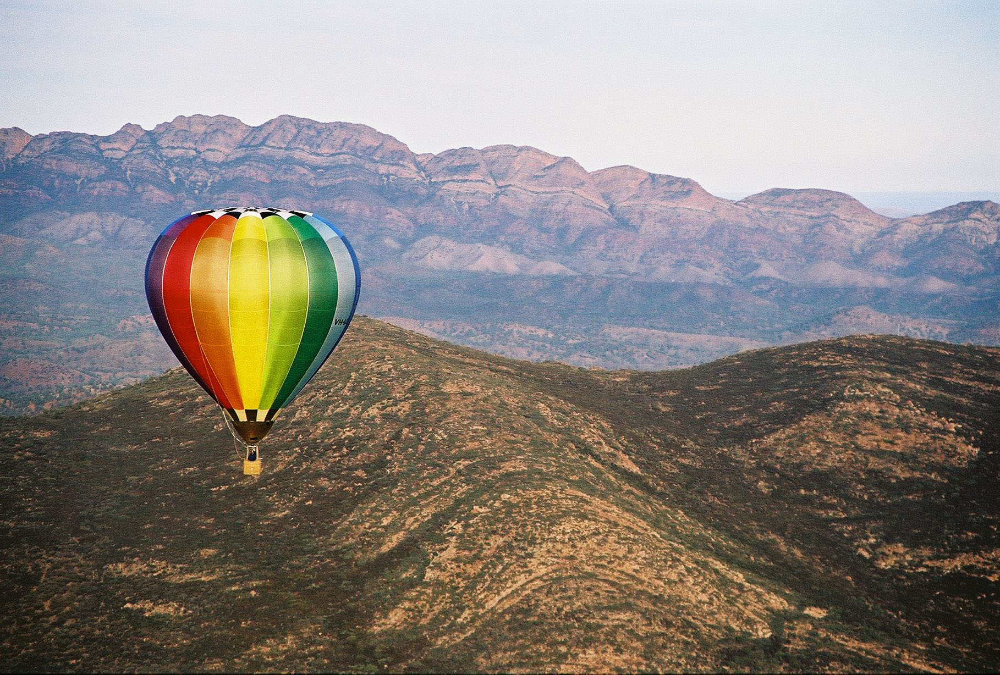

See Victoria’s High Country
Beautiful alpine scenery
A glorious sense of freedom
and adventure
The best way to experience it all is by hot-air balloon !
Live the romance and adventure of a hot-air balloon flight in the Victorian High Country over Mansfield district at dawn. Take in the beautiful scenery, and awaken to a new perspective. We top off the experience with a delicious champagne breakfast after the flight.

Contact our friendly team for information
flights@goldrushballooning.com.au

(logo)
Your Flight
- Safe and Professional
- Fly for approximately 1 hour
- Entire experience lasts 3-4 hours
- We meet in Mansfield before dawn
- Suitable from age 7 to 87
- Accommodation & flight packages available
- Group discounts for groups of 5 or more
- Gift certificates available

Safety is our first priority. Should unsuitable conditions prevent us from flying, you can rebook for another day, or
you will be entitled to a refund.
No Shows & late cancellations cannot be not be refunded - be sure to check our Terms & Conditions.
Goldrush Ballooning operates under Air Operator’s Certificate C569224-08 issued by the Civil Aviation Safety Authority

High Country Adventure with Goldrush Ballooning

(logo)

flights@goldrushballooning.com.au

Phone: 1300 255 666
www.goldrushballooning.com.au

