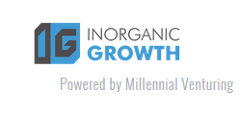
There aren't many solutions out there that talk about acquisitions and inorganic growth strategies for mid-market companies - we're changing this.

Our new website will deliver our private investor insights and solutions from growth strategists that will enable you to successfully implement acquisition and other inorganic growth strategies at your business.

We'll give you our experience and insight collected over the past decade as investment banker, corporate M&A executive, and now private investor, including our observed success strategies from our experience with growing and then selling, in a $1 billion+ deal, a private equity-backed mature technology company.

To subscribe to this free newsletter please visit www.Inorganicgrowth.io

Brought to you by Millennial Venturing

