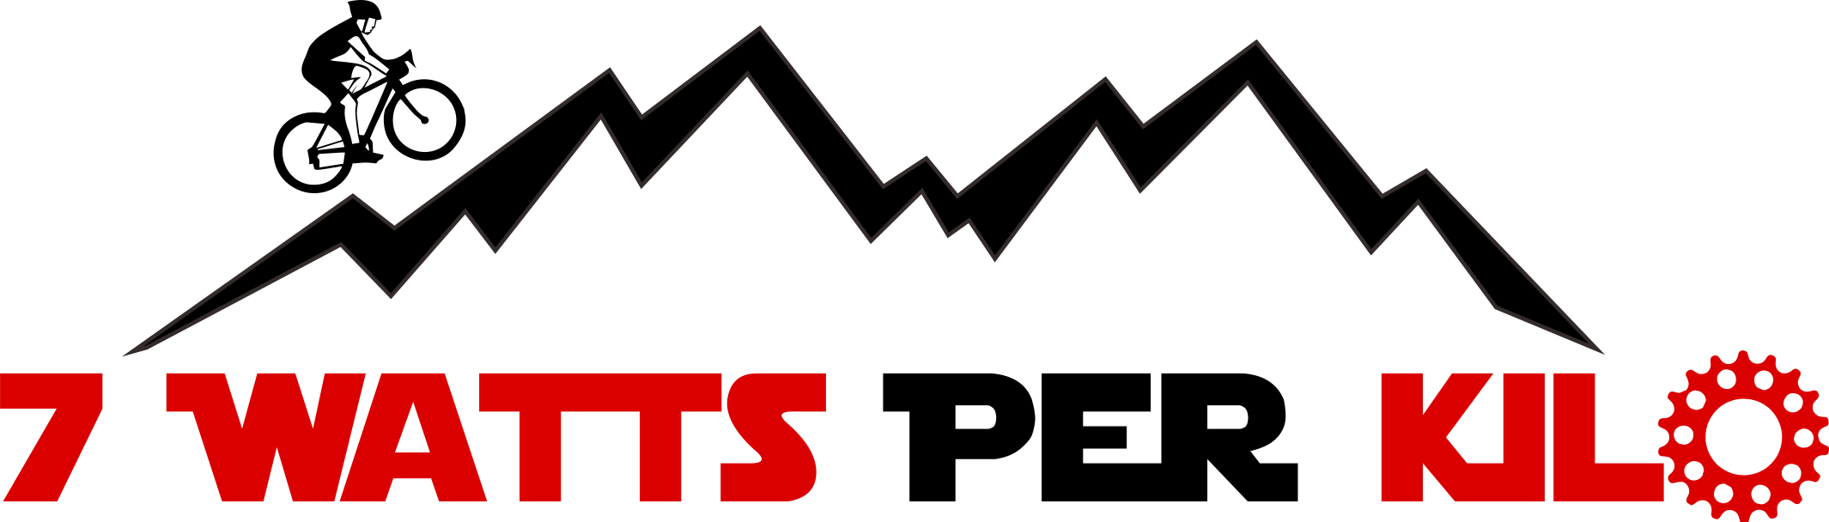

“Do you want to dominate on the road next season?”

(I’d like to use this background image on the color tones you used in the other flyer)

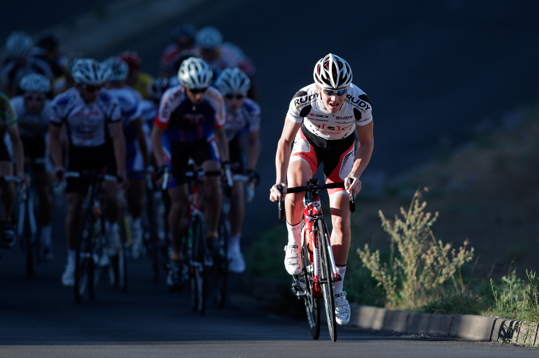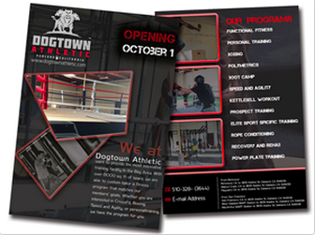

Training Camp

October 23/24/25
“Winter training and optimal nutrition”

November 27/28/29
“Performance tests and training planning for 2016”

Hotel Villa Ariston, Lido di Camaiore (LU) – Tuscany, Italy

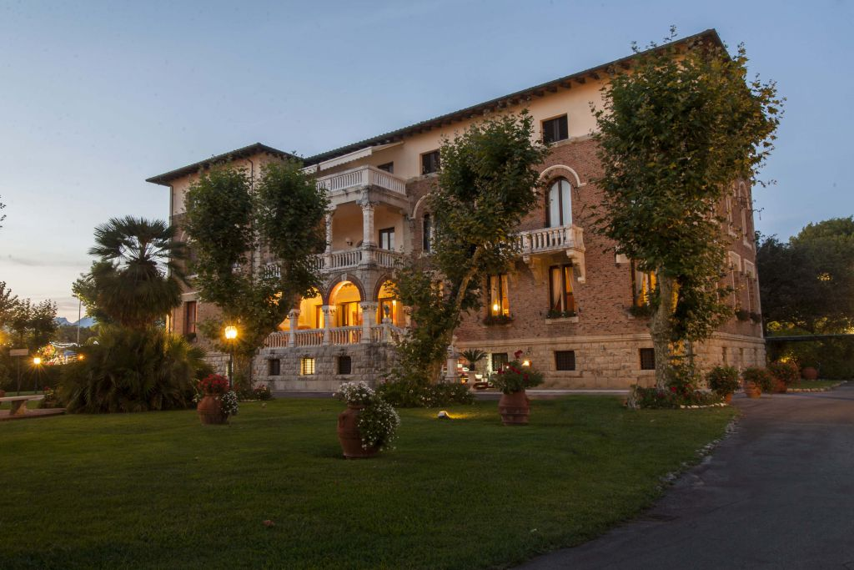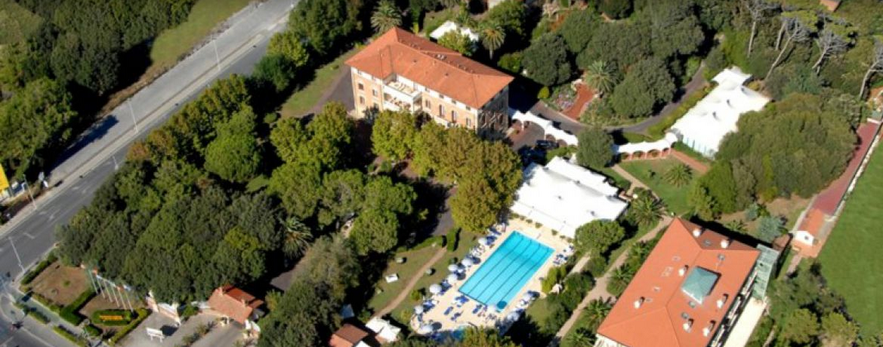

Join us at the most complete cycling training camp you can attend:
- Training together with coaches and professional riders,
- Performance tests,
- Nutritional strategies,
- Mental training,
- Cross training,
- MAX 20 participants accepted.

Our Programs

October 23/24/25 - winter training and optimal nutrition

Coaches:
Dott. Gherardo Marcolin
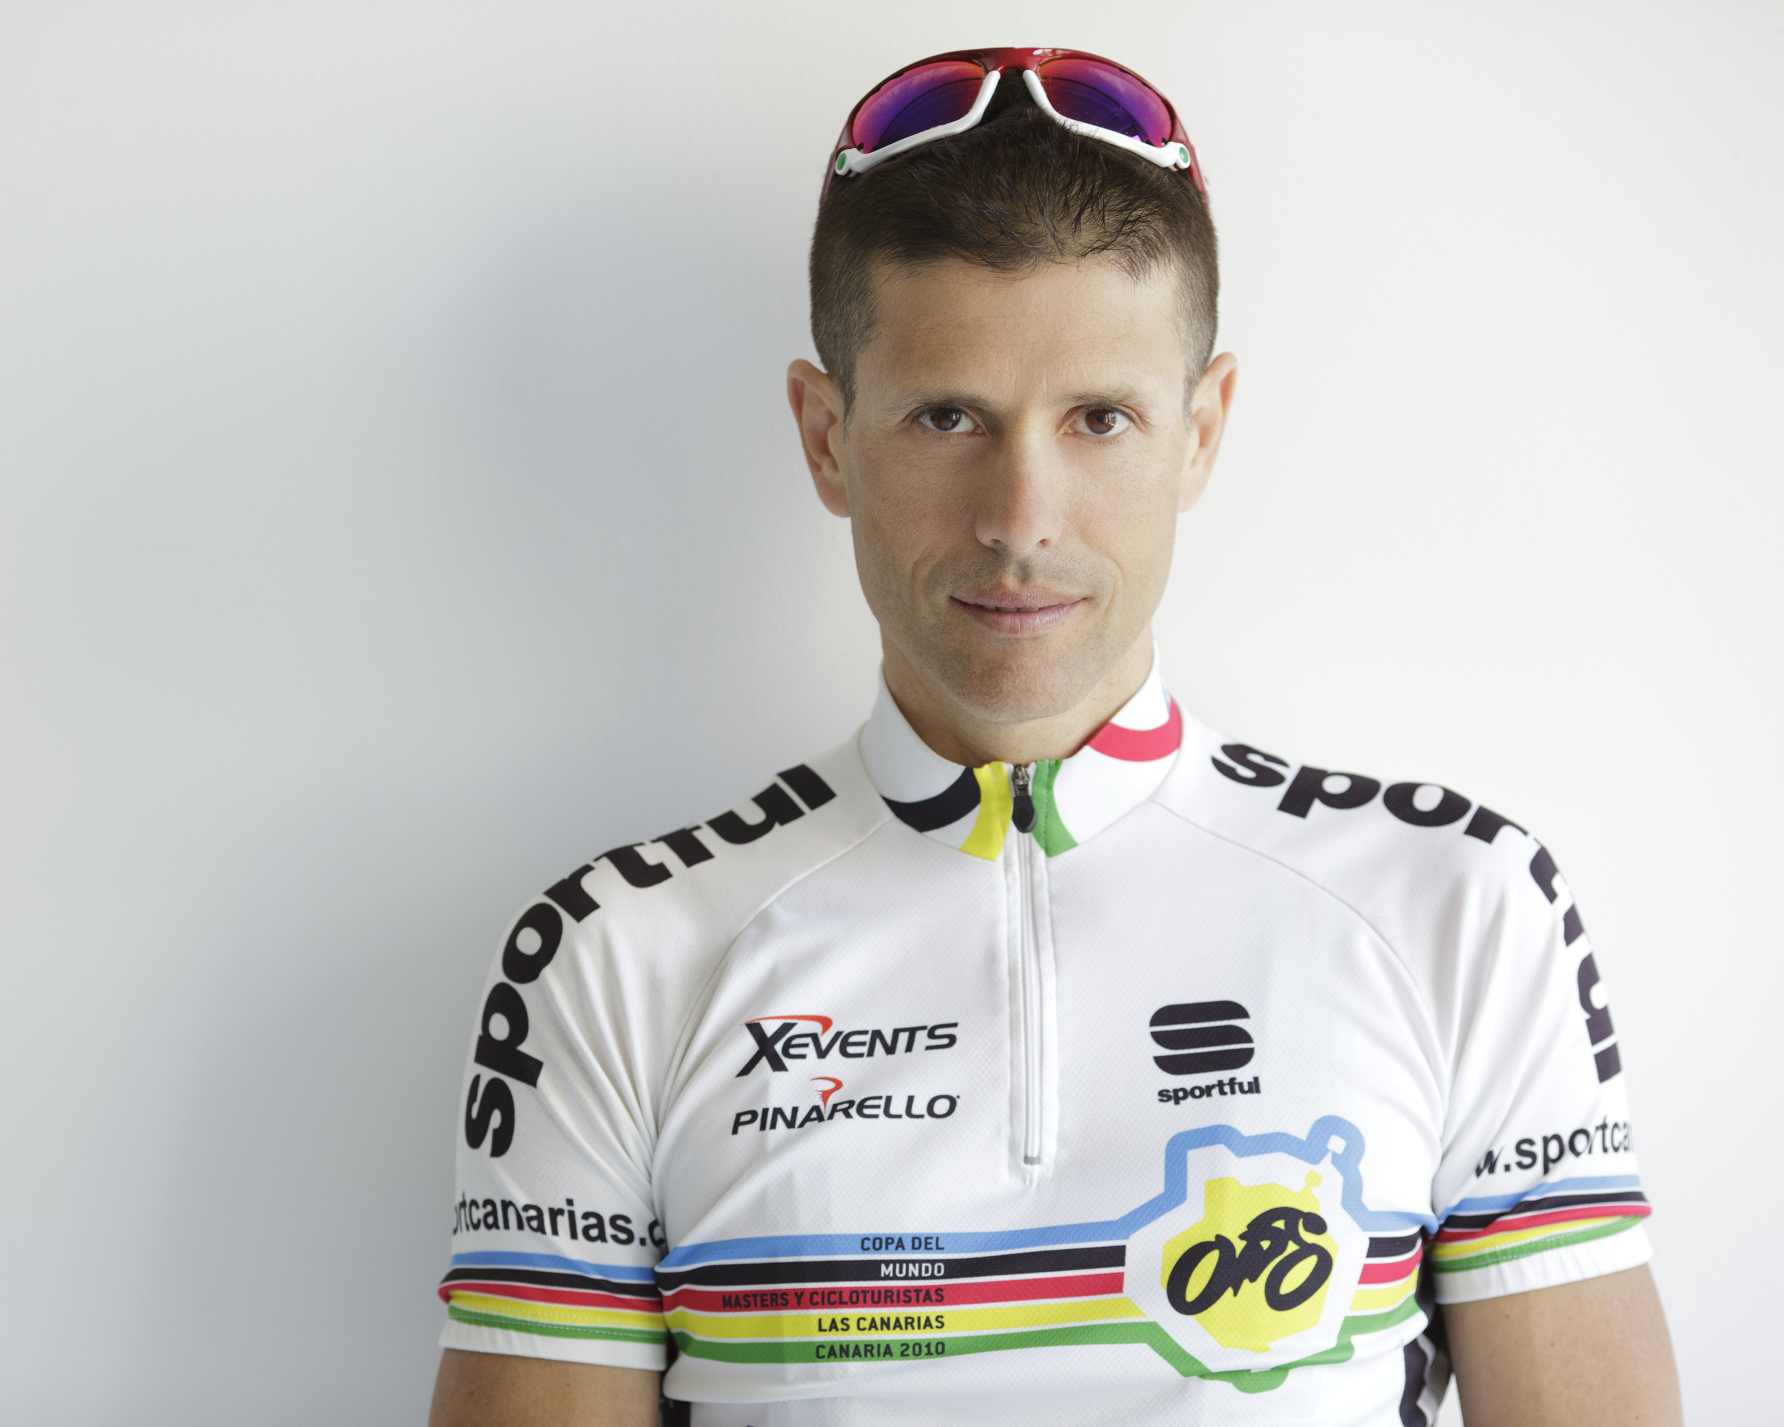
D.ssa Erica Lombardi (Diet Coach)
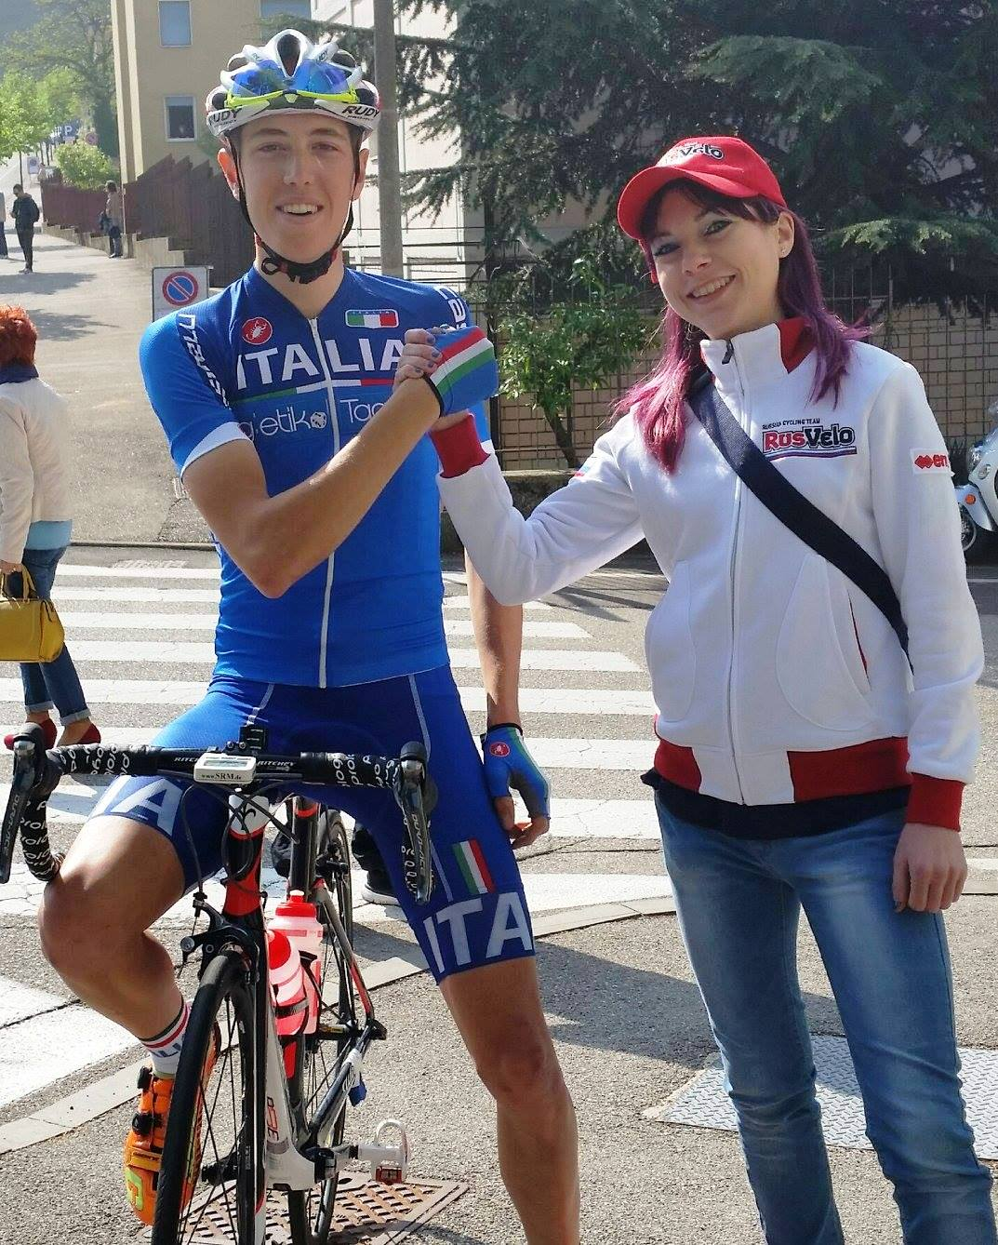
Special Guest: Davide Rebellin
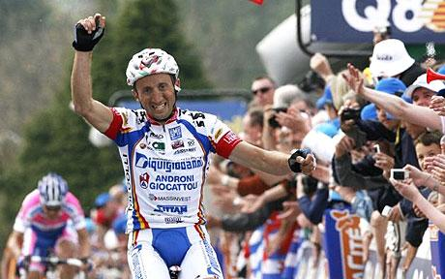

Friday 23:
Check in and Dinner together
Saturday 24:
- 7.30 muscular awakening,
- 8.00 Breakfast,
- 9.00 Training with Davide Rebellin (Group A),
- 9.00 Performance tests, body and nutritional assessment (Group B)
- 13.00 Lunch
- 14.30 Relax at wellness area (Group A)
- 14.30 Training ride (Group B)
- 18.00 Bio - energetic, stretching and ROM (range of motion) optimization
- 19.00 Optimal nutrition during the off season
- 20.00 Dinner
- 21.00 Questions and answers
Sunday 25:
- 7.30 muscular awakening,
- 8.00 Breakfast
- 9.00 Training ride with Davide Rebellin (Group A+B)
- 13.00 Lunch
- 14.00 Check out

Price: € 249,00 per person.
+ Accommodation:
- € 63,00 per night, per person, in a double room, full board,
- € 78,00 per night, per person, in a single room, on a full board treatment,
Available Upgrade:
- Blood Lactate Test: € 69,00
- Diet Coach consultation: € ?

November 27/28/29 – Performance test and seasonal planning for 2016
Coach:
Dott. Gherardo Marcolin
Special Guest: Davide Rebellin

Friday 27:
Check in and Dinner together
Saturday 28:
- 7.30 muscular awakening,
- 8.00 Breakfast,
- 9.00 Training with Davide Rebellin (Group A),
- 9.00 Performance tests, Blood Lactate and VO2max (Group B)
- 13.00 Lunch
- 14.30 Relax at wellness area (Group A)
- 14.30 Training ride (Group B)
- 18.00 Bio - energetic, stretching and ROM (range of motion) optimization
- 19.00 Building Mental toughness
- 20.00 Dinner
- 21.00 Questions and answers

Sunday 29:
- 7.30 muscular awakening,
- 8.00 Breakfast
- 9.00 Training ride with Davide Rebellin (Group A+B)
- 13.00 Lunch
- 14.00 Check out

Price: € 249,00 per person.
+ Accommodation:
- € 63,00 per night, per person, in a double room, full board,
- € 78,00 per night, per person, in a single room, on a full board treatment,
Upgrade:
- Blood Lactate Test or VO2max: € 69,00

SPECIAL DISCOUNT FOR BOOKING BOTH CAMPS:

€ 389,00 (instead of €498,00).

Send an email to: training@7wattsperkilo.com and reserve your spot now!
+39 338 7702907

7 Watts Per Kilo Sarl
Rue du Tronchet 10
CH-1870 Monthey
info@7wattsperkilo.com
www.7wattsperkilo.com

Who is interested, can book in advance Blood Lactate test and a Diet Coaching consultation.
Who is interested, can book in advance Blood Lactate test and a Diet Coaching consultation.

