3D Wording for: Leadership, Training, Mentoring, Coaching ……
The font sizes of the words can be different so long as all the words are arranged in a 3D triangular arrangement and it looks professional.
I’m looking for these words to have a 3D effect the example links below.
Example 1: Sport
https://www.bing.com/images/search?q=3+dimensional+word+design&view=detailv2&&id=FE2CE49A705AEA951D39205B2ACAD1931FDE25D2&selectedIndex=13&ccid=5FVF2a1Z&simid=608019906406058481&thid=OIP.Me45545d9ad5939ba4615ff7b1a0ec895o0&ajaxhist=0

Example 2: 3d Scrabble Board
https://www.bing.com/images/search?q=3+dimensional+scrabble+board&view=detailv2&&id=CD55E275CBEAA28E040279077007A5F44975B619&selectedIndex=0&ccid=x4HN9ZMV&simid=607987114328327408&thid=OIP.Mc781cdf5931570bf0a00fc0f785165ebo0&ajaxhist=0

Example 3: Graphic Design word
https://www.bing.com/images/search?q=3+dimensional+word+graphic+design&view=detailv2&id=5643F010E1C14684395E6AC0DB7881260F39EE4F&selectedindex=28&ccid=jg9jWRsX&simid=608034938791398293&thid=OIP.M8e0f63591b17b1b6400a7e43612724a6o0&mode=overlay&first=1

Word “Tax” layout out is similar effect to “Effective Communication Skills”.
Example 4: Word “Tax” layout out is similar effect to “Effective Communication Skills” which I would like to use as the base of the triangular layout
https://www.bing.com/images/search?q=3+dimensional+word+graphic+design&view=detailv2&id=EBD9E00B5C740894EEB990A61864D075950456C6&selectedindex=93&ccid=2%2F2hzKrH&simid=608028908669239928&thid=OIP.Mdbfda1ccaac711caa4b3c5da128a168ao0&mode=overlay&first=1

Eagle Design and LEADER. I provided the original drawing as EXAMPLE ONLY. Please redesign so it unique and not based on cut and paste from Shutter Stock or other sources. For the Business card Front and Back please design a background with lighter contours of colours/shades and contrasting shapes and sizes. Please give the design a Wow factor See the example of SIMPLE cards which have the WOW factor
- Overall card to have different variations of ice blue colour and wheat colour. See colour example link.
- Wheat colour only within the centre bit of the Earth. Please see my original attached drawing. Please pick a “Wheat colour”shading that works with a shading of “ICE Blue”
- Please give different contrast/shades/effects if possible

Colour Example Links:
Example 1: Ice Blue Colours
https://www.bing.com/images/search?q=ice+blue+colour&view=detailv2&id=530ED0AEC3C787B2541C246E56F917E0258C6842&selectedindex=91&ccid=br6WnhrI&simid=607991671294198074&thid=OIP.M6ebe969e1ac8973aa985d1597206c8edo0&mode=overlay&first=1

Example 2: Ice Blue Colours
https://www.bing.com/images/search?q=ice+blue+colour&view=detailv2&id=CE49AC7C47082E07F8273A3984445DC95129018D&selectedindex=123&ccid=xjZiikrJ&simid=608034101278871454&thid=OIP.Mc636628a4ac9d02101688c4a93157da9o0&mode=overlay&first=1

Example 3: Wheat Colours
https://www.bing.com/images/search?q=wheat+colours&FORM=HDRSC2

Please refer to
For example “Spaceclaim Engineer 2010”
- Has different shadows and shades.
- Eagle Design and the Centre to have different shades of ICE Blue Colour, no other colours. From dark Ice Blue wings of the eagle to light blue/grey
- “Republic of Communication” to standout with the same letter for “ROC”
- “Growing Future Leaders” Similar letter design but SMALLER Size Fonts.
- Use my original Eagle and Earth as Example Only. Please re-design the eagle and centre so it looks unique from the original source. Example use different wing design, head design boundary contours etc.
- Design the centre of the eagle so that LEADERS is the same size.

Have a look at “Spaceclaim Engineer 2010” which shows a professional simple graphics.
Example 1: Spaceclaim Engineer 2010.
https://www.bing.com/images/search?q=3+dimensional+word+graphic+design&view=detailv2&id=AFACBE8884B3B8D43CADFF06EBB9F554C648F4F5&selectedindex=76&ccid=EH5jLYcG&simid=608024665234276550&thid=OIP.M107e632d870638ab8efde937c3e4ace5o0&mode=overlay&first=1

Example of professional card “Franco” – Simple and Elegant with;
- Great colour background, Font Style which are dimensionally correct.

Example 2: Franco Card
https://www.bing.com/images/search?q=amazing+business+cards&view=detailv2&id=F5E6E582892F351829C19DC85ECAFD8C6E0EA35B&selectedindex=248&ccid=ENAgh3gO&simid=608009516885803373&thid=OIP.M10d02087780e0f0f34f5311630b76afeo0&mode=overlay&first=1

Sean Kinberger Business Card:
- Great use of black ground to use blue border for “SK” contrast well with blue.

Example 3: S Kinberger card
https://www.bing.com/images/search?q=amazing+business+cards&view=detailv2&id=99B23613EDC00F95709D8DC2ACA06B270600D21B&selectedindex=453&ccid=4xfBvrIu&simid=608007601326721840&thid=OIP.Me317c1beb22ee690f98d5e7c926fdeceo0&mode=overlay&first=1

“Digitalfish”example of professional lettering

Example 4: Digital Fish
https://www.bing.com/images/search?q=amazing+business+cards&view=detailv2&id=99B23613EDC00F95709DC600DF329910DB78993A&selectedindex=482&ccid=xLTKaDYI&simid=608010135359784704&thid=OIP.Mc4b4ca68360866174800111a57cb0f36o0&mode=overlay&first=1

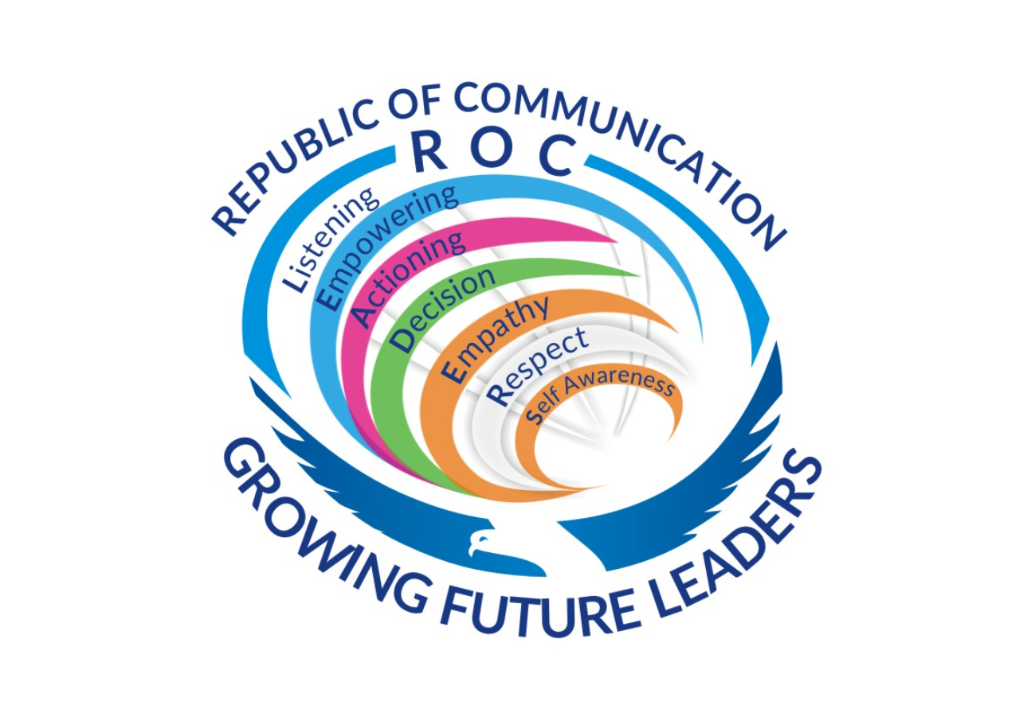

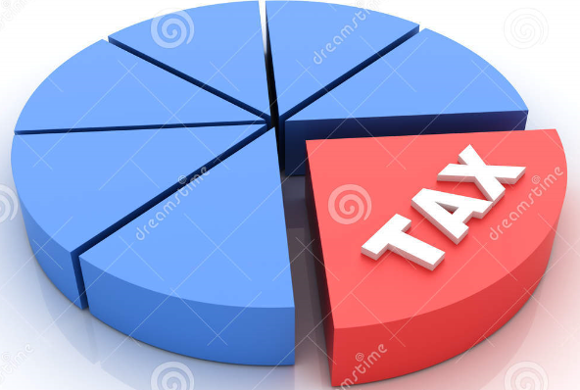

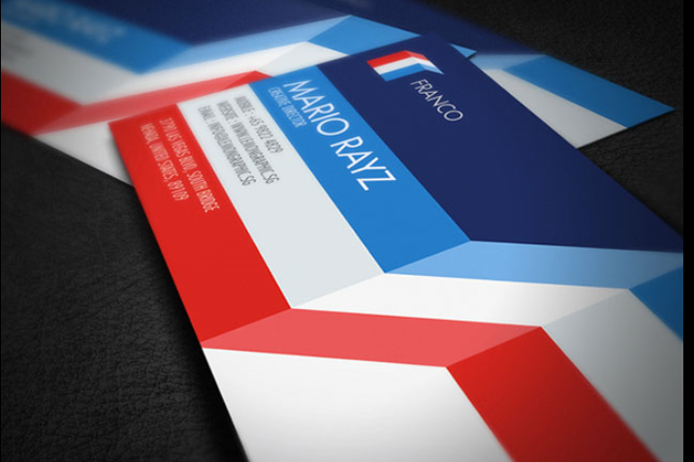

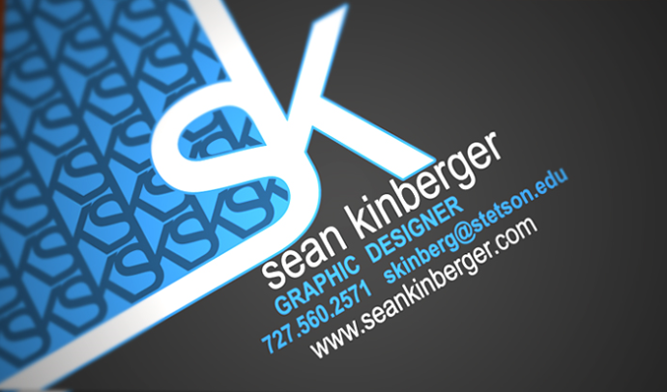

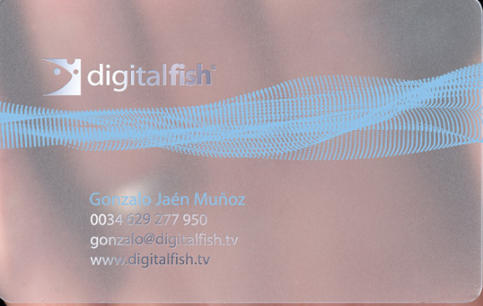

Hi All,

Thanks for the designers putting together a proposal. Please note my original drawing was an example only. Please see comments which I know can improve the design work.

3D Wording for: Leadership, Training, Mentoring, Coaching ……
The font sizes of the words can be different so long as all the words are arranged in a 3D triangular arrangement and it looks professional.
I’m looking for these words to have a 3D effect the example links below.
Example 1: Sport
https://www.bing.com/images/search?q=3+dimensional+word+design&view=detailv2&&id=FE2CE49A705AEA951D39205B2ACAD1931FDE25D2&selectedIndex=13&ccid=5FVF2a1Z&simid=608019906406058481&thid=OIP.Me45545d9ad5939ba4615ff7b1a0ec895o0&ajaxhist=0

Example 2: 3d Scrabble Board
https://www.bing.com/images/search?q=3+dimensional+scrabble+board&view=detailv2&&id=CD55E275CBEAA28E040279077007A5F44975B619&selectedIndex=0&ccid=x4HN9ZMV&simid=607987114328327408&thid=OIP.Mc781cdf5931570bf0a00fc0f785165ebo0&ajaxhist=0

Example 3: Graphic Design word
https://www.bing.com/images/search?q=3+dimensional+word+graphic+design&view=detailv2&id=5643F010E1C14684395E6AC0DB7881260F39EE4F&selectedindex=28&ccid=jg9jWRsX&simid=608034938791398293&thid=OIP.M8e0f63591b17b1b6400a7e43612724a6o0&mode=overlay&first=1

Word “Tax” layout out is similar effect to “Effective Communication Skills”.
Example 4: Word “Tax” layout out is similar effect to “Effective Communication Skills” which I would like to use as the base of the triangular layout
https://www.bing.com/images/search?q=3+dimensional+word+graphic+design&view=detailv2&id=EBD9E00B5C740894EEB990A61864D075950456C6&selectedindex=93&ccid=2%2F2hzKrH&simid=608028908669239928&thid=OIP.Mdbfda1ccaac711caa4b3c5da128a168ao0&mode=overlay&first=1

Eagle Design and LEADER. I provided the original drawing as EXAMPLE ONLY. Please redesign so it unique and not based on cut and paste from Shutter Stock or other sources. For the Business card Front and Back please design a background with lighter contours of colours/shades and contrasting shapes and sizes. Please give the design a Wow factor ☺ See the example of SIMPLE cards which have the WOW factor ☺
1. Overall card to have different variations of ice blue colour and wheat colour. See colour example link.
2. Wheat colour only within the centre bit of the Earth. Please see my original attached drawing. Please pick a “Wheat colour”shading that works with a shading of “ICE Blue”
3. Please give different contrast/shades/effects if possible

Colour Example Links:
Example 1: Ice Blue Colours
https://www.bing.com/images/search?q=ice+blue+colour&view=detailv2&id=530ED0AEC3C787B2541C246E56F917E0258C6842&selectedindex=91&ccid=br6WnhrI&simid=607991671294198074&thid=OIP.M6ebe969e1ac8973aa985d1597206c8edo0&mode=overlay&first=1

Example 2: Ice Blue Colours
https://www.bing.com/images/search?q=ice+blue+colour&view=detailv2&id=CE49AC7C47082E07F8273A3984445DC95129018D&selectedindex=123&ccid=xjZiikrJ&simid=608034101278871454&thid=OIP.Mc636628a4ac9d02101688c4a93157da9o0&mode=overlay&first=1

Example 3: Wheat Colours
https://www.bing.com/images/search?q=wheat+colours&FORM=HDRSC2

Please refer to
For example “Spaceclaim Engineer 2010”
1. Has different shadows and shades.
2. Eagle Design and the Centre to have different shades of ICE Blue Colour, no other colours. From dark Ice Blue wings of the eagle to light blue/grey
3. “Republic of Communication” to standout with the same letter for “ROC”
4. “Growing Future Leaders” Similar letter design but SMALLER Size Fonts.
5. Use my original Eagle and Earth as Example Only. Please re-design the eagle and centre so it looks unique from the original source. Example use different wing design, head design boundary contours etc.
6. Design the centre of the eagle so that LEADERS is the same size.

Have a look at “Spaceclaim Engineer 2010” which shows a professional simple graphics.
Example 1: Spaceclaim Engineer 2010.
https://www.bing.com/images/search?q=3+dimensional+word+graphic+design&view=detailv2&id=AFACBE8884B3B8D43CADFF06EBB9F554C648F4F5&selectedindex=76&ccid=EH5jLYcG&simid=608024665234276550&thid=OIP.M107e632d870638ab8efde937c3e4ace5o0&mode=overlay&first=1

Example of professional card “Franco” – Simple and Elegant with;
1. Great colour background, Font Style which are dimensionally correct.

Example 2: Franco Card
https://www.bing.com/images/search?q=amazing+business+cards&view=detailv2&id=F5E6E582892F351829C19DC85ECAFD8C6E0EA35B&selectedindex=248&ccid=ENAgh3gO&simid=608009516885803373&thid=OIP.M10d02087780e0f0f34f5311630b76afeo0&mode=overlay&first=1

Sean Kinberger Business Card:
1. Great use of black ground to use blue border for “SK” contrast well with blue.

Example 3: S Kinberger card
https://www.bing.com/images/search?q=amazing+business+cards&view=detailv2&id=99B23613EDC00F95709D8DC2ACA06B270600D21B&selectedindex=453&ccid=4xfBvrIu&simid=608007601326721840&thid=OIP.Me317c1beb22ee690f98d5e7c926fdeceo0&mode=overlay&first=1

“Digitalfish”example of professional lettering

Example 4: Digital Fish
https://www.bing.com/images/search?q=amazing+business+cards&view=detailv2&id=99B23613EDC00F95709DC600DF329910DB78993A&selectedindex=482&ccid=xLTKaDYI&simid=608010135359784704&thid=OIP.Mc4b4ca68360866174800111a57cb0f36o0&mode=overlay&first=1

Once again good effort I hope the feedback helps with the changes.

Thanks
Paul

https://designschool.canva.com/
