The old Fever Hospital building holds a rich history and has significant heritage value to the Wellington community. Listed as a Category II Heritage Building in the New Zealand Historic Places Trust register, the building was built in 1918 as Fever Hospital, a hospital for infectious diseases, and has since been referred to as the Chest Hospital (1969-1981) and then the Wellington Polytechnic Conservatorium of Music (1987-1998).

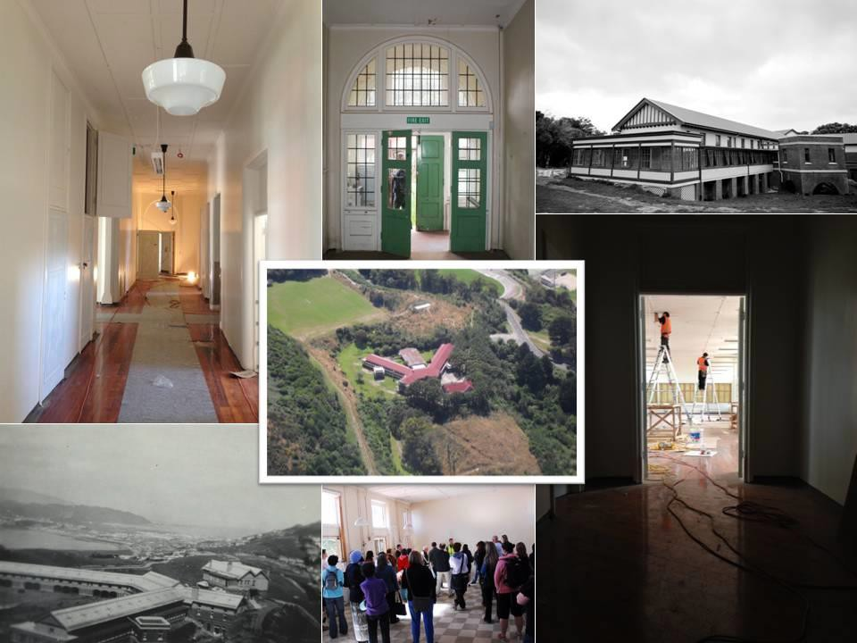

In 2002 the Capital & Coast District Health Board transferred the buildings at no cost to the Wellington City Council. In 2004 the Council issued a request for proposals for the future use of the facility. Wellington SPCA submitted the preferred proposal and in August 2007 Wellington SPCA entered into an agreement to lease and resource consent was achieved. Unfortunately the project was suspended in 2009 due to Wellington SPCA member concerns over the magnitude of the scope of works and the building began to fall into disrepair, with regular and substantial vandalism.

A new Wellington SPCA management team were formed in 2011 and in June 2012 the Wellington City Council and Wellington SPCA reconfirmed the partnership and the future of this wonderful building was assured, with commitment to a lease agreement for 60 years. In July 2012 Wellington City Council commenced their site works and in 2013 handed a water tight earthquake strengthened building to Wellington SPCA. A new internal design was completed by the design team of Pure Evolution, Green Light Projects, Bell Kelly Beaumont Architects, AECOM, Maltbys and Dunning Thornton. In the latter half of 2013 Hawkins Construction began construction and interior fit out and in December Wellington SPCA moved in. An official opening was held in February 2014 and attracted more than 8000 people from the wider Wellington community. This has been a stunning transformation – rescuing a vandalised, neglected piece of history and transforming it into a national award winning beautiful heritage facility, cared for by a community organisation which provides essential community services.

Wellington SPCA have been at the forefront of animal welfare across the Greater Wellington Region for 130 years. In that time it has come to exist far beyond being a law enforcement agency and a shelter for homeless animals. In moving to Fever Hospital we have developed an Animal Care, Education and Community Centre that supports our goal to put a stop to animal cruelty, neglect and abandonment through implementing preventive strategies that focus on community education and engagement.

Education is the way we aim to bring an end to the cycle of abuse and neglect. Our Education team work with schools, at risk youth, hospitals and aged care facilities, as well as running Animal Crew after school and holiday programs. Last year over 23,000 people were reached by the Education team.

Wellington SPCA also runs a private veterinary practice, where any member of the public can bring their own animal for veterinary care – just like any other vet in town. Education is also an essential part of the veterinary practice and each year we have 40 Massey University vet students, 62 WelTEC Animal Care students, and numerous veterinary nursing students from Otago Polytechnic, WelTEC, UCol, SIT and other education institutions on work placement with us. Fever Hospital has been designed as a teaching facility where we will be able to provide increased capacity and facilities to further expand this essential role.

The charity does not receive any direct government funding, and so must find ways to generate the income required to provide the essential services and support its operations. The café at Fever Hospital will financially contribute to these services, and also serve to bring people through the front doors of Wellington SPCA where they can learn about the organisation and hopefully generate on-going support.

