Before you design… remember we want to be a household name in terms of quality, safety, and reliability… we are not another typical lab like Centrum, GNC, etc…

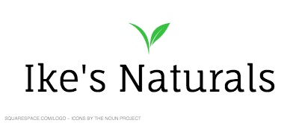
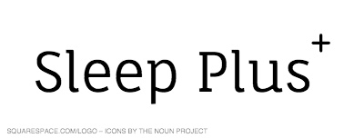
Our company logo and product name (These are open for creative changes as you see fit).. the font used is Faunal.

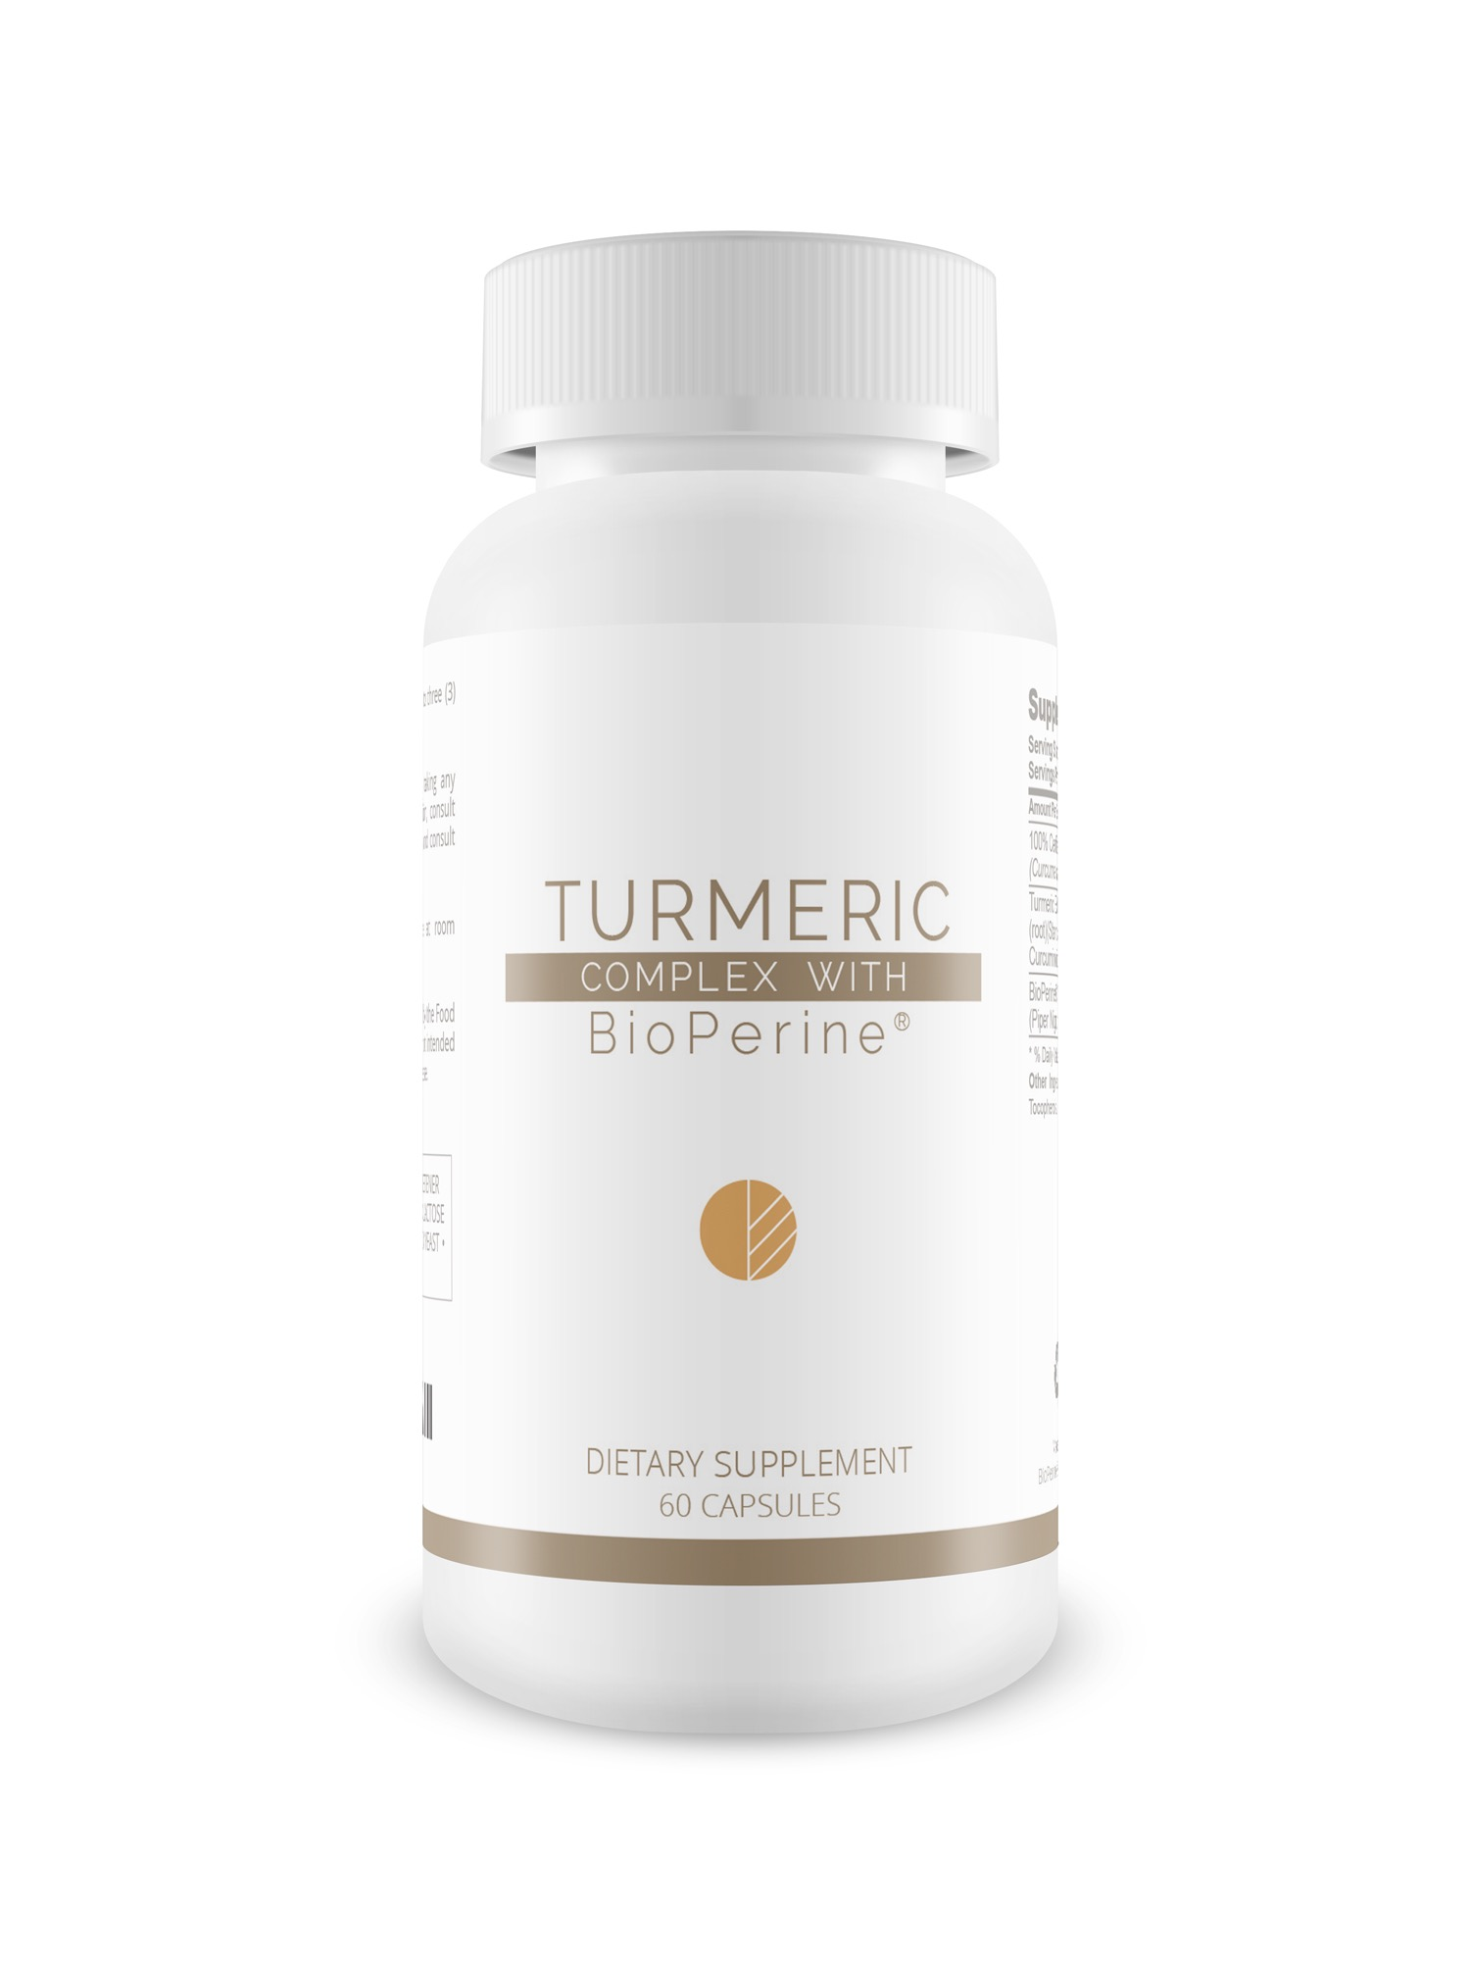
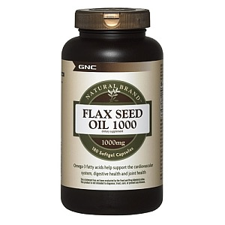
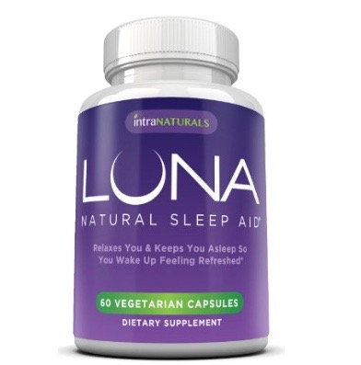
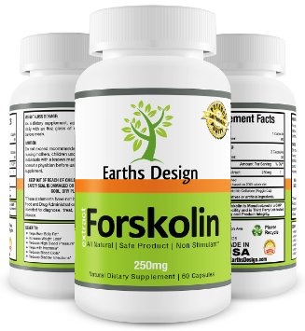
Here are some designs we are attracted to, we believe a product with brown or a tan supplement label or coloring would best showcase our product and company. However, we are very open to all ideas and designs.

