- Docupace - ePACS brochure
- 11 x 17 bifold
- [notes in square brackets are instructions to designer, NOT part of the text]

- [Front panel]

- ePACS Automated Workflow


- Web-based, electronic, straight-through processing app providing fully integrated document management and workflow, e-Signatures, e-Forms, and Check21 processing.

- [inside spread]
ePACS® Automated Workflow
- The effectiveness of traditional processing solutions is limited if every step along the way is not workflow-enabled. Instead of straight-through processing, the result is “part-through processing,” increasing the likelihood of errors and delays. ePACS® is straight through processing in a box, built for financial service firms.

- The patent-pending ePACS is pre-integrated with all the subsystems needed to move any piece of business through your firm. Completely paperless, the experience starts with the client-advisor interaction and continues seamlessly straight through the home office to clearing and fund companies as appropriate.

- Significantly improves turnaround time for new applications and ongoing business
- Integration automatically reduces or eliminates most NIGO conditions
- Integrated supervision system ensures that broker dealer makes best efforts towards principal supervision
- Compliance-approved blotter system makes supervision and auditing transparent and simple.

- ePACS helps you and your advisors succeed because your time and energy can be focused where it counts - servicing the clients.

- StartingPoint
- StartingPoint, powered by Quik!® is the only solution that accommodates all lines of business for an office. With a robust catalog of more than 18,000 integrated forms, it enables you to pre-populate data, thereby reducing errors and decreasing processing time. Forms are kept up-to-date and there’s no need for a desktop application.

- StartingPoint also enables you to customize key documents with broker-dealer specific information. With ePACS, client data can be securely transmitted from the CRM system directly into a form, and the entitlement model offers the right people access for supervision purposes, yet ensures that the form remains secure and protected.
- All forms are immediately entered into the workflow queue.

- [insert info/graphics of the 3 benefits, using the following text]
- Docupace provides a secure and compliant electronic processing platform for financial institutions and wealth management firms.

- Build a Better Connection with Clients [use image of two hands preparing to shake]
- By including the client in the workflow, up front, we create transparency, improve credibility and build trust. The process begins and ends with the client.

- By creating paperless transactions for the client — for example allowing them to sign electronically—we make the entire process both safe and convenient for the client.

- Due to business and compliance realities, the financial services industry has fallen behind in terms of using technology to bring the client into the process. Our state-of-the-art, proven solutions—such as including a secure client portal that allows them to access their documents anytime anywhere—put the guardrails in place, so that everyone can move forward with confidence.

- Reduce Costs and Improve Efficiencies [use image of “Profit” key on computer]
- Our ePACS service combined with our proprietary delivery methodology reduces costs and improves operating efficiencies allowing you to do more with less. ePACS will also reduce both your risk and your compliance burden.

- Our systems eliminate rework and improve data integrity, substantially reducing NIGO rates. ePACS forms coupled with CRM integration automates form-filling, assuring “once-and-done” data entry and a completely electronic process. This is a huge cost saver. And, from the client’s perception, less mistakes mean more trust.

- Firms using our system are provided with rich data points that allow them to model, measure and manage their business according to the numbers. Our workflow monitor and reports will give you a 360-degree view of KPI’s to drive continuous process improvement. This helps firms and advisors alike grow and build their businesses.

- Protect Your Data and Your Firm [use image of fingerprint scanner]
- A centralized SEC/FINRA compliant WORM repository allows secure access to all of your workflows, business processes, and documents. Robust search capabilities allow you to do federated searches across the entire repository. Multiple layers of physical security and proprietary technology coupled with the most secure data center on the planet provide peace of mind.

- The central repository allows you to aggregate all your documents in a disaster-proof virtual vault. The world’s top 25 Internet providers converge at the Switch location, thus Docupace traffic is routed based on the highest speed and availability. ePACS logical security is powerful, flexible and battletested.

- Security rights are applied according to the user’s role. Access is granted on a need-to-know basis, ensuring your client’s privacy and thus reducing your liability. The law states that you are required to make your best effort to protect client data. Anything short of ePACS—which was built to solve for the most complex user access and rights scenarios—is not your best effort.

- [back panel]
- ePACS - The Bottom Line
- Contains every form you need, online, easily accessible, and part of a single subscription fee, with no added costs
- Meets the highest levels of compliance and security
    - Security for specific filing cabinets, indexing fields, document types by groups, roles, and/or users.
    - Searchable notes are audit ready and configurable based on firm’s operational and compliance needs
    - Security for principal supervision accommodates the most complex requirements
    - Approved Third Party Provider for SEC/FINRA books and records, supervision, disaster recovery and electronic signatures
    - Centralized compliance and auditing functions provide 360-degree view across the entire organization
    - Enables branch audits from the home office
- Facilitates advisor transitions
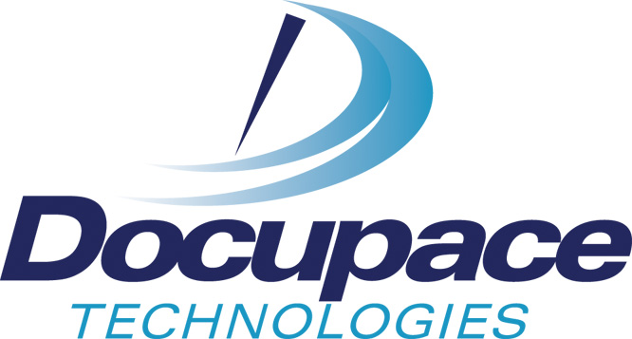

- CALL US - 866 582-3713

- SECURE AND COMPLIANT ELECTRONIC PROCESSING SPECIALISTS

- 2001 S. Barrington Ave., Suite 215, Los Angeles, CA 90025 310 445-7722

