Data Quality / Stewardship
Data quality is a journey not a destination and we help you with strategies and monitoring tools to identify, prioritize, fix, and prevent data quality issues. This involves the implementation of architecture and tools that capture data lineage, document metadata, promote reuse, and help you track the quality of your data. We have seen companies derive significant benefits from incremental changes in discipline around design and monitoring. The impact of data quality is magnified as systems get more complex and data is distributed throughout the organization.
BI / Analytics
We focus on Business Intelligence and Analytics to help you create a comprehensive picture of your customers and marketing programs. Operationally we help you track Marketing Performance KPIs to help you identify the returns associated with initiatives across Omni-Channel Marketing Programs. We develop customer acquisition monitoring tools to help you identify trends and anomalies. Finally we look at customers and behavior to help you identify changes, create segments, and more effectively communicate with your audience.
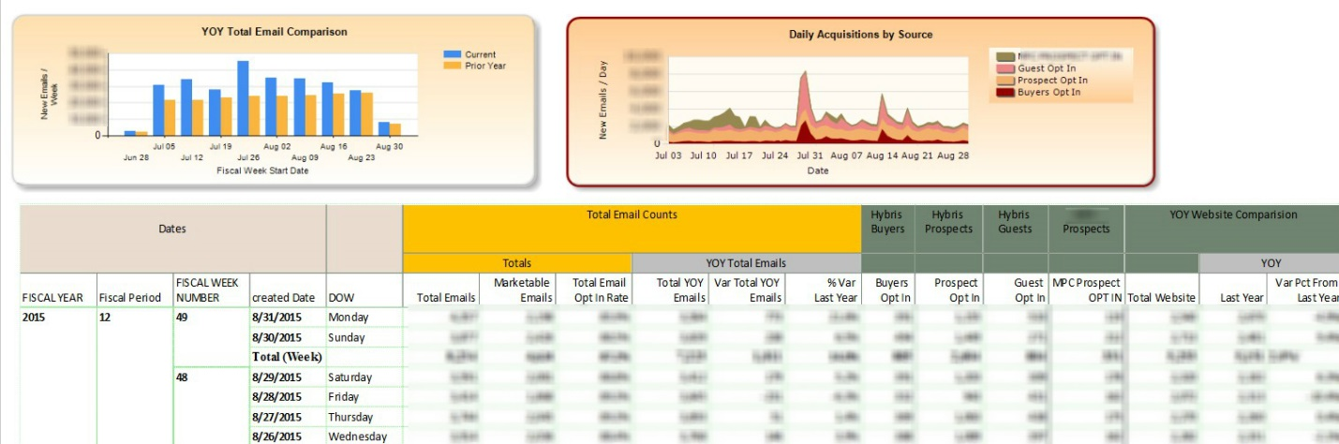

Data Integration
We help companies enable capabilities in disconnected systems, power comprehensive reporting, and develop analytic capabilities through data and solution integration. Our experience includes on premise and cloud integration to and from Customer Relationship (CRM), Marketing Automation, Loyalty, eCommerce, Online Behavioral (clickstream), Email Solutions (ESP), and numerous other disconnected applications and platforms.
We combine more than twenty years of large scale and big data application deployment experience with industry best practices related to data integration, architecture, stewardship, governance, and master data management to create practical robust solutions. We monitor both established and emerging technologies to help companies fill gaps, extend their architecture, and solve other marketing data integration problems.

Marketing Specific Capabilities
E-mail Integration
Integration with cloud services including Email, Marketing Automation, Contact Integration, and other data providers
CRM Integration
You will have the ability to deliver targeted marketing programs through your CRM platform.
Sales Funnel Development
Funnel Definition
We will work with you to define the stages within your marketing and sales lifecycle by identifying predicative online browsing behavior and actions so that you can track and message your prospects more effectively.
Tracking Implementation
Implementation of digital tracking mechanisms creates the technical foundation for reporting and marketing automation throughout the lifecycle of a marketing program.
Lead Scoring Management
Development of routines to automatically identify qualified leads and push them to a salesperson or the CRM system.

Marketing Database Optimization
Identify the best leads and the focus your marketing efforts through more relevant and accurate data. We offer the following consulting services:
- Lead Scoring and Qualification
- Segment Analysis, Identification, and Automated Selection
- Data Cleansing and Standardization

Marketing Plan Development
Create a marketing plan to generate new leads and engage your existing customers through the development of targeted content and consulting to help you identify the best vehicles and channels for your marketing effort. Your customized marketing plan will include:
- Marketing content assessment
- Technology assessment
- Program recommendations
- Assessment of your call to action a
- Lead funnel generation
- Event and networking
- Blogging setup, recommendations, and review process development

