Slides should be able to be shown on an iPhone

slide 1- various industries we cover -- and want to cover. (there are hundreds)

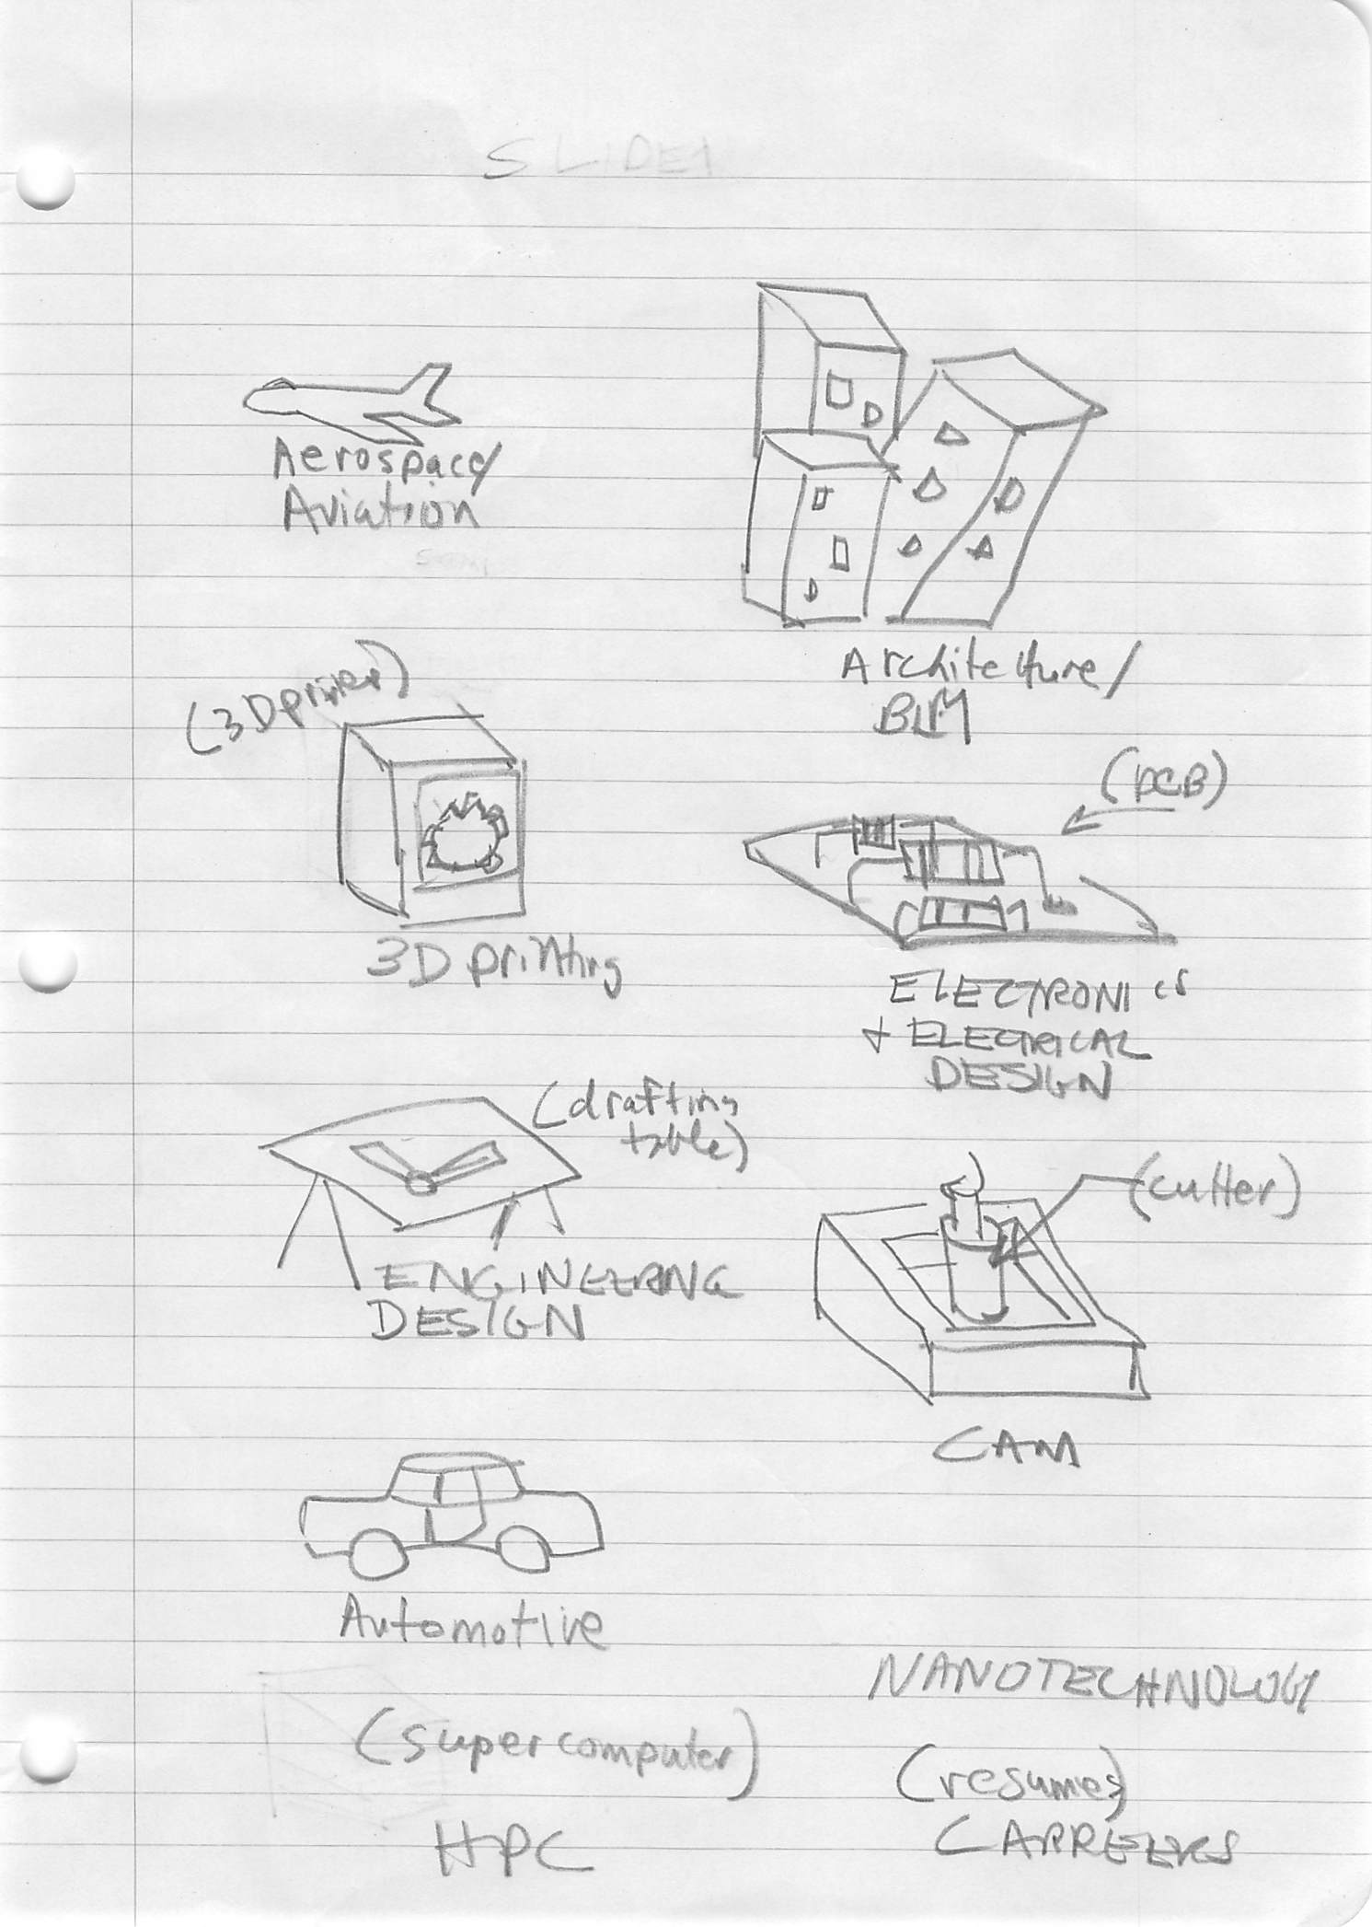

need graphic for HPC and nanotechnology

SLIDE 2 - industries have ideas and need coverage

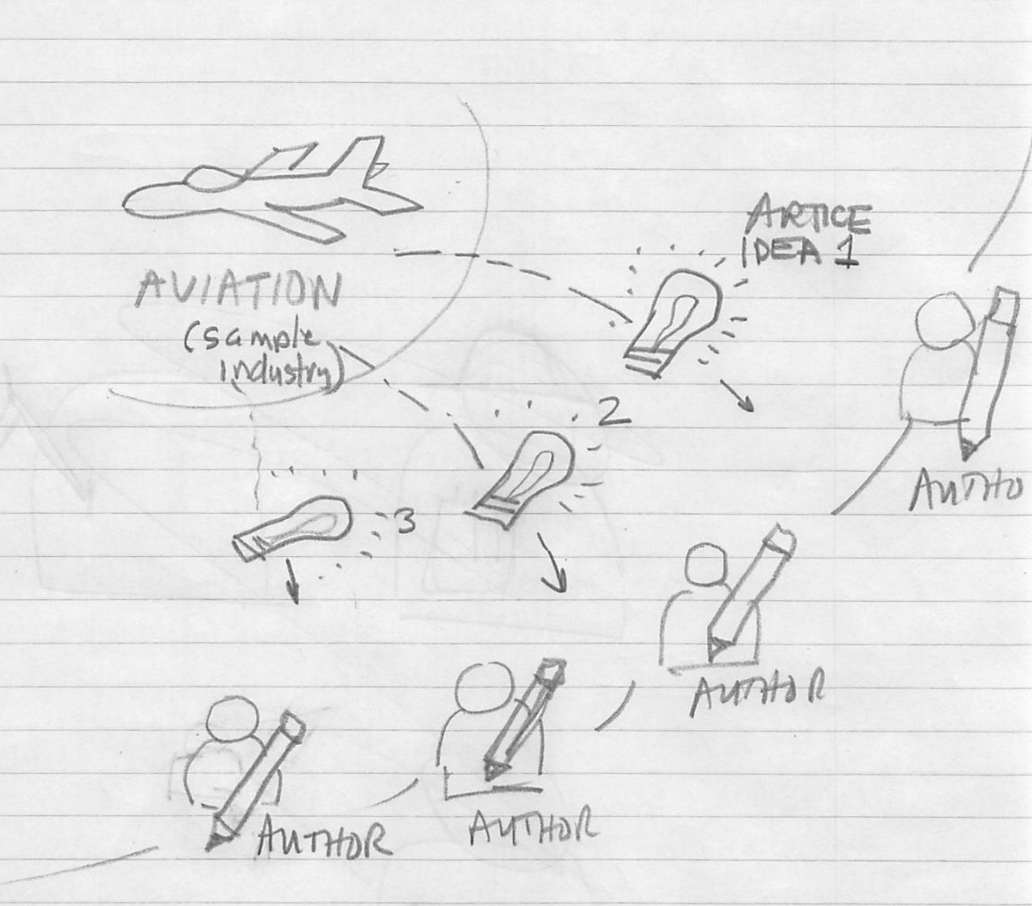
animate ideas coming out of sample industry and being accepted by authors

SLIDE 3 - author makes articles available to tech editors

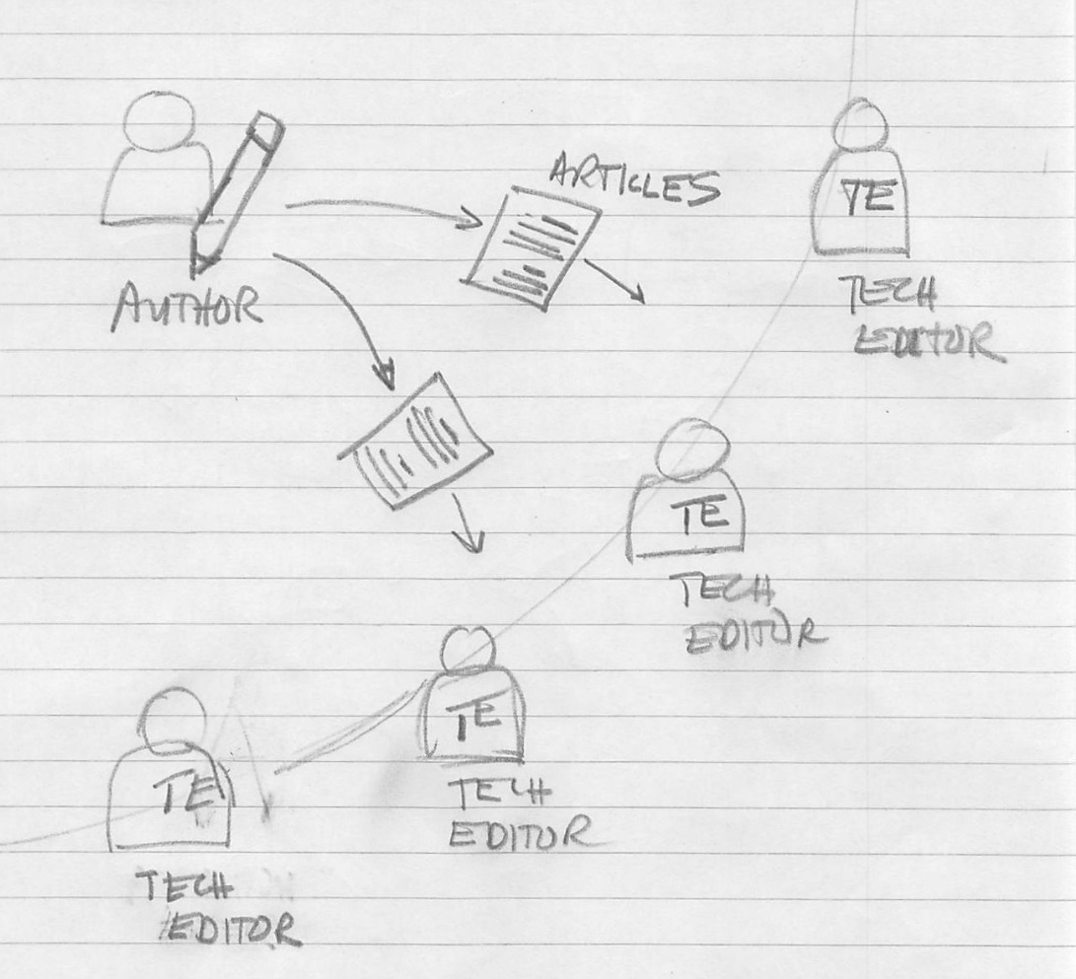

SLIDE 4 and 5 - Tech editor posts articles, waiting copy editor receives it,
then copy editor posts articles, and waiting production person publishes it
