Screen Designs

From a high level, we have an existing app that is live in iTunes. We are in the process of re-branding it to “Friendable” http://friendable.com . I am attaching our new logo. We are trying to keep the existing brand colors (Blue, Grey, and Orange), with updated logo, possibly making the blue more dominant than the orange (But up to designer), and new photo images. I am attaching the main image we are using on the website and in our marketing, but we need to add some additional ones for the new home screen design, website, and marketing. Please refer to ihookupsocial.com and friendable.com, as well as the new mock up screens, to get a better idea. We would like the fonts to match the new IOS9 font style guides (Fonts have been changed for IOS9), and everything should adhear to the IOS Human Interface guidelines published by apple.

We like the style and look of the new Clover App that was featured by Apple recently. Please take a look at that also for style: https://itunes.apple.com/us/app/clover-dating-app/id771990977?mt=8

You do not need to follow any of the style that is outlined in the mock up screens. They are just mockups.

It will help to download the existing free app https://itunes.apple.com/us/app/ihookup-free-meet-new-people/id674962256?mt=8 , as most of this will stay the same, but will be accessed from a new home screen (Find New Friends) that will go in front of what is there now.

I am attaching a user flow so that you can see how the UX flows and how they go together. We are open to moving elements around and to other screens if it makes sense in the UX. Here is an overview of each screen:

New Homepage Screen (Screen1): This page should include 4 main links. The images on this screen can be dynamic and rotate.

- Find New Friends – This will link to the app as it exists today (iHookup, rebranded as Friendable)

2. Create Friendable request - This series of screens will allow a user to specify what they are friendable for (i.e. a drink, dinner, movie, etc.) and a description, then select a nearby place (If applicable), then select a date and time (If applicable). From here you can invite one user, or multiple users based on which screen it was accessed from.

3. Requests Nearby - This series of screens will allow a user to view these requests based on their location (Similar to YikYak), the app will display all the requests within a certain mile radius, and should be able to be filtered or searched.

4. Trending hotspots - These screens will show places nearby that users are “trending”. If a user selects the local, then all the friend able requests for that location will be shown.

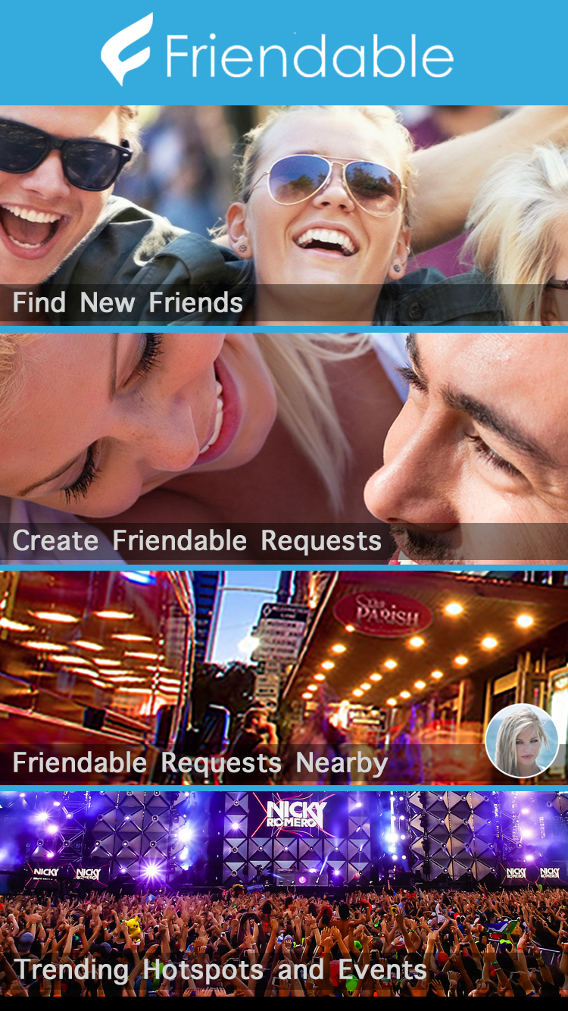

Homepage Link #1: Links to Existing iHookup / Friendable App

Homepage Link #2 (Screens 2,3 &4): Create Friendable Request

We have this mocked up as 3 separate screens. Please review the data and mock up screens, If there is a better UX to accomplish the same thing we are open to seeing it – i.e. combining 2 screens into 1, or moving anything around, etc.. This series of screens will allow a user to specify what they are friendable for (i.e. a drink, dinner, movie, etc.), provide a description, select a nearby place (Optional), then select a date and time (Optional).

Data Needed:
(Screen1)
-- What are you friendable for?
Options:
- Dinner
- Drinks
- Coffee
- Concert
- Event
- Movie
- Hiking or Biking
- Up for Anything
- Enter your Own Title (Optional)
- Enter a Description (Optional)

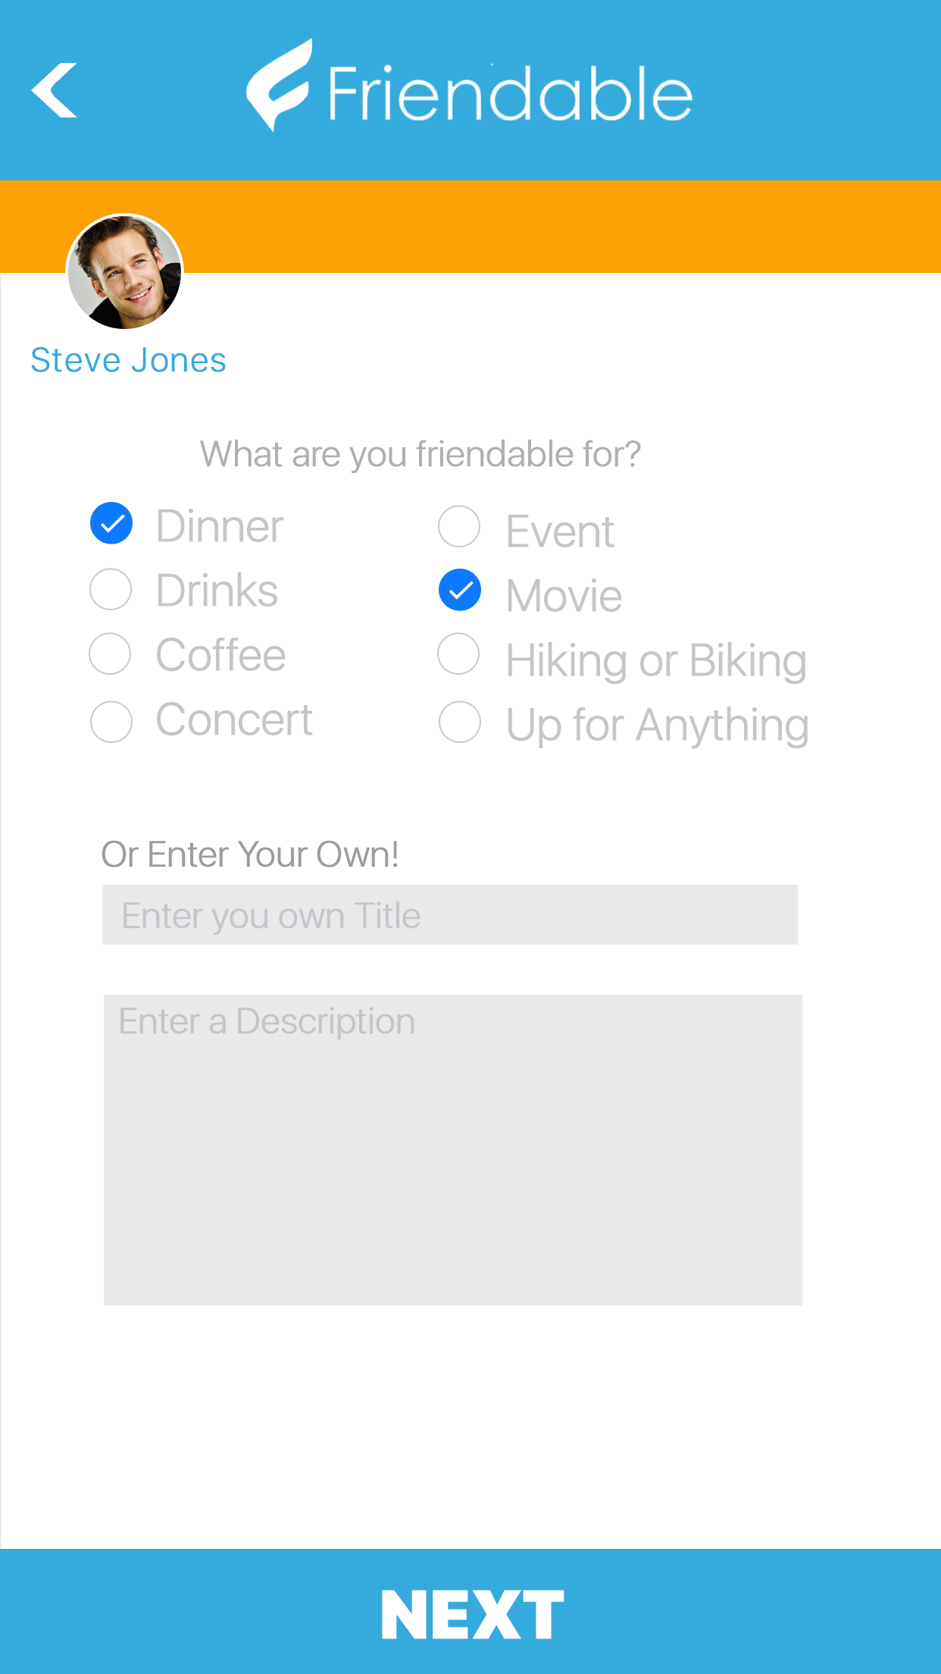

(Screen2)
-- Select a place or activity (Title)
Options
- None / Anywhere
- Select a place
- Select an event
- Enter your Own Location
- Location Name
- Location Address

-- Select a Time and Date
Options
- Date / Time
- Anytime

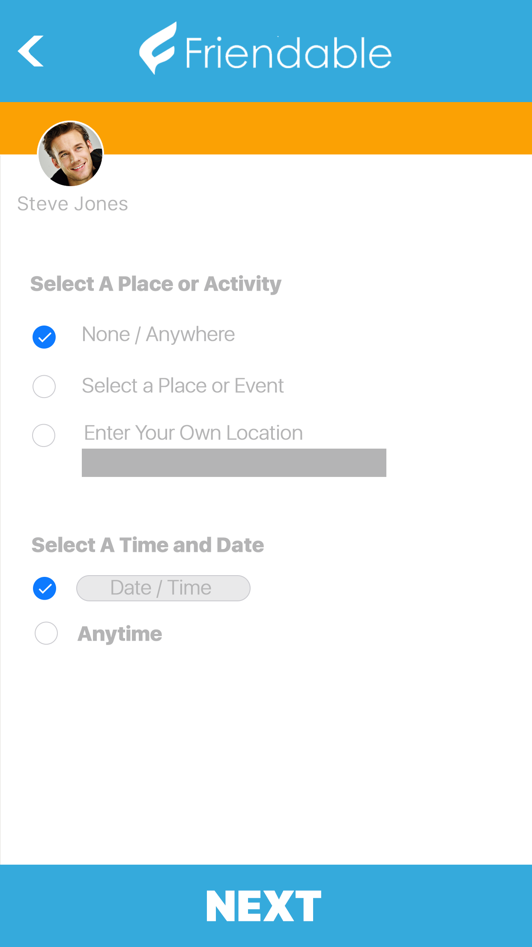

(Screen3)
-- Invite Users
This screen should be a fun “Tinder Like” experience, where you can view one user at a time and make a decision to Invite or move on to the next user. This screen needs the following information:

Profile Photo
Link to full profile
Invite Button
“NO” or “NEXT” button (Open to other text ideas)

Countdown Counter: “9 Invites Left”
Upsell Button “Add More Invites” or “Invite more users”

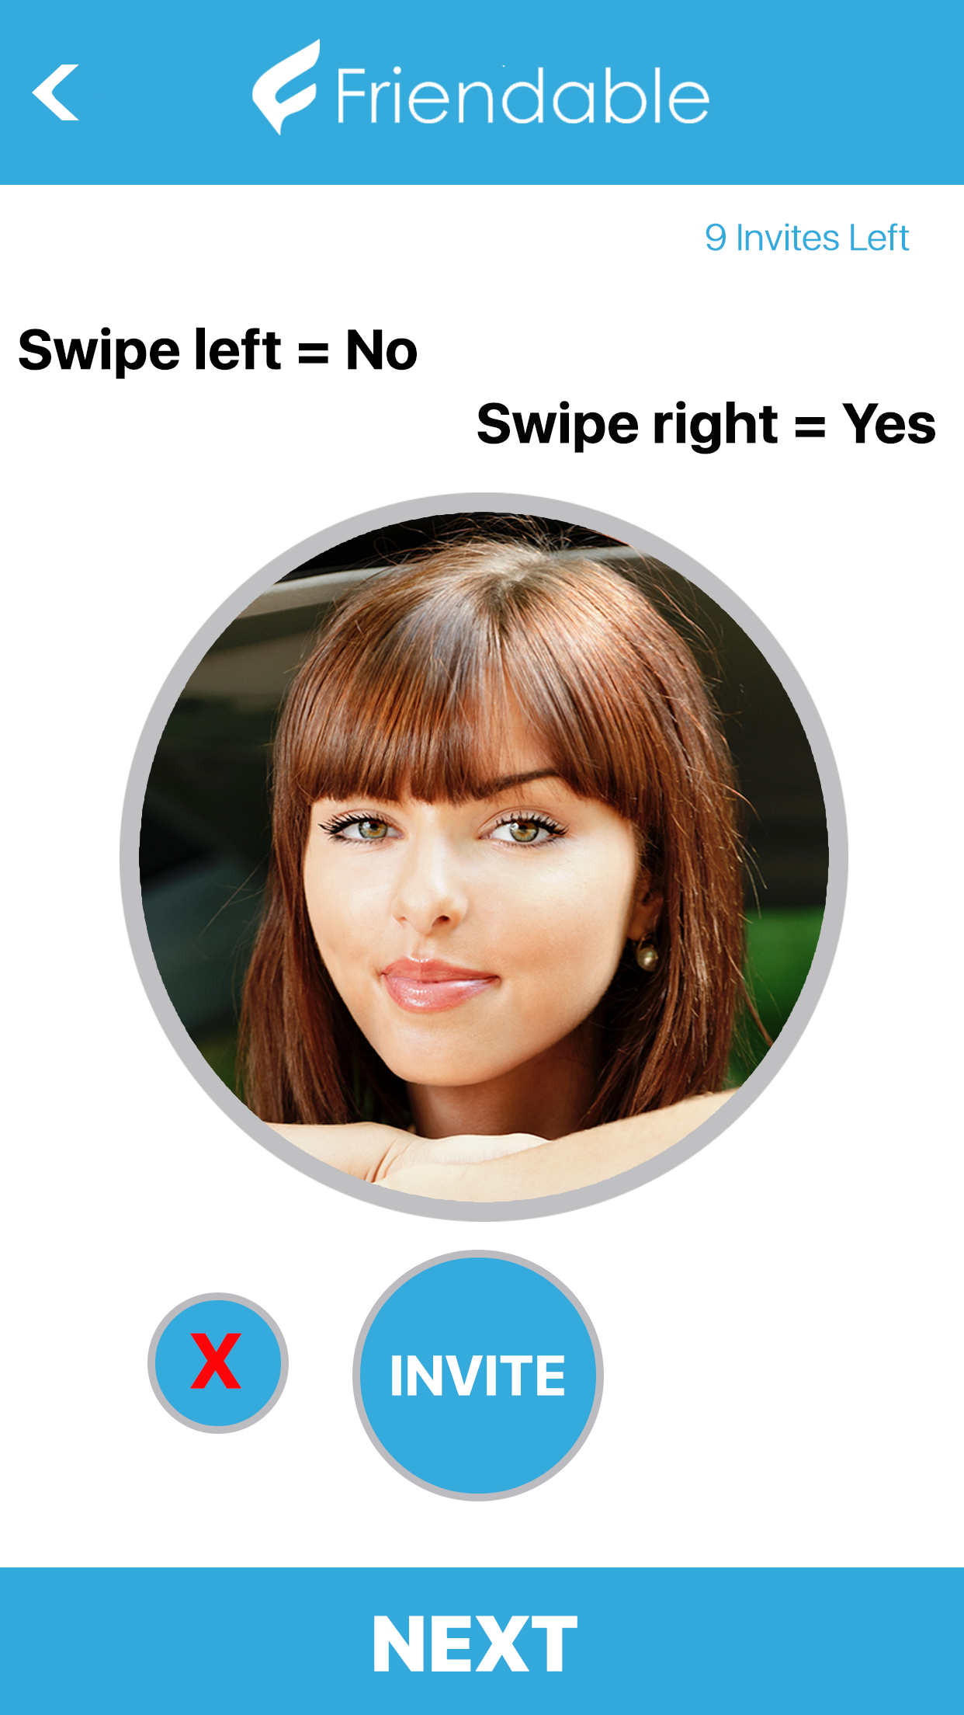
Homepage Link #3 (Screen 4): Requests Nearby

This series of screens will allow a user to view these requests based on their location (Similar to YikYak), the app will display all the requests within a certain mile radius, and should be able to be filtered or searched. The main interface of this screen should show an abbreviated listing of the friendable request and have a look similar to other social applications like YikYak, Facebook, Twitter, etc.).
Data:
-- Title
-- Description
-- # of Replies
-- # of Comments
-- When: Date/time or anytime

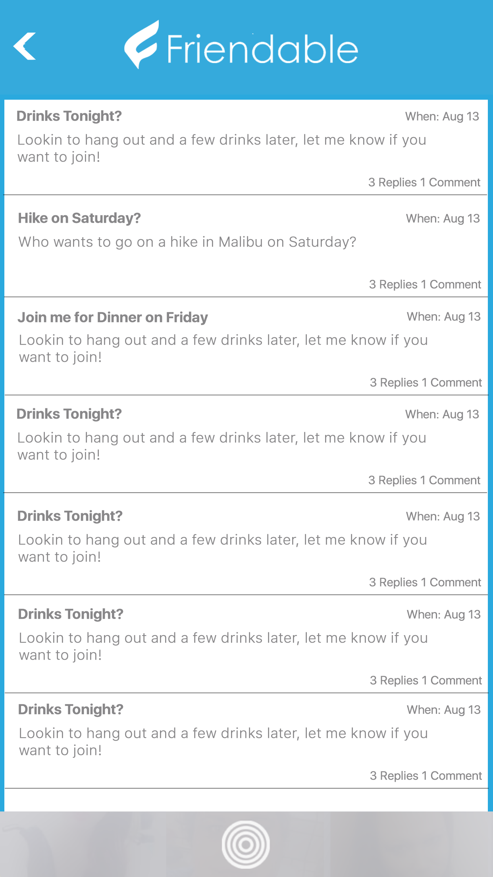
Homepage Link #4 (Screen 5): Trending HotSpots

This page should be similar to the Requests Nearby screen, but indexed by location or venue - the Titles should lead with the venue or place as well.

Screen 6: Friendable Request Detail Page
This page will be displayed when a user clicks on a request from the request nearby screen and also when clicked on a request from the trending hotspots page. This is just a detail page that displays all the information collected in the Create Friendable Request pages. It should allow a user to Join or accept the request, and it should allow users to add a comment (Again similar to the Yik Yak detail page. Yik Yak is a little plain looking, we would like it to look a little visually appealing, with mini user profile photo’s, etc.

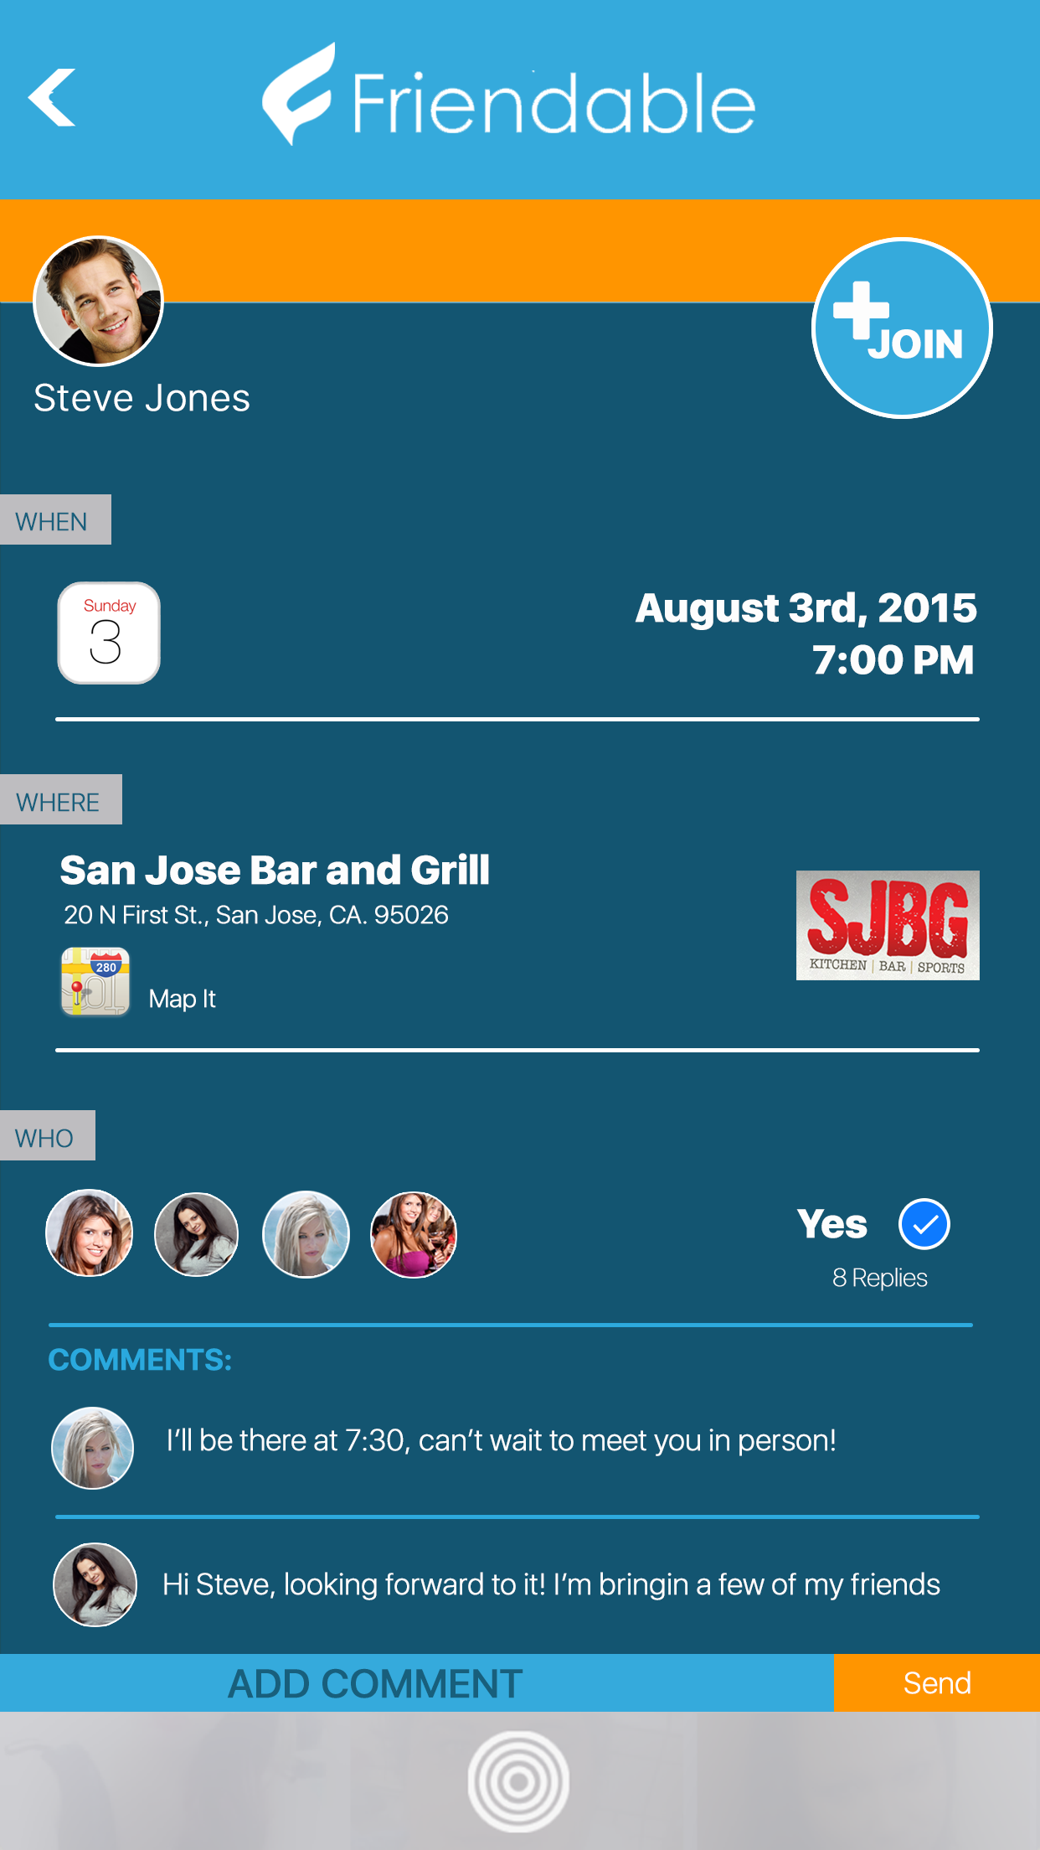

Screen 7: Upsell Page

Shown at the end of the registration / onboarding process:

Start 7 day Free trial

Show benefits:
- Respond to friendable requests
- Full chat functionality with photo and video sharing
- Ability to send virtual gifts to users
- Join events and invitations

Please review the screens and description and let me know what additional information that you might need.

https://ihookupsocial.box.com/s/zha1s5xzz9d8tzswo5828gclpl9an8ey

Screen 8: Splash “Launch” Screen



Screen 9: Login Screen

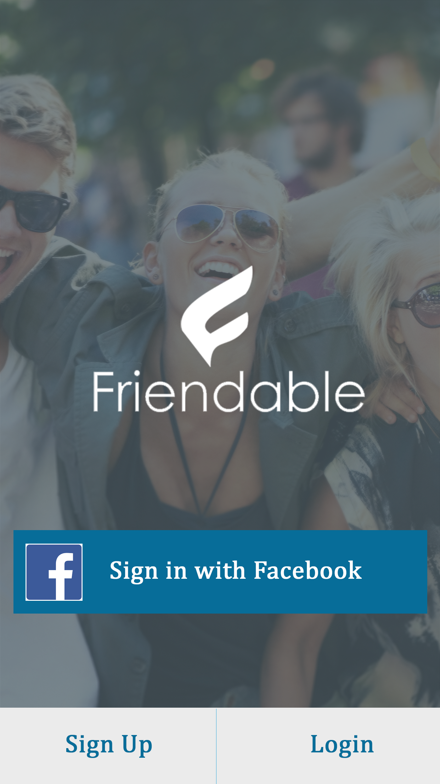

Must include 3 buttons:
- Connect with Facebook
- login
- Sign Up

Screen 10: Select a location

When a user selects “Choose a location” on Screen #2 above, this screen will appear and allow a user to select from nearby locations. This should be a listing of nearby places or events that the user can select from. It should include the name of the place, distance from you, short description, in case of event, a day and time, photo if available. These will be separated screens based which the user selects, but the look should be identical, just that the data will either be from a place or an event.

