Oxmoor Bourbon and Music Festival
Business Plan
Prepared By:
Rory Cameron

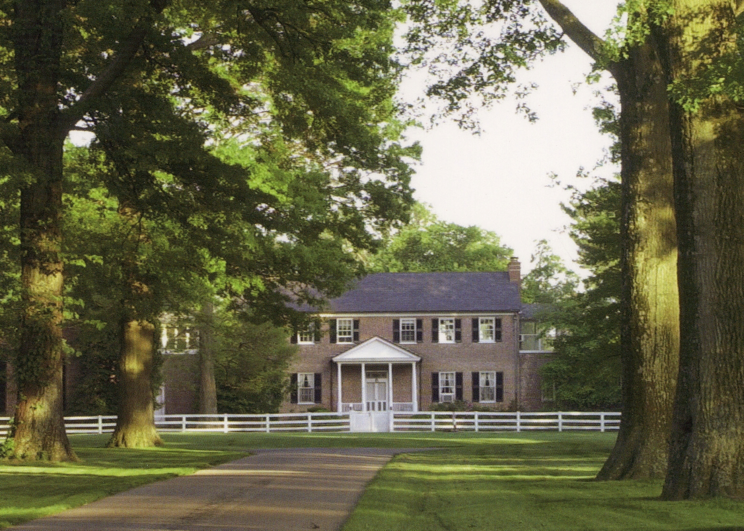

Executive Summary:
This business plan will detail the idea to hold a bourbon and music festival with complementary food offerings on the grounds at Oxmoor Farm on annual basis in the late Spring. Given the worldwide boom in the bourbon trade, Oxmoor’s connection to Evan Williams (as recently uncovered in a news article on WDRB in August of 2015 - http://www.wdrb.com/story/29689856/history-behind-louisville-cemetery-and-cabin-revealed), Oxmoor’s natural beauty and location, and the opportunity to pair bourbon with successful music acts, we believe there is an opportunity to establish a profitable and positively influential event for Oxmoor Farm and the trusts that own it. We also believe that a synergy can be created Louisville is a centrally located city with easy driving access to over 10 million people within a three hour drive. The focus of the festival will be to start small and focus on the bourbon enthusiasts as key customers to start. We believe that the Forecastle festival held in mid-July every summer will be difficult to compete with “music-wise” and thus the primary focus will be on bourbon and its devoted followers with music as a complementary aspect of the festival to start. If this project is successful, the music component can grow into something larger with a focus on country music/Bluegrass or even the local symphony.
Suggested Dates to hold event:
Date Ideas: Memorial Day Weekend, early June every summer. There is a “hole” in the calendar in Louisville in late May and early June for a festival to be held with minimal competition.
Concept:
Engage every single Kentucky Bourbon producer through the Kentucky Distiller’s Association and other avenues to create a presence at the festival by way of tasting booths where customers can experience every Kentucky bourbon offering out there in one place with great food and good music. The focus will be on Kentucky producers only, no Tennessee Whiskey or whiskey produced out of the state of Kentucky. There will also be a music stage set up where a concert will be held that will serve as an important backdrop for the bourbon tasting. We believe that the focus of music shall be Country Music so that the music line-up will not compete with the Forecastle Festival. The target number of attendees in year 1 will be 10,000 people at an average ticket cost of $65.
Location on Oxmoor:
The ideal location shall be the fields immediately to the southwest of the historic easement property. These fields are also used for Polo in the late summer and are approximately 25 acres in size. This location provides easy access to the entrance to the property, level ground and room for parking.

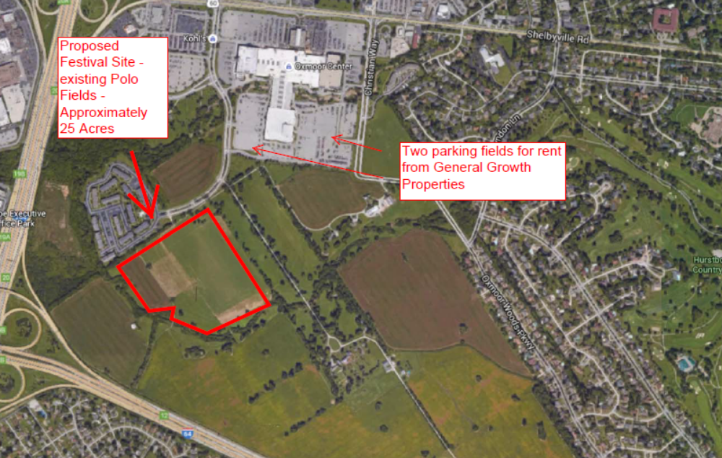

Budget:
Start up Budget/Working Capital: $15,000
Architect to draw site plan for vendors, stage, back of house and parking: $5,000
Marketing, website creation: $10,000
Event Management: $25,000
Management Plan
Rory Cameron and Ivor Chodowski will be the co-presidents of the to be formed LLC to manage the event.
Enagage PR Firm such as Boxcar to handle marketing, promotion, web-site creation. Engage Kentucky Distillers Association, Louisville Chamber of Commerce and other agencies to get involved to create buzz. Engage event management firm to handle logistics.
Work with JK McKnight, the founder of the Forecastle Music Festival, to consult on the festival and discuss bringing JK in to be a partner in the festival.

Security
Gather quotes from Louisville Metro police to have police presence at site.
Insurance
No investigations have been made into pricing for Insurance Coverage for the festival at this time.
Competition
Forecastle Music Festival
Kentucky Bluegrass and Bourbon experience
Another idea is to partner with the existing Kentucky Bluegrass and Bourbon experience by offering that festival a better venue in Oxmoor and a more robust music offering with county music and bluegrass.

Parking
The ideal parking fields will be the southern parking lots at Oxmoor Mall. Efforts will be made to reach out to General Growth to determine the availability and pricing for these parking areas. Shuttle service would be provided from the parking lots. The proposed site is also within easy walking distance of the General Growth lots.
Marketing Plan
Engage PR Firm such as Boxcar to create marketing plan for print, radio, TV, online and social media presence.
Vendors
- Music Stage Company
- Signage
- Bourbon Stalls
- Food Stalls
Production Company

Target Musicians
We believe the target musicians should be country music performers with a focus on one big headliner to draw attention to the festival. Target musicians for the headline act will be:
- Dwight Yoakam (Kentucky Native)
- Luke Bryan
- Zac Brown Band
- Kix Brooks
- Dierks Bentley
- Rascall Flats
Pricing
Pricing should be competitive with the Forecastle festival and tickets should be sold for $65-$95 for general admission.
Food and Beverage
Focus on local chefs and local foods for the event. This will be Ivor’s specialty in order to bring in the local, chef driven concepts to be preparing food for the event.

