Benefits
- Promotes Positive, Educational play among children and adults

- Increases Social Interaction among children and adults

- Increases Fine Motor and Gross Motor Development

- Provides a safe environment for children with special needs to play

- Creates employment opportunities

- Provides an environment where parents can receive and provide support for one another

What Can
You Do?

FACTS
- About 1 in 68 children has been identified with autism spectrum disorder (ASD) according to estimates from CDC's Autism and Developmental Disabilities Monitoring (ADDM) Network
- ASD is reported to occur in all racial, ethnic, and socioeconomic groups
- About 1 in 6 children in the United States had a developmental disability in 2006-2008, ranging from speech delays to cerebral palsy and autism.

Decentea’a Playhouse
CONTACT
Frank Trimble
123 Main Street
Anywhere, USA 98765
Phone #: 661-234-6789
decentea@yahoo.com
www.decenteasplayhouse.com
Nonprofit Status Tax ID #

A safe place for parents to play with
their special needs child.

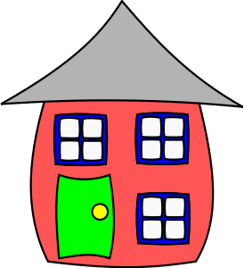



Mission Statement
Decentea’s Playhouse is a California non-profit 501 C3 educational corporation dedicated to the creation and operation of a multi-purpose recreational facility providing a safe environment for families and children living with Autism and related disabilities.


Jump Up

Decentea’s Playhouse is a multi-purpose play facility for children with Autism and special needs. The Playhouse will be a facility that helps support and develop interactive play and social interactions among children with Autism and special needs and the parents that support them.

ACTIVITIES
- Computer Labs
- Jump Houses
- Quiet Room
- Video Games
- Music Room
- Reading Area
- Indoor Play Area
- Outdoor Playground
- Recreational Room
for events & Parties



Place picture of Father and son playing

Decenetea’s Playhouse will be the Only full time, in-door / our-door educational play facility, where parents play with their Autistic and special needs children in a safe and stimulating environment.
We are seeking your support to help us create and develop this one of a kind playhouse.
We are launching this campaign to help raise $1.5 million to develop this one of a kind safe environment.

Sing  Dance Make Music
