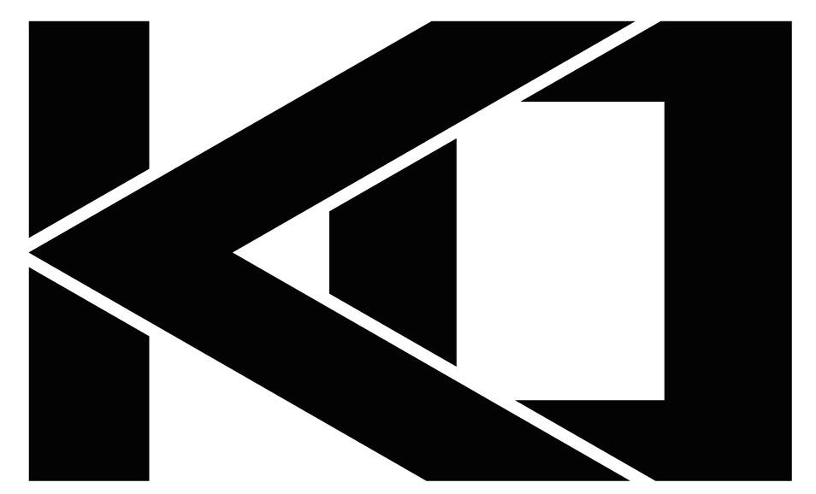

KO
kāˈō
a knockout it’s that simple

KO Investments is the privately held Investment and Holding company located in Newport Beach California. We only accept new investors by referral or invitation only.

Known as the “heavyweights” of the OC, KO Investments delivers a knockout every time with its team of accomplished professionals.

We are a referral only investment group composed of high net worth private investors actively investing in residential real property, commercial and retail development, commercial buildings, multi tenant units, repossessed and foreclosed dwellings, modernization of historical districts and telecommunication tower - land proprieties.

It’s all about having the right team in your corner and KO Investments delivers a knockout every time!

If you are seeking additional information please use our contact us page.

All media inquires, please contact us at media@koinvestments.com

http://www.520newportcenter.com/day-in-the-life

We are an Ultra High End PRIVATE Investment Group that is known for being ULTRA EXCLUSIVE and High NET WORTH. We are kind of the American Express Black for the private investment space in OC, we only invite new investors by referral only.

We are looking for a information only web site that has a big impact once we invite new investors to our site. It needs to be Ultra Modern, Sophisticated, and make an impact. The only contact information that will be listed on the web site is a place where if invite a new investor they can enter a code to unlock access to our members contacts (future page)

