9900 Maumelle Blvd, North Little Rock, AR 72113

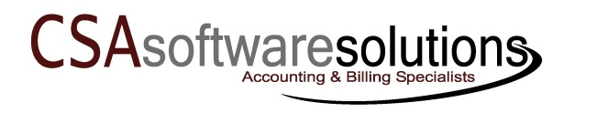


Some things are just

Better
Together!

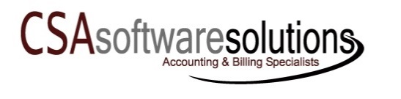
  - Incredible Software & Exceptional Support
For Your Municipal Accounting, Payroll and Utility Billing Needs


Some Things Are Just Better Together...
  - Incredible Software & Exceptional Support
From CSA Software Solutions

Working Better Together!


Since 1983, CSA Software Solutions has partnered with small to medium sized cities and utility companies. Our main goal is to provide our clients with incredible software that best meets their accounting and utility billing needs. Then, to help our clients effectively serve their communities, we provide exceptional support and training throughout the year that helps them master the software and find ways to reduce the workload of their staff.


CenterPoint Fund Accounting is an affordable, comprehensive fund accounting and payroll solution designed specifically for municipals with small to medium size populations.

- GASB Recommended Format
- Customizable Annual Financial Statement
- Budget by Individual Fund and Departments within the Funds
- LOTS of Reports - Customizable to Your Needs
- CenterPoint Payroll – Payroll that Saves You Both Time and Money
- Interfaces with RVS Mosaics Utility Billing System
- Exceptional Support Team - Working together for your success!!!

●●●
“We have found CenterPoint to be very user friendly and support that CSA has provided has made it very easy to use. There is a comfort in knowing that the staff of CSA are just a phone call away from helping you solve your problem.”
Sharon L,
City of Ash Flat

●●●

RVS Mosaics Utility Billing Software includes all the features that thousands of utility billing customers have come to expect. Here are a few:

- Help Control Water Loss
- Unlimited Transaction History
- Unlimited Note Space
- Complete Rate Analysis
- CASS Certification Available
- LOTS of Report Options
- Exceptional Support Team - Working together for your success!!!
800.264.4465
9900 Maumelle Blvd, North Little Rock, AR 72113
Fax: (501) 801-3573 E-mail: info@csasoftwaresolutions.com
www.csasoftwaresolutions.com

“RVS is the simplest billing software any utility company could use. The staff is always there to help, they are always pleasant and patient. We would recommend RVS to any billing company in the market for a quality upgrade or new billing system.”
Willette T.
Clayton Village Water Assn.

●●●

