FRONT COVER

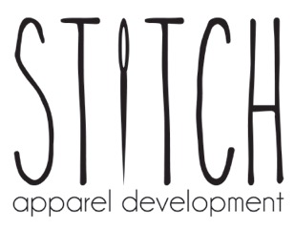

Specialists in customised dance uniforms and attire

- Create a unique custom design
- Promote your dance studio brand
- Generate additional income
- Fast turnaround and cost effective solutions

(USE A DANCE UNIFORM SHOT AS MAIN IMAGE)

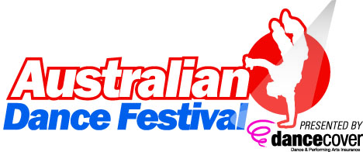

www.stitchapparel.com.au

Specialists in customised dance uniforms and attire
Stitch Apparel can provide your dance studio with uniforms and dance attire uniquely designed to help you implement a uniform program that meets your specific needs.

Uniforms keep your teacher’s and student’s focus on learning and away from clothing, and encourages students to develop their personal flair in dance rather than dress.

Stand out in the crown at your next Eisteddfod and Competition by bridging the gap between fashion and dance. Your students will thank you for it!

Chat with us today to see how we can help you promote your studio brand awareness, plus generate an additional income stream.

Using our vast experience in fashion production we manage the whole apparel development process to ensure our customers get a hassle free and streamlined experience. We will guide you through each process of your unique custom made dance uniform and dance attire development.

(DANCE UNIFORM IMAGERY)

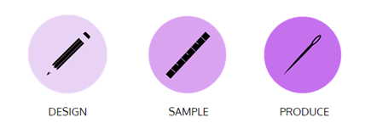
(Possibly use the above icons for the 3 key areas below – but would also like to have a corresponding image with each one, as shown)
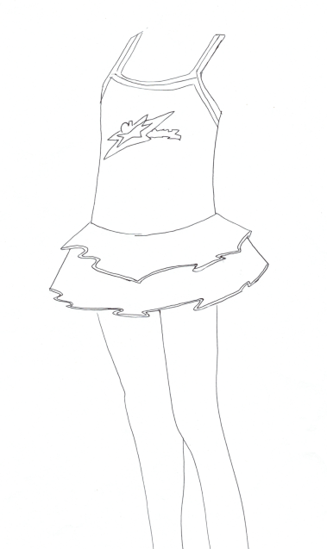
DESIGN
We offer guidance and advice to our customers by drawing on our fashion experiences.
We offer the abillity to:
- Produce samples from photos and sketches alone
- Source suitable fabrics
- Vary price and quaility depending on your requirements and budget
- Embroid and hand bead
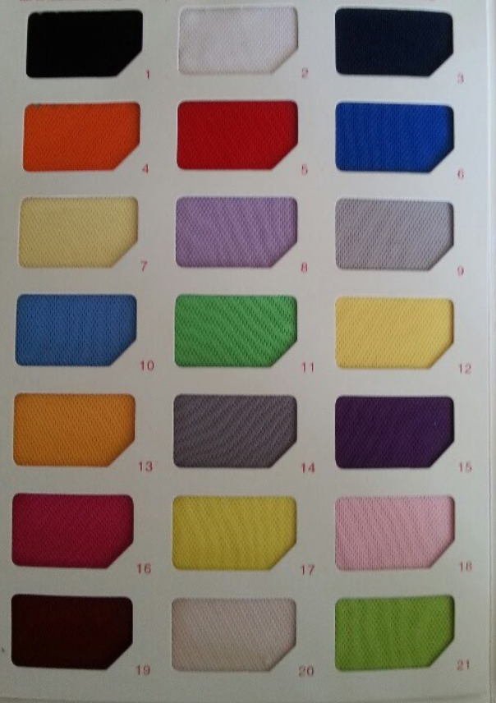
- Develop exclusive designs and prints
- Print desired graphics using a variety of techniques

SAMPLE
Our expert team of technical designers, pattern makers and fabric sources transform designs to reality.
We offer:
- Technical change recommendations to improve garment production
- Fabric recommendations
- Fast sample production
- Free fit ammendments

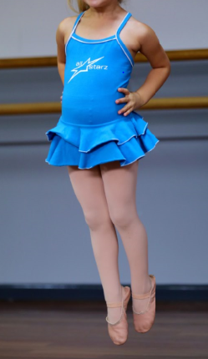
PRODUCE
Our team on the ground in China are experts in quality apparel production.
We offer:
- CAD pattern sizing to ensure consistency
- Quality finishes and trims
- Low minimums
- Ability to produce high volumes
- Delivery options for different timelines and budgets

OUR DEVELOPMENT PROCEDURE

Below outlines the procedure we follow with relevant time frames.

DESIGN
Our dedicated team are happy to liaise with you to create a look. We offer advice on fabric, colour and style. We have a catalogue of designs and looks that may be used as a design starting point to help bring your vision to life. We also offer graphic design solutions to complete the look.

SAMPLING
An original sample may be provided to us as a fit reference. We can also sample from photos as a base. Please note it is the customer’s responsibility to ensure the design does not infringe any copyright laws.
Sampling time: 3-5 WEEKS
It generally takes 2-3 weeks for the 1st sample to be produced. We allow an extra 2 weeks for resampling with minor changes. Upon receiving the sample we require the customer to fit the sample and notify us of any fit adjustments as well as any design adjustments. Should there be a Major Adjustment, then the sampling time is pushed back to 3-5 weeks as the process begins again.

Minor Adjustments: Sleeve length
Body length
Inseam length
Stitch colour
Colour Change
Major Adjustment: Body adjustments
Alternative Fabric
We are happy to attend fittings by appointment to ensure the correct adjustments are made.
PLACING AN ORDER
An order can be placed upon approval of the sample. It is the customer’s responsibility to ensure the sample completely meets their requirements. All prices are quoted exc. GST. Upon placing an order a 30% deposit is required. Minimums must be met.

DELIVERY
Shipper Delivery: 4 -5 weeks
A shipper sample (i.e. a piece taken from the bulk production) will be sent for final approval by the customer prior to bulk delivery.

Production Delivery: 3-4 weeks by SEA after shipper approval
1 week by AIR after shipper approval
(A surcharge is applicable by AIR)

If the product requires YKK zipper an extra 2 weeks allowance must be made.

CREATE AN ADDITIONAL INCOME STREAM
(dollar sign imagery / icons?)

The way we develop your custom uniforms gives you the opportunity to create an additional income stream for your studio.

For example,
If your studio has 100 students;
Each student buys the following studio branded attire at total retail price of $200 to the students:
- Leotard
- Singlet
- Wrap
- Shorts
- Winter Jacket
The cost of purchasing the uniforms to your studio is $100.

This means your studio makes an additional $10,000 additional income ($100 x 100 students) from selling your custom made uniforms, with the added bonus of uniformity and brand recognition.

(USE A FLAT LAY IMAGE SHOWING DIFFERENT TYPES OF PRODUCTS IN A DANCE UNIFORM KIT)

BACK COVER

S73, L7, 8-24 Kippax St
Surry Hills NSW 2010
 02 9281 9870
info@stitchapparel.com.au
www.stitchapparel.com.au
ABN: 63 169 206 6324

