Matrix Software Consulting
New Company Logo Brief
August 26, 201
Objective
Develop several logo options for LendWorks (formerly Matrix Software Consulting).
Background
- Matrix was established in 2004, and has provided outstanding proprietary technology solutions for clients in the mortgage banking industry
- The company provides services including: Project Management, Business Analysis, Windows Application Development, Web Development, Database Architecture, XML Interface Development and Hardware and Network Consultation
- Steven Watts, President and CEO of MSC has over 30 years of software development and project management experience in the Mortgage Banking, Real Estate and Escrow industries
- Justin Smith, Sr. Systems Architect has over 14 years of software development experience, focused on the Mortgage Banking Industry
- Tyler Hill, MCSE, DBA, Systems Architect, has over 15 years experience as a Network Administrator, DBA and MCSD for Mortgage Banking Companies and Classified Military Projects
- The team is committed to delivering solutions that make sense given a company’s business model, and that WORK, making the company more productive and successful

Naming Objectives:
Create an appealing, relevant and memorable logo that makes current and prospective clients confident in the company’s ability to deliver technology solutions that work within their current realities and make a difference in their bottom line

Core Benefit/Reasons-to-believe:
For naming and positioning development, an illustrative benefit hierarchy serves as a guide for linking company attributes to rational and emotional benefits:

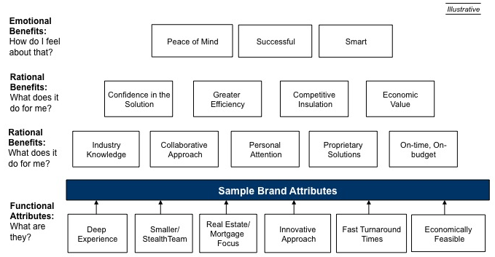
Target:
- President or CEO of Mortgage Banking Division and IT Department
Working Brand Positioning
For companies in the mortgage banking industry, ABC Software is the only developer of proprietary software solutions that take your current system to the next level with a thoughtful, collaborative and innovative approach to driving greater growth and efficiency in your organization.
Potential Brand Character/Tone and Manner:
What do we want clients to think and say about us?
- Well-respected  - Impressive Track Record  - Insightful  - Innovative  - Forward-looking | - Efficient  - Can-do attitude  - Top-notch performance  - Exceeds Expectations  - Affordable

