  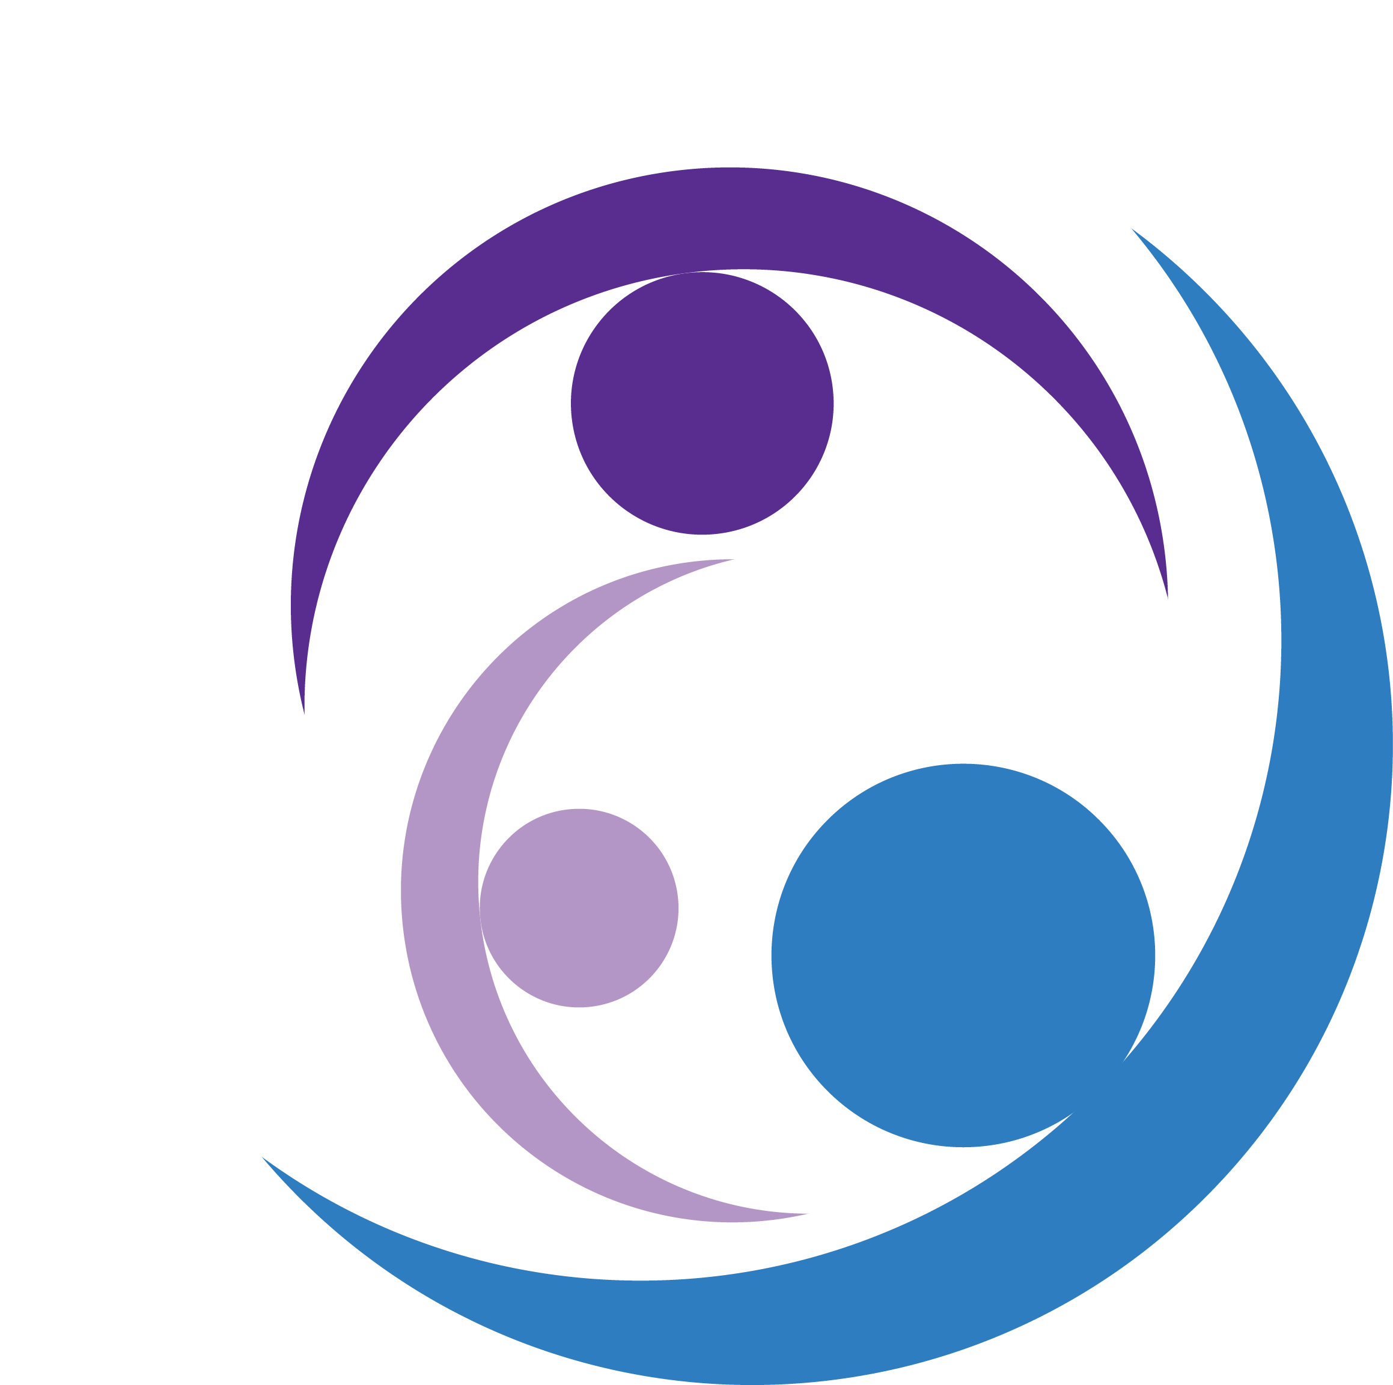
  Integrity Clinical Consulting & Training
  What we do…..
  We are here to give you the tools to learn to live the best life you can live. We are also here to provide clinical therapy and to individuals, families, couples, children, teens and adults who may be experiencing life challenges.
  How we can help…..
  We can see you in your home or in our office for sessions with daytime, evening and weekend hours.
  Who we are………
  We are an IL-licensed business offering services under the direction of an IL Licensed Clinical Social Worker (LCSW) with over 20 years of experience working the field of mental health, foster care and adoption, substance abuse and domestic violence and juvenile court system.
  We’re here to help and support you!
  Want help for yourself, your children or as a family?
  We work with various insurance companies and EAPs
  Call for free consultation
  We also accept IL Medicaid and Medicare
  Integrity Clinical Consulting & Training
  4440 Lincoln Hwy
  Suite 100-G
  Matteson, IL 60443
  www.integrityclinicalconsulting.com
  (708) 794-6511

