For use on our website, correspondence, publications and certificates, ANSA requires a consistent visual image. These are the logos/banners in current use.

1] Original ANSA neurons banner
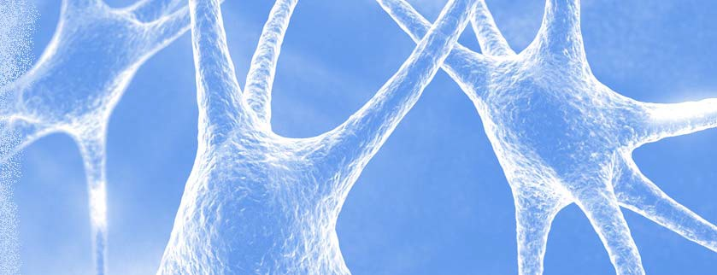
ANSA
Bringing Applied Neuroscience into Clinical Practice

The Applied Neuroscience Society of Australasia
Incorporation No: INC9878397
ABN No. 22896855463
c/- The Secretary
address…

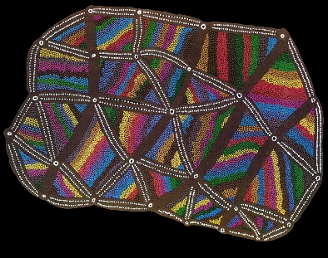
2] Braintracks – on black
The Applied Neuroscience Society of Australasia
Incorporation No: INC9878397
ABN No. 22896855463
c/- The Secretary
address…

3] Braintracks – on white
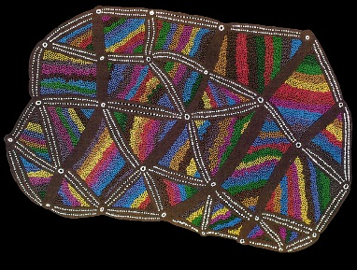
The Applied Neuroscience Society of Australasia
Incorporation No: INC9878397
c/- The Secretary
address…

4] URL option


