Name: Little Athletes
Slogan: Healthy wellbeing, Healthy future
­­­­­­­­­­­­­­­­­­­­­­­­­­­­­­­­­­­­­­­­­­­­­­­­­­­­­­­­­­­­­­­­­­­­­­­­­­­
Little Athletes is a sports coaching organisation that specialises in the physical development of young children. We aim, to develop children’s gross motor skills, fundamental and social skills through sports and exercise. Alongside this, we want to help to promote a healthy and active lifestyle for young children to follow.
So in essence the logo must be suitable for both a website, letterheads, and printing ( as we will be promoting the business by having our logos printed on to vehicles) .The colour scheme of our vehicles consists of a white background so whichever colours you choose to use for the logo must work with this. Also, the logo must work in colour or black and white in print.
We want the logo to be resizable but must work with measurements of 224 pixels width / 73 pixels height, as we will be enlarging the logo to different sizes i.e. when having the logo printed on to our vehicles.
We would like an iconic logo that will be very identifiable and unique, something that will catch the eye and will be remembered. “ Little Athletes” must be very clear, but I want it to look athletic, The picture must be colourful but the font has to look clean and unfussy, but different than what’s already out there, I want my logo to be completely unique. Whether there is a space between the two words is entirely up to what you think will work best creatively.
I want people to look at my logo and instantly know who Little Athletes are and what we do, so I would like you to incorporate some sort of physicality into my design, weather that is sports equipment, children playing sport, that is entirely up to you, but the picture MUST relate to “ Little -Athletes” Perhaps try to think more imaginatively and again, try and come up with something that isn’t already out there. Whatever you decide, iconic and definitely not cheesy.
Our target audience are male and female, between the ages of 2-6, so it is very important that the logo appeals to this demographic. I don’t want my logo to look too babyish or toddler-ish, the “ Tumble tots” logo is the perfect example of what I DON’T want. I want it to look professional, smart and “ cool” but it’s got to be effective. We want our logo to appeal to children, parents, and employees but also look 100% professional.
We look forward to seeing the amazing, clever and innovative logo designs you can concoct for
us and choosing our winner. Let your creative juices flow!
P.S.
I have attached some examples of some logos that I like, the style of writing and the font used.

THIS IS WHAT I WANT AS A LOG0

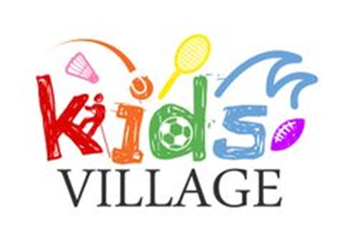

Logo and text must work on a white background.
Logo must work in print as well as online.

