
Élan Learning Institute Australia
Corporate Training, Consulting & Executive Retreats

HOW DO WE MEASURE SUCCESS?

The answer lies in the people we train. Our programmes create a positive cultural shift and those who have experienced our programs consistently confirm the results produced. Because every organisation is unique, we tailor each programme towards the needs, goals and outcomes the organisation wishes to achieve.

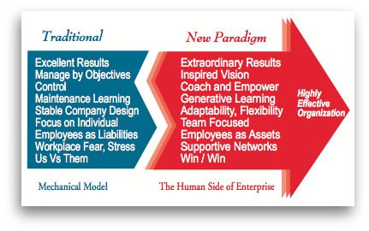

PROGRAMMES TO ACHIEVE YOUR GOALS & OUTCOMES
MANAGING CHANGE:  Learning to Learn, Drawing Outside the Lines, Organisational and Departmental Visioning. Facilitating Change in the Organisation  LEADERSHIP:  5 Pillars of Leadership, The Learning Organisation & the 21st Century Executive, The 21st Century Leader, Managing Managers' Time, Project Management, The Coaching Clinic I - IV, Balancing Intellectual, Emotional & Social Competencies, Negotiation Coaching, Handling Difficult Conversations, Conflict Management  FACILITATION SKILLS | TEAMWORK:  Developing Team Flow, Team Effectiveness, Team Communication Skills, Meetings that Motivate, Building your High Performance Team, Sales Mastery  COMMUNICATION:  Interpersonal Communications with NLP I & II Framing, Handling Difficult Conversations  TOTAL QUALITY MANAGEMENT:  Kaizen: Continuous Improvement I & II  SERVICE:  Service Excellence, Our Attitude is Our Message  EXECUTIVE MANAGEMENT RETREATS:  Designed for your Specific Needs

© Élan Enterprises LLC

