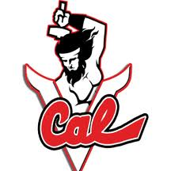
Image holding the hammer like a blacksmith

Sword and wings
Not Engineering wheels
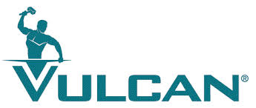
Blacksmith image maybe at the H
.
Otago Highlanders Colours
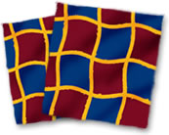

HIGHLANDER STEEL
Claymore handle. Design of handle
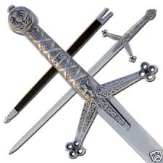
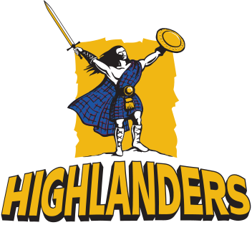
Otago Highlanders logo/picture

Like the font and the sword arrangement
Perhaps t in steel???
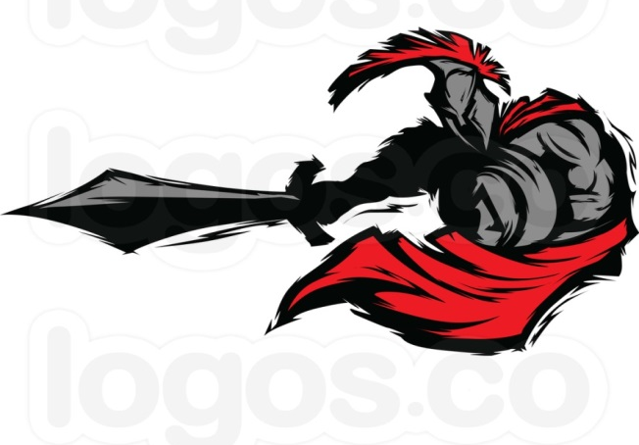
Car wrap
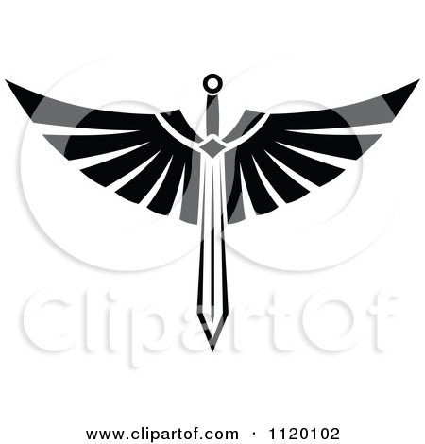
Sword and wings style

Maybe for something else

Shield and claymores. Like this with two types of claymore handles
Maybe HS across the shield, possibly in font type selected.
Banner yes/no
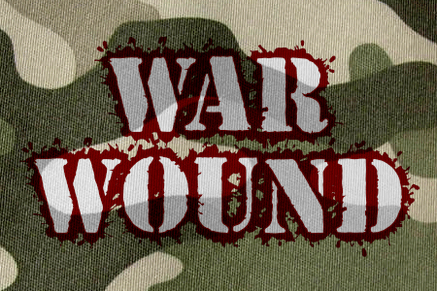
Dafont style
War Wound

Car Wrap???
Highlander Steel
Highlander Steel
Dafont Styles
Caution (Maybe with steel beams top and bottom)

Highlander Steel
Dafont Style
Ultramarine
Clean
Dafont Style
Texas Troupe FP
Maybe

Highlander steel
Dafont Style
Spacecraft2
Maybe

Highlander steel
Dafont Style
Heavy Gothik
Hmmm??!!!

Highlander Steel
Company Name: HIGHLANDER STEEL PTY LTD
ABN/ACN 81 167 845 543 / 167 845 543

Business profile
Specialising in steel fabrication and installation. Supplying services to the commercial, residential and industrial sectors.
Logo design background
The name Highlander is poignant given the Scottish heritage of the vested interests. Coincidentally and in parallel with this heritage key staff are from the Otago New Zealand region, having strong ties to Scotland and home to the Otago Highlanders rugby team. Including the family history traced to Dunedin the company name evolved quickly.
Images of strength, such as the two claymore and shield combination are desirable. Images of blacksmithing etc are of interest. See attached ideas, existing logos of interest.
Colours
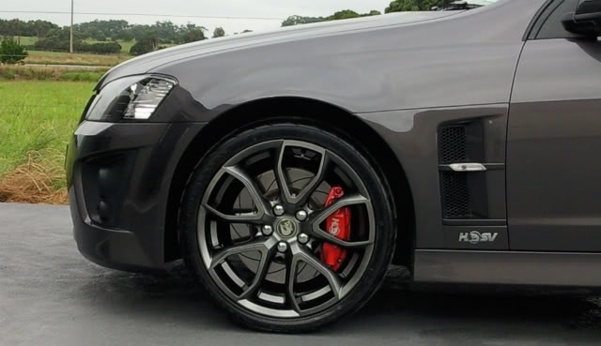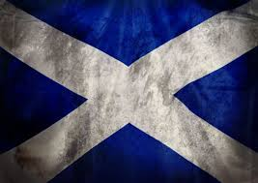
Font in Gunmetal Grey or similar. A couple of ‘left field’ colour ways appreciated.
Logo. Dominant in Maroon (toward red), Navy (toward blue) with embellishments in gold (towards yellow). Refer to attached or Otago Highlanders website.
Other colour influences; MacDonald tartan at http://www.scotclans.com/scottish_clans/clan_macdonald/tartan.html
Scottish Flag

