Company Description & Logo Ideas

Company Description:
We are 1 HP, 1-Health Providence, an online blog aiming to provide practical and valuable health management tips and guidelines to gamers. Health management with gaming is becoming more and more important with the rise of the gaming industry. While it has always been present, gaming binges and limited activity is becoming more prevalent today with no valid and reliable resource to provide health management tips/issues. As a Physical Therapist/Healthcare Professional, I feel that I am the most equipped to provide this information to the gaming niche. I teach gamers how to prolong their gaming careers through the management of their health. From nutrition, injury management, exercises, health prevention, and even the mental component related to esports, 1 HP aims to become the number 1 resource for health management of esports athletes in the world.

1 HP – Live, Game, Replenish

Logo Thoughts:
With regards to the style of our logo, we were looking for a simple, minimalist and clever type design based on what our company represents. A sleek looking font would be desired as well. We hope to have the logo represent, if possible, some of the following phrases/words
- Health
- Longevity
- We know Gaming
- Inspires Healthy Living
We were also looking for a logo that translates well in different sizes that conveys the playful, warm, human and giving spirit we embody. In the end, we are here to help the gamers. Attractive, Professional yet playful and conveys positive emotions so people smile when they see it. I have some ideas below

Ideas:
- I’m looking for maybe a clever adaptation of a health bar within one of the most popular games:
League of Legends, Counter-Strike Global Offensive, Dota 2, Starcraft 2, Halo, World of Warcraft, Call of Duty, etc. If there is text included, I wouldn’t want anything to overpower the other.
- Clever adaptation of anything related to one of the aforementioned games above.
- I’m also open to any unique interpretations

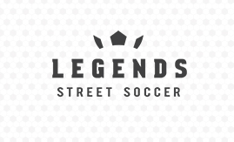
Examples:
1. Legends Street Soccer
We like this one as it utilizes the soccer pattern that doubles as a crown. It is clever in its presentation and is a great visual metaphor
2. Volt Rabbit
Another clever interpretation of the words
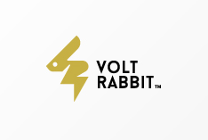
3. Atrium
I love the simplicity of this design.
4. Midnight Coffee Creative
Smart interpretation of the words with a soft color contrast
5. Spartan Eatery
Another clever interpretation of two concepts

