EXAMPLE LOGOS/STYLES/COLOURS


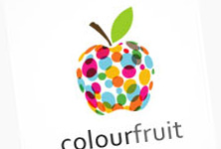




LOGO AND WEBSITE COLOURS
Green
Represents health, serenity and freshness. Green motivates, promotes belonging and satisfaction and is a social colour. Light green is particularly calming. Turquoise provides clarity, calms emotions, recharges the spirit and inspires positive thought. This colour inspires self-expression.
Blue
Blue represents trust, honesty and dependability which is good to promote customer loyalty. Light blue is particularly good for health.
Yellow
Yellow promotes optimism, positivism and warmth. Bright yellow draws the eye’s attention before any other colour.
Purple
Purple represents spirituality.
White
White represents simplicity, purity and cleanliness.

